IFRC Aerobic Faecal Waste Treatment Unit
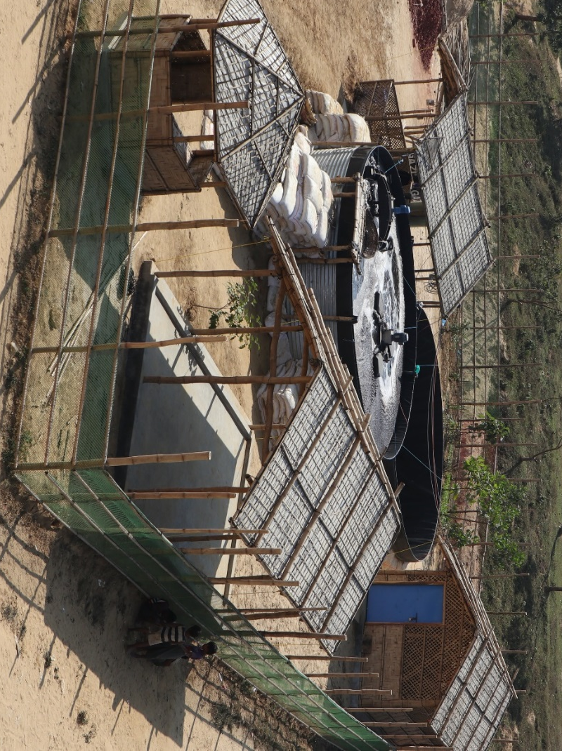
The IFRC Aerobic Faecal Waste Treatment Unit is a rapidly deployable and scalable equipment package for treating human waste in natural and manmade disasters. The unit safely treats wastewater and faecal sludge with efficient use of both energy and land and without strong odours. This fact sheet presents the details and specifications of an upgraded unit based on a system piloted by the IFRC in Cox’s Bazaar, Bangladesh in 2018 and 2019. This treatment process is used globally, but this unit can be transported, set up and operated in emergency field conditions.

Treatment technology: | Aerated active sludge treatment
Treatment objective | COD reduction and pathogen elimination
Treatment capacity | 10 m³/day (estimated 20,000 people) per treatment line, scalable
Site requirements | Accessibility | on foot as equipment can be hand carried and assembled on site
 | Utilities | Equipment package comes with 12 kVA genset and wiring for connection to renewable energy. Water needed for inception and backwash.
 | Area | 200 m² per treatment line plus storage and office space (0.02 m2 per person)
 | Discharge | Estimated 0.1 m3 dried sludge and 10 m3 treated wastewater per day (wastewater can safely be used for irrigation or added to a surface waterway)
 | Site location and security | Fencing and security are needed for health and safety and theft prevention. The unit does not produce strong odours or attract insects but the unit should be as far from settlement as possible while still allowing for efficient delivery of faecal waste.
Life expectancy | Short, mid and long term treatment
Weight and volume | 11,790kg / 41.71m3 per treatment line. One 40 ft container
Start up time | Construction: 2-5 days  Inception: 4 weeks or more depending on waste characteristics
Capital cost | $180,000 per treatment line ($9.00 per person) ex works, plus local materials (e.g.fencing, gravel), includes genset rather than renewable energy source
Operational cost | $5 per m3 treated, reduced with use of renewable energy. Excludes sludge transport cost.
Skills required | Set up and oversight: Aerobic treatment expertise
 | Daily operation and maintenance: Basic mechanical and electric skills & low skill labour
Treatment technology | The aerated active sludge treatment consists of grate for large solid waste removal, anaerobic baffled reactor for pre-treatment, the aerated sludge reactor for COD reduction, a settling tank for solid liquid separation, a glass bead filter for parasite reduction and a disinfection step (UV or chlorination) for pathogen elimination. Accumulated sludge is treated in an anaerobic digester or lime treatment.
Process overview | The anaerobic baffled reactor is used as pretreatment, to remove solids from the waste stream. The waste then moves to two reactor tanks in series. The aeration of the incoming faecal sludge in the a reactor tanks leads to the breeding of bacteria that metabolize the organic content (COD/TOC) together with the oxygen, turning the organic content into a gas (carbon dioxide).  The supernatant from the two reactor tanks is transferred to a settling tank, where the remaining solids are separated. The supernatant of the settling tank is then passed through a glass bead filter, which is regularly backwashed, for the removal of parasites and parasite eggs. Finally, the liquid is disinfected by chlorine or UV. Sludge from the settling tank is added to the reactor tank. Reactor tank sludge is treated by anaerobic digestion or lime treatment.
Additional requirements | A fully functional faecal sludge quality laboratory is a requirement for this unit.
Advantages over other faecal sludge methodologies | Odour and solid reduction  Low land use  Effective and efficient

Frequently Asked Questions
What does it do? Treat a variety of faecal waste streams in emergency settings.
Does it smell? The pilot unit has produced no noxious odours or attracted insects.
Does it work? Yes, much better than expected. The pilot is small, too small for the tanks we chose. But we are seeing substantial COD reduction and parasite elimination. We believe that the planned larger unit will achieve the required COD and pathogen reduction.
Isn’t all faecal sludge management context specific? Yes, but this technology is in use all over the world. Outside of extreme cold climates, the main challenge with deploying aerobic treatment is the sustainability issues (cost, spare parts, technical support) present in all low income settings. However, we are developing a short to medium term solution for acute emergencies. As with emergency water treatment, there are different considerations in the emergency context.

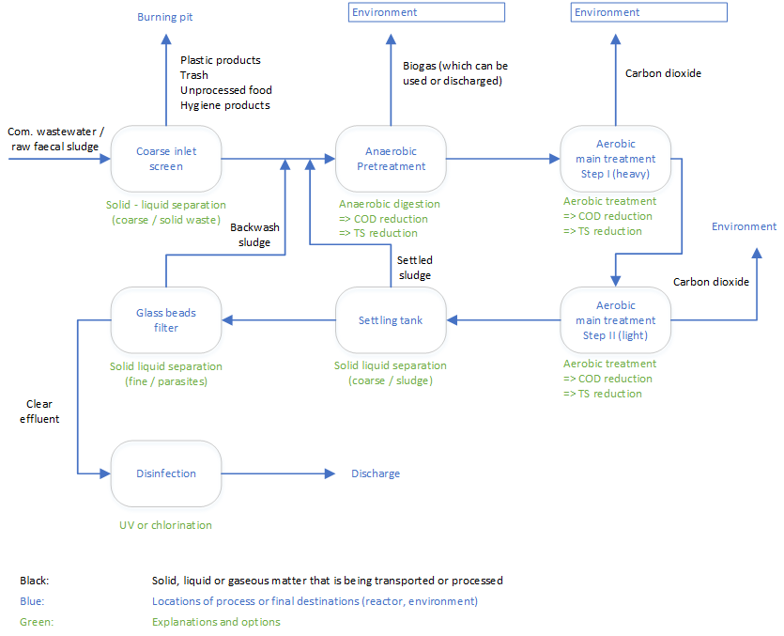
Process Flow
Indicative Equipment List and Total Cost
No. | Description | Qty | Notes
1 | Coarse screen | 1 | For large solid removal
2 | Anaerobic Baffled Reactor (ABR) tanks (T11s) | 3 | Further discussions needed to agree best inlet/outlet flow positions
 | T11 Plinth Kit | 1 | Added by BPL, in case further gravity is required to assist flow
3 | Sludge pump, 3" | 1 | Diaphragm pump
4 | Anaerobic Digester | 1 | Spec of Flexigester
5 | Aeration Tank | 2 | (02 T48 uprated steel)
6 | Plinth Kit | 1 | In case further gravity is required
7 | Surface agitator unit | 2 | Spec of Oloid 400 includes floats, fastenings and packing
8 | Surface aerator unit | 5 | Spec of Hydro2
9 | 12kVA Generator | 2 | For agitator and aerator plus back-up generator
10 | Effluent pump | 1 | Submersible sludge pump
11 | Sludge transfer pump | 1 | Single Screw pump
12 | Settling tank | 1 | T48 with tapered liner and uprated steel
13 | Glass beads vessel | 2
14 | Glass beads 1,000kg | 3 | To fill vessel and approximately 1,000kg spare
15 | Backwash pump | 1 | Peripheral Pump
16 | Backwash tank (2m3) | 1
17 | Reaction tank | 1 | T7 tank
18 | 4 kVA Generator for pumps | 2 | Included a back-up generator to ensure continuous power
19 | Control panel to retro-fit solar | 2 | To enable connection to solar power
20 | Pipe runs (suction hose) | 20 | 3" Suction hose with storz ends
21 | Aquagranule 5kg Tubs | 120 | In case HTH is not available locally
22 | Tools (assortment) | 1 | Engineers tool kit + excavation tools - kit to be agreed
23 | Consumables | 1 | Sundry items - kit to be agreed
24 | PPE (6 persons) | 1 | PPE as per previous DRK experience
25 | Packing | 1 | ISPM15 heat treated plywood casing throughout
 | Total Estimated Price $180,000 ex works

Learn more at www.emergencysanitationproject.org or email wash.geneva@ifrc.org

Chemical Oxygen Demand
Based on the an estimated sludge accumulation rate of 0.5 l/person/day from the Cox’s Bazar, Kutupalong-Balukhali experience, results may vary by location
Total Organic Content

