PRACTICAL FORM

WATER NETWORK

AIMS:

- To learn the capacity of SRC WATSAN M15 ERU to install a water network for a field hospital, health centres and IDP Camps.
- To learn the materials used for the SRC WATSAN M15 ERU to install an internal water network.
- To learn the pressure groups used in the water network.
- To install small networks with polyethylene, its components and pressure groups.

TIME: 3 hours

PARTICIPANTS: The course is divided into 3 smaller groups.

MATERIALS:

- 1” Ø polyethylene pipe (100 m.) (To be purchased for the practice. Do not use the pipe which is part of the ERU equipment).
- 50 metre, 1kV, 3 x 1.5 mm² electric wire to connect the groups to a electricity source (To be purchased for the practice. Do not use the pipe which is part of the ERU equipment).
- 3 special scissors to cut pipes and/or saws to cut polyethylene pipes.
- Box SP/ERU/WATSAN/EQU/GTO/ 01
- Box SP/ERU/WATSAN/EQU/CAN/01 (with pressure groups)
- Box SP/ERU/WATSAN/EQU/PIP/01
- Box SP/ERU/WATSAN/EQU/PIP/02
- 2 WTP o 2 generators

HANDOUTS:

- Water network installation handbook

LOCATION: A flat area close to a water source. The same area as the water practical and with possibility of electricity supply.

PRACTICAL DESCRIPTION:

The practical is divided into the following activities:

Activity a) To learn how to use polyethylene materials (pipes and components) (20 min.)
Activity b) To assemble and operate the pressure groups (30 min)
Activity c) There are 90 minutes available for these activity. The activity is divided into 3
practicals which are performed at the same time.

Practical 1: Installation of a simple network composed by: Bladder tank – pressure group –
2 waterhorses in series (90 min.)
Practical 2: Installation of a simple network composed by: Bladder tank – pressure group –
2 waterhorses in parallel (90 min.)
Practical 3: Installation of a simple network composed by: Bladder tank – pressure group –
5 taps for washing area (90 min.)
Activity d) Debriefing (15 min.)
Activity e) Equipment packing (15 min.)

The participants use the water network installation handbook to identify the components and to use polyethylene materials.

The assembly and startup of the pressure groups is made by each participant group, after the explanation of the facilitator. Therefore, all participants can observe the assembly process.

Three full bladder tanks (10,000 or 5,000 litres) are necessary for the implementation of activity c). They must be sufficiently close to the WTP in case there is not electricity supply and we have to use the ancillary socket of the plant’s generator. The tanks should not be far away from each other.

The length of the water lines should not be more than 25 metres in order to avoid casting material. The electricity supply must be within the cable range.

PHOTOS:

Assembly of pressure groups and knowledge of polyethylene material.

(Spanish Red Cross WATSAN M15 ERU, Madrid 2007).

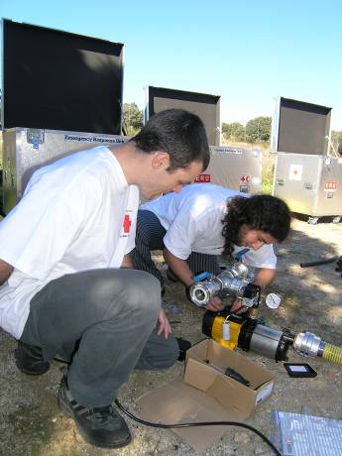

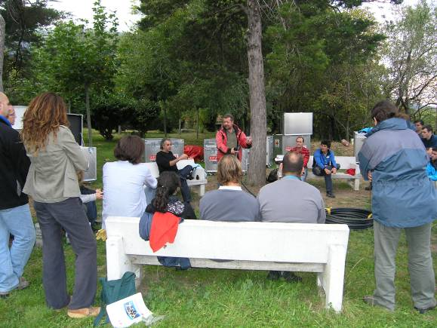

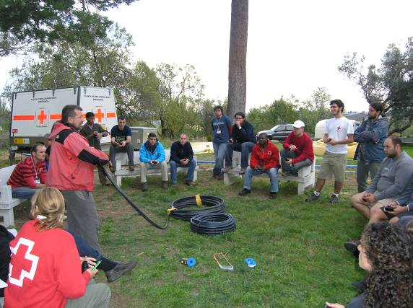

CASE STUDIES OF DIFFERENT INSTALLATIONS

FIELD HOSPITAL
HAITI 2004

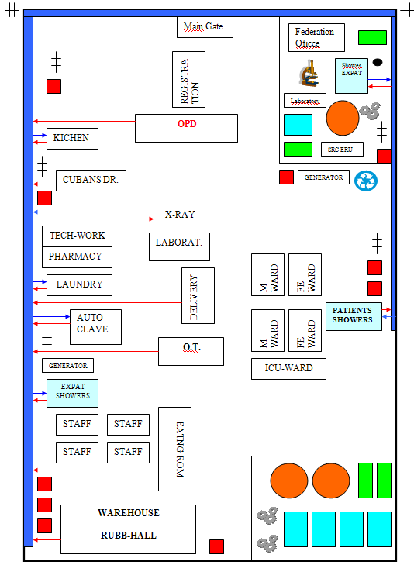

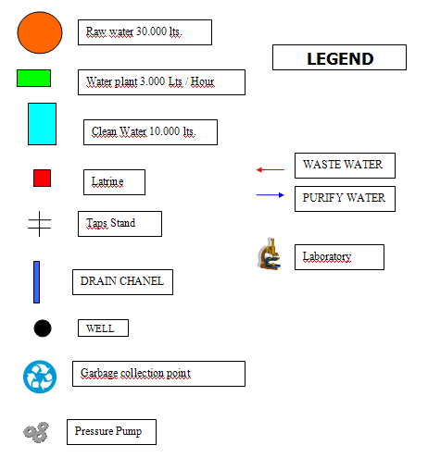

QUIROFANO
The plan shows the installation of water supply points, pressure groups, wastewater Management, latrines, showers
and collection of solid waste.

INTERNAL DISPLACED PEOPLE CAMP AND BASIC HEALTH CARE ERU
IRAN 2004

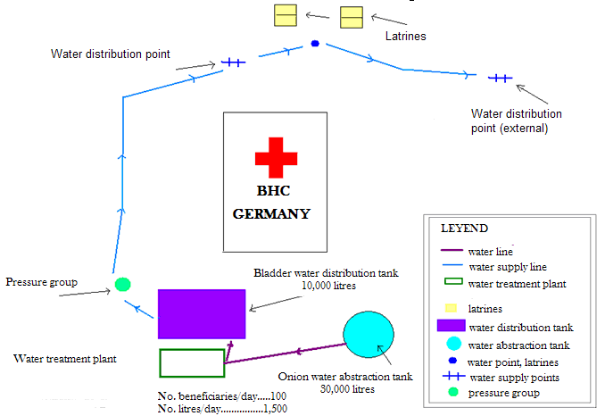

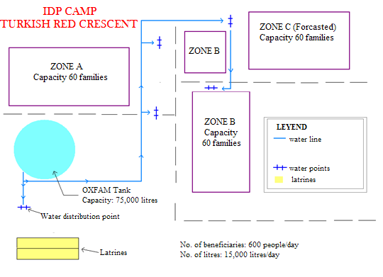

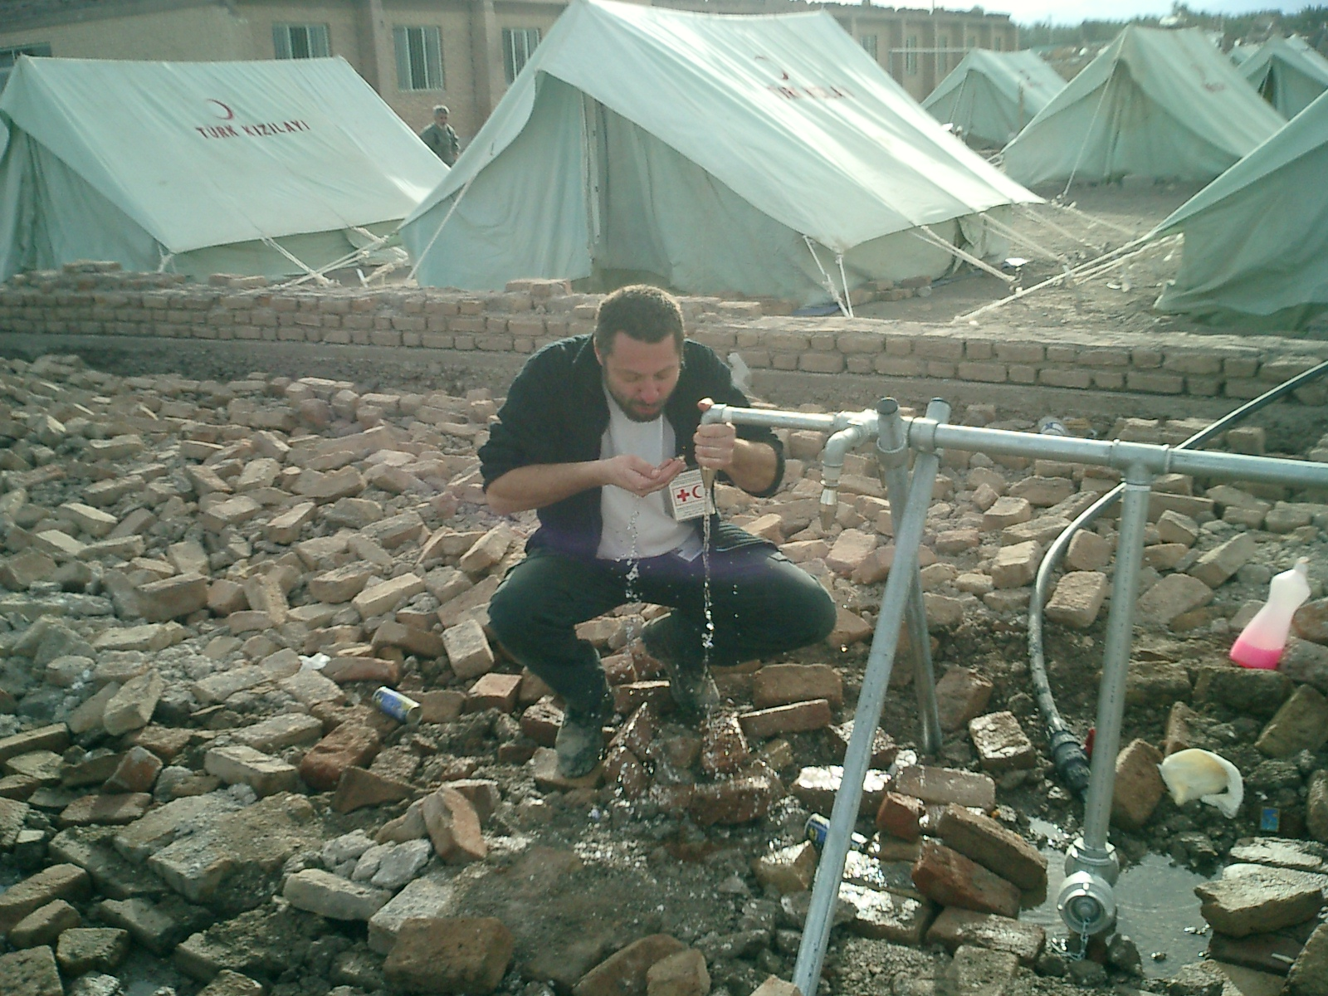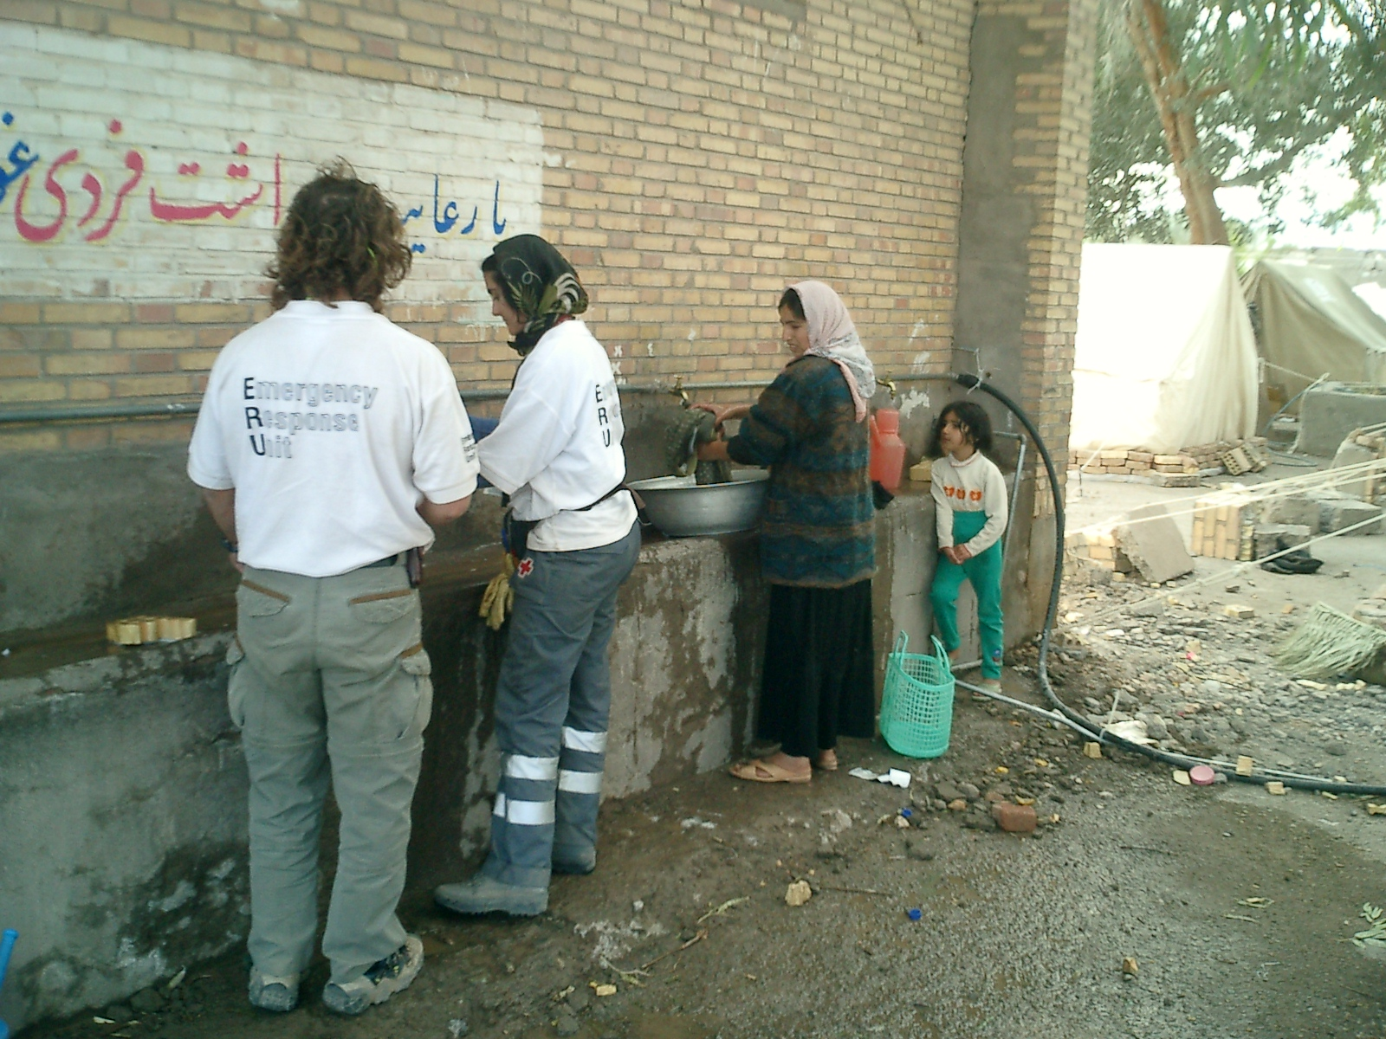

INTERNAL DISPLACED PEOPLE CAMPS CHINA 2008

Five small water networks are installed in total. All the polyethylene (PE) material available in the Unit (1000 metres) is used in the installation. In addition, local compatible materials are used. Four pressure groups are installed (one group remains as backup) plus one local Chinese group. The electricity is supplied by the mains which work.

Water points where the groups are installed

DISTRIBUTION POINT ALFA (J1)

First distribution point installed according to the assessment planning. A pressure group is connected to a 5,000 l. bladder tank which supplies water to two waterhorses (J1A and J1B). PE material is used in the amount of 150 metres.

DISTRIBUTION POINT DELTA (J7)

The Danish RC Camp, the British RC Mass Sanitation ERU and the Spanish RC WATSAN M15 ERU are located in the same area (DELTA). Treated water is stored in four 10,000 litre bladder tanks which is mostly used for daily tankering.

One pressure group is installed to provide pressurized water to the Camp and to two waterhorses (J7A, J7B and J7C). PE material is used in the amount of 150 metres.
.
DISTRIBUTION POINT ZUNDAO (Z3)

Pressure group connected to two 5,000 l. bladder tanks which supply water to two waterhorses (Z3A and Z3B). PE material is used in the amount of 300 metres.

DISTRIBUTION POINT PENGUA VILLAGE (Z9)

Pressure group connected to one 5,000 l. bladder tank which supplies water to two waterhorses (Z9A y Z9B). PE material is used in the amount of 200 metres.

The group used in this installation is locally purchased. Once its reliability is checked we are in the position of expanding the network by using this particular pressure group brand and also guaranty the provided service in case of breakdown by using the backup group.

DISTRIBUTION POINT PENGUA CAMP (Z10)

Pressure group connected to two 5,000 litre bladder tanks which supply water to two waterhorses (Z3A y Z3B). PE material is used in the amount of 200 metres.

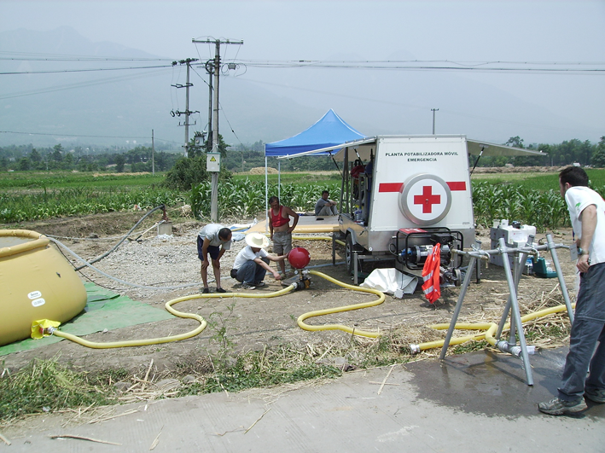

Photo 1. Checking pressure (Jiulong J1)

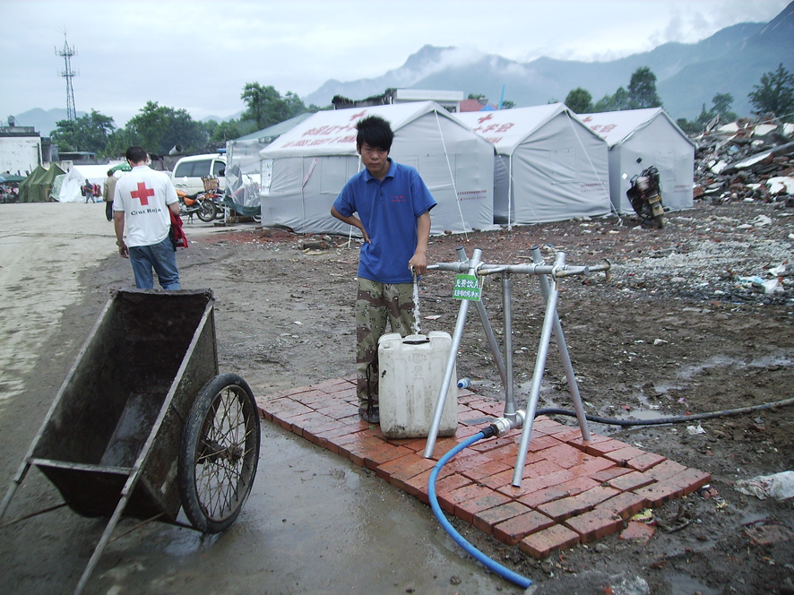

Photo 2. Installation with ERU PE material and compatible local material (J1A)

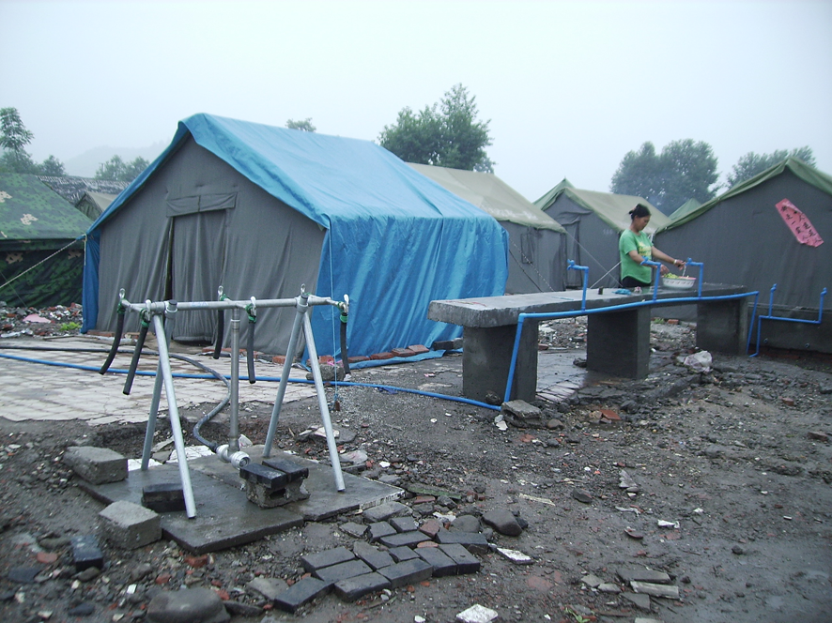

Photo 3. Waterhorse close to a washing area (Z3B)

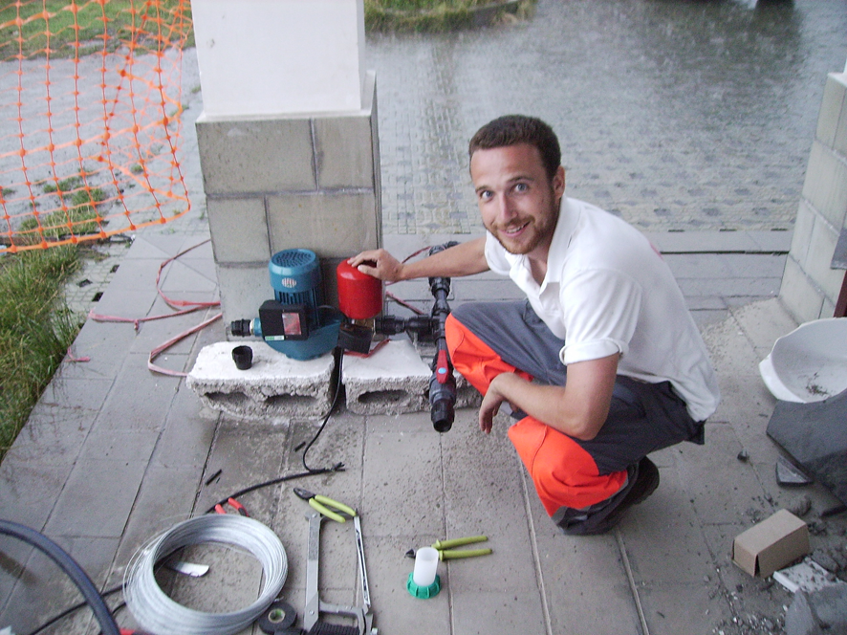

Photo 4. Installation of the locally purchased pressure group (Z9)

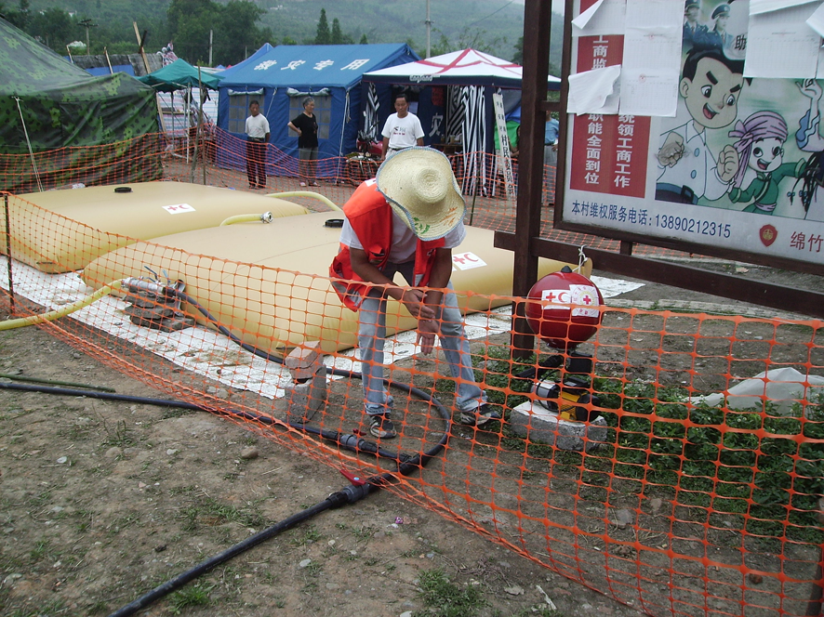

Photo 5. Pressure group connected to two 5000 L bladder tanks (Z10)

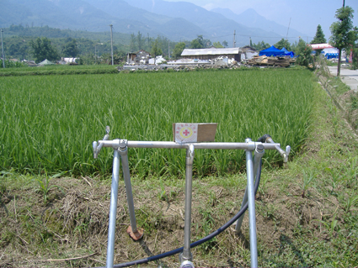

Photo 6. Waterhorse equally located to different beneficiaries (Z9B)

