**Taking Stock**

**Going Beyond Posters - Maintaining and Improving RC RC Hygiene Promotion Capacity**

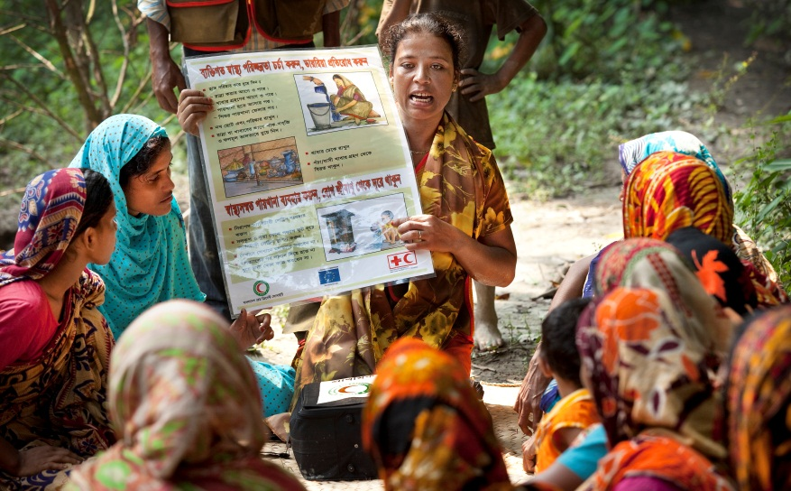**1. Background**

No programme to provide safe water supply and sanitation can be effective without a substantial hygiene promotion component to support hygiene behaviour change and proper use and maintenance of facilities. The important role of hygiene promotion is clearly defined in the Federation’s Water and Sanitation Policy and in key strategic documents. The Red Cross Red Crescent Movement has, over the last ten years, dedicated a substantial amount of time and resources to improve its ability to deliver hygiene promotion in acute emergencies and long term development.

At various forums and through gap analysis surveys, IFRC and external partners have discussed critical gaps in hygiene promotion capacity. These gaps include:

* Updating existing hygiene promotion approaches (i.e. PHAST[1])
* Addressing the sustainability of new approaches (i.e. CLTS[2])
* Understanding how to restore community engagement in those communities that have failed to maintain their WASH infrastructure or gains in hygiene behavior
* Gathering scientific evidence on the effectiveness of community mobilisation methods and exploring new training modalities (such as e-learning)
* Improvement and innovation in the area of hygiene behaviour change communication (BCC), including the increased use of technology to amplify their scale and effectiveness
* The development of a more standardized approach to hygiene promotion in emergencies, while maintaining the flexibility needed to adapt to local contexts
* Community mobilization and hygiene promotion in urban and peri-urban settings.

In the face of these challenges, the Federation finds itself without the resources to drive the hygiene promotion agenda forward. For the first time since 2004, the Federation has no global focal point for WASH software and severely limited technical support capacity available from other sources.

Not so long ago, inclusion of hygiene promotion in RC RC WASH activities was a contentious topic. It is now a standard component of emergency operations and long term programming. Years of work and substantial investment have gone into making the Movement a recognized leader in hygiene promotion. Clearly there is a need to build on our strengths and improve our hygiene promotion capacity in disaster response and developmental programming.

**2. Scaling up and getting better**

**2.1 Develop a software competency matrix**

Hygiene promotion human resources have historically been in short supply in comparison to engineers and other hardware focused roles. Although the pool of hygiene promotion specialists has grown significantly in recent years (due in part to the increased number of GWSI projects and the development of the Mass Sanitation Module), recruitment still remains a challenge. One barrier to expanding the pool of personnel is the lack of clarity on what exactly qualifies someone to be a software specialist. When it comes to hygiene promotion, there is no universally recognized equivalent to an engineering or medical background.

In line with the equivalent initiative undertaken by the Federation’s Emergency Health Team, a competency matrix would be developed for hygiene promoters in emergency response. This would clearly lay out the expected competencies required for different levels of responsibility and the path that would allow personnel to advance to higher levels. Advancement would include academic and internal RC RC training, such as ERU and RDRT. The competency matrix would eventually be expanded to other WASH technical roles, including hardware roles.

**2.2 Revitalize the Federation’s guidance on software in long term development**

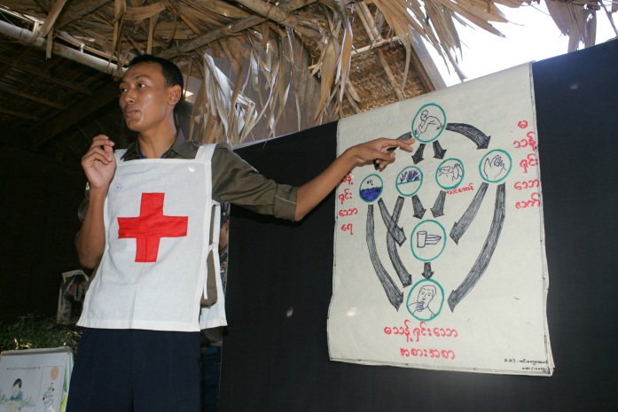When the Federation launched the Global Water and Sanitation Initiative (GWSI) in 2005, a key criterion for GWSI projects was a balance between hardware and software activities. This requirement in the context of the ambitious scale of GWSI meant that a standardized methodology to hygiene promotion was necessary. The PHAST approach was chosen for a variety of reasons, including its activities related to both hygiene behavior change and infrastructure selection and maintenance. Nearly a decade on and after implementation in over 60 countries, PHAST today varies significantly across the world and often bears little resemblance to the original approach. PHAST is also operating in an environment with other community mobilization methodologies, some of which are government mandated. New tools to reach target populations are available and promise faster and larger scale assessment and communication.

The Federation released a publication providing guidance on software in long term development programmes in 2007. The document primarily focusses on PHAST. The guidance document should be revised to reflect the evolution of hygiene promotion in the developmental context.

One topic missing from the software guidelines is CLTS. The Federation released a discussion paper on CLTS in 2010. At the time, it was a struggle to find RC RC projects which utilized the approach. Since then, the number of GWSI projects with a CLTS component has soared and CLTS has been implemented in a wider array of contexts, including urban and peri-urban settings. Furthermore, CLTS itself has changed. On certain points, the Federation discussion paper differed from the standard CLTS approach. The sector has come closer to the Federation’s stance on some issues, such as shame, while others, such as subsidy, remain divisive. The Federation would like to draw on the wealth of project experience to update the CLTS discussion paper and provide guidance on best practice to National Societies who are implementing the approach.

Since the Federation launched GWSI in 2005, more than 450 large scale long term projects have been completed in 80 countries. It has been challenging to assess, immediately after project completion, to what extent communities and local authorities are truly self-sufficient in operating and managing the facilities provided by the intervention, and how changes in hygiene behavior and access to safer water sources and sanitation services are sustained in the target area. The ‘Look-Back’ methodology provides a framework for a post-project evaluation years after project completion. The purpose of the methodology is to facilitate a better understanding of the long-term impact of a WatSan intervention and the sustainability aspects of that intervention over 2-4 years after project completion.

Look Back studies undertaken to date have shown impressive results in terms of sustained WASH coverage and behavior change. However, even 90% sustainability still means 10% of the target population no longer have access to water or sanitation infrastructure or are no longer practicing improved hygiene behavior. The Federation and partner National Societies are exploring innovative methods of financing repairs to poorly maintained infrastructure. However, we lack the tools to “fix” problems that have gone wrong with hygiene behavior and community management. Developing tools to improve software in completed projects would help ensure that the same cycle is not repeated.

**2.3 Develop and field test a Hygiene Promotion Framework for emergency WASH response**

****PHAST, for all its limitations, has allowed the RC Movement to significantly scale up software activities and reach millions of beneficiaries in long term developmental projects. However, no such standardized approach exists for the acute emergency context. The humanitarian sector still lacks a sufficient understanding of how best to achieve behaviour change or a systematic approach to training and programme design which allows large scale emergency interventions to be delivered with consistent quality. Hygiene promotion is a standard WASH activity in RC RC emergency operations. Whether these activities are achieving the hygiene behavior change so critical for human health and dignity remains an open question.

A standardized approach would allow agencies to deliver the hygiene promotion component of large scale WASH projects with consistent quality and without the need for involvement of experts. In the same way a chemical engineer is not needed to calculate and deliver the correct dose of chlorine into a water tank, a minimum level of hygiene promotion should be able to be carried out anywhere by anyone who has a modest amount of training. Put simply, it should be easier to become a hygiene promoter in emergencies and programme quality should be more universal; rather than exclusive to experts.

RC RC volunteers often work with minimal training and guidance in small scale responses. More experienced HPs deployed to large scale or complex emergencies in varied contexts draw on the learning from long term WASH community approaches such as PHAST, CLTS, Child to Child and Community Health Clubs, but they lack field tested models and approaches in emergencies to help them design and deliver hygiene promotion to quality standards at scale. Furthermore, there is a wealth of guidance on monitoring WASH in emergencies, yet selecting and measuring clear HP indicators and using the results to review and adapt programme activities remains challenging.

The WASH sector requires a common framework for emergency hygiene promotion to enable HPs of different levels of experience and capacity to implement good quality interventions to agreed standards. Using clear process and outcome indicators for each phase of the emergency response would provide a critical pathway for all hygiene promotion activities, accessible and realistic for less experienced promoters and yet useful in situations where experience and judgment is needed to adapt activities for more challenging environments.

The framework will be based on the BCC Framework developed by the Federation’s Health Department and will incorporate elements of existing resources developed for communicating about WASH and health in emergencies. Once the HP Framework is developed, it will be rolled out in a limited number of pilot trainings and will be refined after extensive field testing in a number of real time emergency contexts before being disseminated broadly throughout the sector.

**2.4 Develop and improve HP practitioners’ mobile technology skills**

While interpersonal communication will remain an important feature of hygiene promotion, developments in mobile phone technology have opened up new opportunities for mass communication with the use of SMS for digital data gathering and targeted, inter-active message delivery.

The increasing availability of mobile phones presents an opportunity to greatly improve data collection in both development and emergencies. Mobile phone-based questionnaires combined with more conventional methods of face to face community consultation, could result in better WASH planning and programme monitoring in less time and at a reduced cost.

Mobile technology need not be limited to data gathering nor a one size fits all SMS approach. Hygiene promotion messaging can be specifically targeted at individual neighborhoods or sections of the community, and the inbuilt inter-activity of more recently developed mobile phone applications can enable two way communication channels so that beneficiaries can provide feedback on the activities of organizations and seek information on health and hygiene issues. Programme accountability mechanisms are thus strengthened.

While the management of digital communications has been seen as the domain of IT / communication specialists to date, the potential to increase their impact would be enhanced if we could equip hygiene promoters with the knowledge and skills to carry out rapid mobile phone based surveys and create two way communications platforms themselves.

**3. Support Needs**

The RC Movement will not be able to develop more human resource or technical capacity without software focal points to provide technical support to IFRC and member National Societies. Our technical support capacity is at its lowest point since 2004, while the high demand for hygiene promotion technical support remains unchanged.

We are seeking partners within the RC RC Movement and in the broader humanitarian community to support our efforts in improving hygiene promotion. The IFRC aims to restore its technical support capacity and improve the Movement’s pool of software specialists through a staged recruitment process. We propose a series of short term consultancies, possibly with more than one software specialist, in order to identify the best candidate. The terms of reference for these consultancies would include activities outlined in this document as well as normal technical support to ongoing activities and emergency operations as they arise. The position would support Federation and National Society activities, including trainings, reviews, and resource development. Eventually, the Federation would create a full time position for a global software focal point. This position would not necessarily be based in Geneva or even a Federation office, but would require external funding.

1. Participatory Hygiene and Sanitation Transformation (PHAST)
2. Community Led Total Sanitation (CLTS)