SPANISH RED CROSS

WATSAN MODULE 15 ERU

WATER TREATMENT PLANT

SETA MOD. SETAQUA 2E3000 version 3

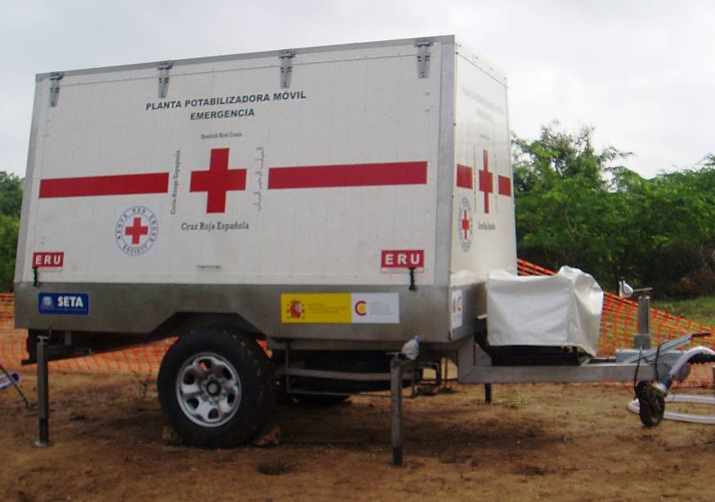

INDEX

DESCRIPTION OF THE WATER TREATMENT PLANT

- COMPONENTS

- HOW THE PLANT WORKS

TRANSPORT

INSTALLING THE PLANT

STARTING THE PLANT

ADJUSTING THE PLANT

DAILY MAINTENANCE

REGULAR MAINTENANCE

POSIBLE FAULTS AND SOLUTIONS

PLANT STOPPAGE FOR STORAGE OR TRANSPORT
10. LIST OF EQUIPMENT

ANNEX 1

WATER ANALYSIS, PRODUCTION, STORAGE AND DISTRIBUTION DIAGRAMS

1.- DESCRIPTION OF THE WATER TREATMENT PLANT
1.1-COMPONENTS
Nº | ELEMENT | FUNCTION | TECHNICAL DATA
1 | Generator | To produce energy to run the plant. | 9 HP 4 kW 7.5 KVA  Gasoline
2 | Control panel | To hold the switches to power the submersible pump, pressure pump and dosage pumps. | 230 V.  2 Switches  Omnipolars
3 | Submersible pump | To pump water from the source/tank to the plant | Q = 5 – 60 l/min  H max = 58 m
4 | Settlement / flocculation tank | Water is clarified through flocculation by using aluminium sulphate. | 3 Chambers with lamellas to decrease the speed of the water and to allow settlement.
5 | Chemical solution tanks | To contain the chlorine and aluminium sulphate solutions | 50 litres each. Plastic with bottom drainage
6 | Dosage pumps | To adjust the dosage of the chemical solutions. | P = 7 bar  Q = 3 l/h  I = 0.3 A
7 | Centrifugal pump | To maintain the required pressure for water to circulate from the filters to the outlet. | H max = 47m  Q max = 70 l/min  P1 = 2.9 bar
8 | Silex filter | To retain the particles not flocculated.
9 | Carbon filter | To retain the excess of chemicals in the water
10 | Rapid mixer | To add residual chlorine to outgoing drinking water. | PVC with balls in the interior
11 | Water level control | To control the water level in the settlement tank by switching on and off the submersible pump. | Aluminium  230 V  10 A
12 | Pre-filter | To retain gross solids. | Net 2mm size
13 | Trailer | Chassis that allows transporting the plant. | 1.6 m width  4 m length  2.4 m height
14 | Bladder tank | To store for treated water | 10 m³
15 | Valves | To control water flow | 1”

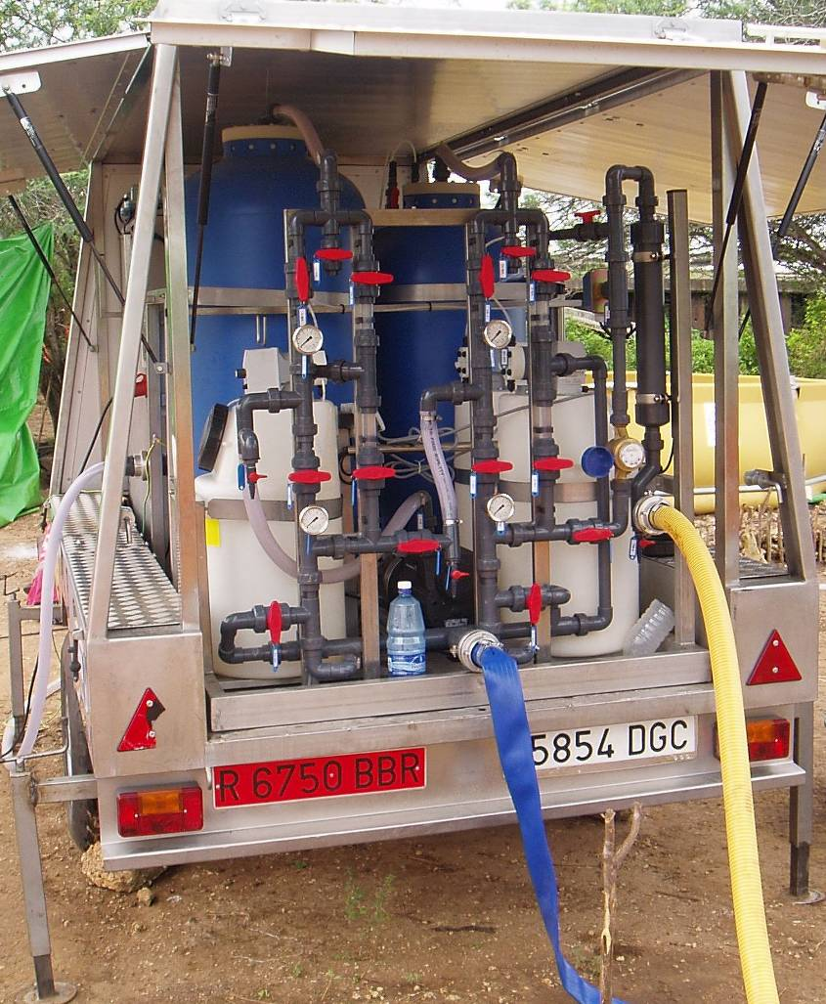

Figure 1. General view of the plant

10. Rapid mixer
5. Chemical solution tanks

6. Dosage pumps
7. Centrifugal pump
14. Water tank
8. Silex
filter
9. Carbon
filter

2. Control panel
Drinking water

12. Pre-filter

4. Flocculation tank
11. Water level controls

1. Generator

3. Submersible pump

Figure 2. Trailer lay-out plan

1.2- HOW THE PLANT WORKS

Step 1
Raw water is pumped from the selected water source or storage tank to the sedimentation/flocculation tank (fig.2/4 and fig.4) with the submersible pump (fig.2/3). This pump works while the water level inside the flocculation tank is in-between the minimum and maximum levels of the automatic level control (fig.2/11 and fig.3).

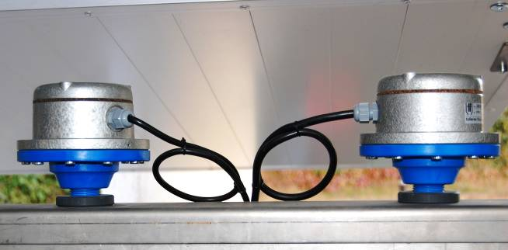
Figure 3. Automatic water level control
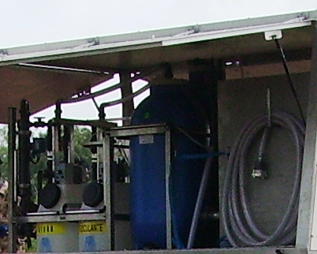

Figure 4. Flocculation tank

Step 2
Raw water circulates through the pre-filter (swimming pool filter) (fig.2/ 12 and fig.5) to retain solids greater than 2mm Ø.
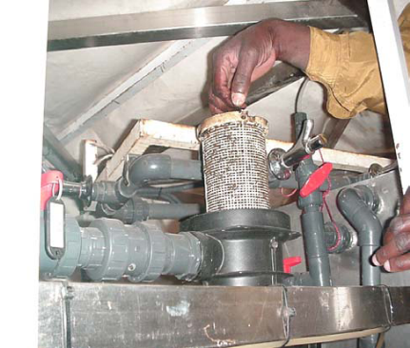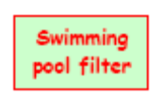
Figure 5. Cleaning the swimming pool filter (pre-filter)

Step 3
The dosage pumps inject a high concentrated solution of chlorine and aluminium sulphate to raw water held in the settlement tank. Aluminium sulphate favours solids to flocculate and sediment at the bottom of the tank and chlorine disinfects water by destroying all the pathogens.

Step 4
The flocculation tank (fig. 4) also favours the processes of sedimentation and disinfection by lengthening the time of water circulation through a system of lamellas.
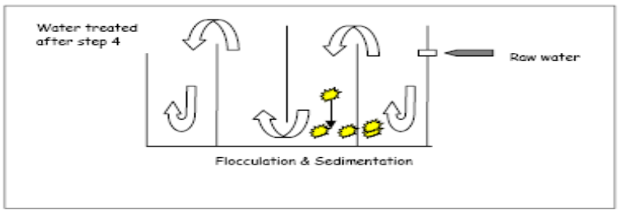
Figure 6. Water flow inside the flocculation tank

Step 5
Once the water has passed through the flocculation tank it enters the filter system (fig.2/8 & fig.2/9). The pressure needed to circulate through both filters (silex and carbon) (2.5-2.9 bar) is provided by the pressure group (fig.2/7). The silex (sand) filter (fig.2/9) removes the finest solids remaining in the water. Afterwards, the carbon filter (fig.2/8) removes the bad taste and odour as well as the excess of chemicals added in step 3.

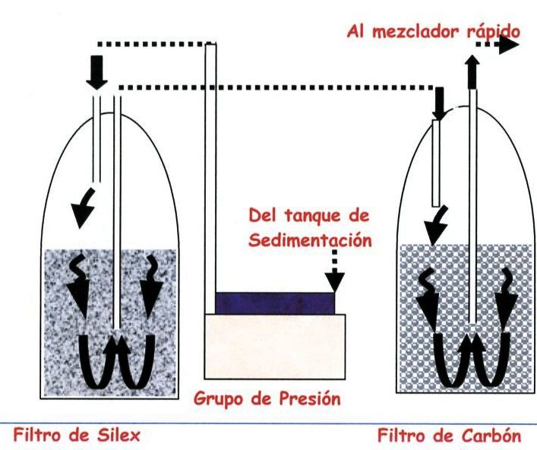
To rapid mixer
From
Flocculation
tank
Silex Filter Centrifugal pump Carbon filter

Figure 7. Water flow inside the filters

Step 6.
Finally, the water passes through the rapid mixer (fig.2/10) where more chlorine solution is injected by another dosage pump (fig.2/6). This solution is added to leave enough residual chlorine in the water for its storage and to prevent possible contamination after its supply to the population. The solution is added only when water circulates through the rapid mixer. Circulation is detected by the flow detector (fig. 8). There is also a flow metre which measures the amount of water produced by the plant.

Water is stored in a closed water tank (fig.2/14) from which it will be distributed to the population. Water should remain in the tank for at least 30 minutes before its distribution in order to provide a minimum contact time between water and chlorine.
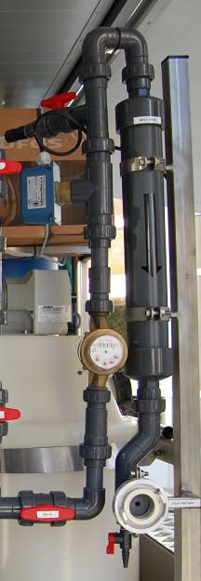
Flow detector
Rapid mixer
WATER TREATMENT PLANT
Chlorine = 0.3 mg/l – 0.6mg/l
Chlorine = 0.1mg/l – 0.3 mg/l
Turbidity ≤ 5 NTU
Turbidity ≤ 20 NTU
Rapid mixer
Figure 8. Rapid mixer for residual chlorine

2.-TRANSPORT
First of all, check that you have a vehicle powerful enough to tow the plant and with the adequate hook.
* Never move the plant without emptying the water from
the filters and the settlement tank

* Never exceed 60 km/h with the plant.
The gravity centre is too high to take curves at high speed.

* When the plant is on the road connect the lights of the plant (indicators, brakes) and the inertia brake so it can brake and stop in case of being unhooked from the vehicle.

* Do not allow non-trained staff without a valid license to drive vehicles that tow the plant.

3.-INSTALLING THE PLANT

Step 1
Place the plant in a flat, clean area. This is necessary for the flocculation tank to work properly. Use the front wheel (fig.9/1) and the lateral extensible metal legs (fig.9/2) to level out the plant horizontally. Use the spirit level of the plant to ensure that the plant is totally horizontal. Always use the brake (fig.9/3) to anchor the plant before working.

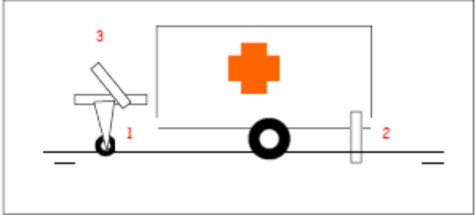
Figure 9. Setting up the WTP

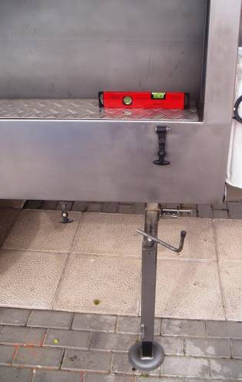
Figure 10 . Levelling out the WTP
Step 2
* Remove the submersible pump from its place (fixed to the flocculation tank) and connect it to the flexible aspiration 1” hose.
* Connect the end of the aspiration hose to the PVC intake at the plant (near the settlement tank).
* Fix the rope to the hole at the head of the submersible pump and place it into the water source (tank, river, lake, well, etc). If the river bed is muddy you should prepare a cage to protect the submersible pump or, if possible, prepare a stone and gravel bed to place it. Take out the pump on daily basis in order to remove any possible debris settle at the intake of the pump.
Never use the electric cable or the flexible hose
to carry or to hang the submersible pump.

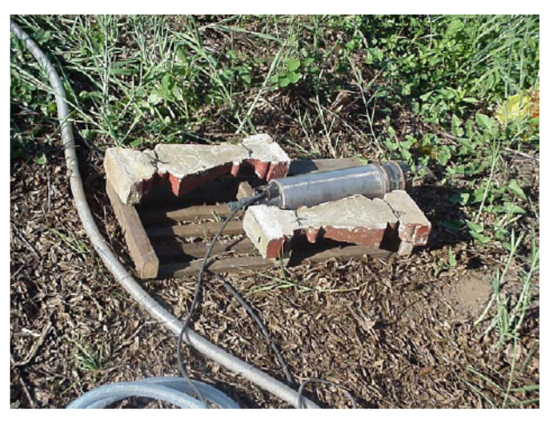
Figure 11. Protecting the submersible pump

Step 3
* Connect the red or black flexible hose (2”) for waste water and drainage at the front of the plant. This will be the outlet of the waste water when cleaning the filters, therefore, place the hose end on a well drained place and at a safe distance from the water source.
* Connect the transparent hose (2”) to the exit of the plant, on its rear part, after the fast mixer of residual chlorine. The connection is of a Storz type. Connect the hose for treated water to the bladder tank and then, distribute water.
* Place the bladder tank in a higher flat surface. Anchor it well with ropes if necessary. Fence around the plant and the tank to protect them from animals, vehicles or people.
* Dinking water might be supplied from the bladder tank or from the water ramp. The water ramp is connected to the bladder tank through the semi-rigid yellow hose with Storz connections.

Step 4
Grounded conductor insulation
To provide insulation against electrical discharges the plant is equipped with a copper spike which should be embedded in wet ground. The spike is connected to the plant through an earth cable.

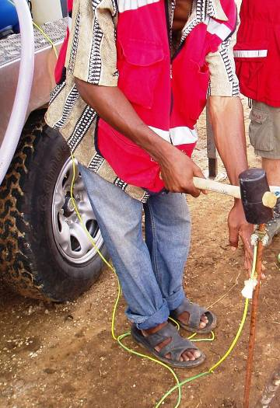
Figure 12 . Grounded conductor insulation

Step 5
Preparation of the chemical solutions
It is necessary to have clean water (without turbidity) to prepare the solution. To obtain clean water you can run the plant without connecting the dosage pumps and add one or two handfuls of Aluminium Sulphate in the settlement tank. We need to produce enough water to fill the three tanks of solutions.

CHLORINE SOLUTION
Chlorine can be presented in different forms: solid (granular), liquid or gas, as well as combined with other substances to give it chemical stability. The most common forms are the calcium hypochlorite (granular or HTH) and the sodium hypochlorite (solution). The concentration of these combinations can also vary. The solution liquid form ranges from 5% to 18% (grams of chlorine per 100 grams of solution), while the granular form ranges from 30% to 70%. For the plant, it is always recommend HTH (High Test Hypochlorite) at 70% of concentration. The reason being the higher the concentration the greater number of litres of solution can be produced with less quantity of product.

The amount of chemicals necessary to prepare the solutions for the two chlorine tanks is presented in the following summary:

To prepare 50 l of a solution of chlorine at 1% (in the tank of the dosage pump that supplies chorine to the settlement tank)
Concentration HTH | Quantity of powder to add
70% | 700 gr. | 50 spoons
The final concentration in the tank will be 10 gr/l (10000 mg/l or 10000 ppm or 1%)
Regulation of the dosage pump at 20% (1 l/h)
Assumption: flow of raw water = 3000 l/h »»
10000 mg/l x 1 l/h = 10000 mg/h / 3000 l/h = 3 mg/l concentration of chlorine in water contained in the settlement tank which, once the organic matter is oxidised, must not exceed 0.3 mg/l.
(Use the pool tester and adjust the potentiometer to reach this value).

Note: The dosage pumps send to the flocculation tank and the rapid mixer 5 l/h of solution with the regulator at 100%
Note: Prepare a thin powder with the granular HTH before mixing to make the dissolution easier.
Note: To prepare a 1% solution based on a product with 100% chlorine concentration we need 10gr. of product per litre of solution. To prepare a 1% solution based on a product (HTH) with 70% chlorine concentration we need 14gr. of product per litre of solution. That means 700 gr. per 50l. of solution.

To prepare 50 l of a solution of chlorine at 1% (in the tank of the dosage pump that supplies chorine to the rapid mixer – residual chlorine)
Concentration HTH | Quantity of powder to add
70% | 700 gr | 50 spoons
The final concentration in the tank will be 10 gr/l (10000 mg/l or 10000 ppm or 1%)
Dosage pump at 6% (0.3 l/h)
Assumption: flow of raw water = 3000 l/h »»
10000 mg/l x 0.3 l/h = 3000 mg/h / 3000 l/h = 1 mg/l concentration of chlorine in water contained in the rapid mixer at the exit of the plant which normally should not exceed 1 mg/l.
(Use the pool tester and adjust the potentiometer to reach this value).

Note: The dosage pumps must be adjusted using the potentiometer to reach the required values. Use the chlorine meter to determine the values of concentration of chlorine in the chamber of the settlement tank as well as at the exit of the plant and at the distribution ramp. The above percentage values are only indicative.

Chlorine is the most readily and widely used chemical disinfectant for water supply. The aim of chlorination is the destruction of pathogens (in our case in the flocculation chamber) and the protection of the water supply (in the rapid mixer at the WTP).

To achieve this, a chlorine dose must be sufficient to:
* Meet the chlorination demand of water, that is, it must oxidise the contaminants (including reacting with any organic or inorganic substances). This is achieved by pumping a strong solution in the flocculation tank.
* Provide residual chlorine in order to give enough protection against further contamination. This is achieved in the WTP by ensuring free residual chlorine in the disinfected water in the rapid mixer and the taps which inhibits any subsequent growth of organisms within the water supply.

TAPS. There are several factors that might affect the residual chlorine present at the taps where the beneficiaries collect their water. The type of containers where end users store water is one of them. We must provide clean 20 litre jerry cans to the beneficiaries to ensure that water is not contaminated. When this is not the case, residual chlorine should be higher to destroy pathogens. Taste of end users is another factor. In many countries where people are not used to drink water with chlorine, values of residual chlorine higher than 0.3 mg/l might cause the rejection of water by the beneficiaries. Nevertheless, the determinant factor is the ruling of the local health authorities or the local water board if they are involved in the process.

OUTLET OF THE PLANT. To achieve the required values at the taps we must ensure that the values of residual chlorine at the exit of the plant are sufficiently higher than those at the taps. However, there also several factors that might condition those values. There are two different scenarios. When water is collected at the site and when water is distributed away from the plant by means of water tanks either flexible bladder tanks that belong to the ERU or rented tank lorries. In the first case as water is stored in closed bladder tanks which are directly connected to the taps the amount of residual chlorine should be lower due to lacking evaporation. For the second case there are some aspects to consider such as distance to distribution points which should not be more than 1 hour driving, environmental temperature and type of containers (close or open) where water is stored at the distribution point. These aspects are important as they lead to higher or lower evaporation of chlorine.

Therefore, the following ranks which are mentioned in different paragraphs of this manual, although thoroughly studied based on experience, are only indicative. The use of the provided ranges will depend on the above factors and the local situation. Nevertheless, what is very important is to trace the water distribution circuit and to record the measurements of the residual chlorine values, at the 3rd chamber, at the exit of the plant and at the taps, in the field log book.

INDICATIVE RESIDUAL CHLORINE RANKS
Residual chlorine at the exit of the settlement tank: 0,1 mg/l – 0.3 mg/l
Residual chlorine at the exit of the plant: 0.8 mg/l – 1 mg/l
(When water is distributed away from the water production site)
Residual chlorine at the exit of the plant: 0.6 mg/l – 0.8 mg/l
(When water is distributed at the water production site)
Residual chlorine at the taps: 0.3 mg/l – 0.6 mg/l

ALUMINIUM SULPHATE SOLUTION
Many raw waters contain colloidal matter (particularly clays) in suspension. This aspect is usually highlighted after natural catastrophes such as floods or earthquakes as the particles settled at the bottom of the rivers and lakes move and dilute in water. Colloids will not settle readily by natural sedimentation alone as their specific gravity weight is similar to water. Therefore, the colloidal particles must be forced to combine to form heavier particles before they can settle as sludge. These processes are called coagulation and flocculation.

In the WTP these processes are achieved by the addition of alum (aluminium sulphate Al₂(SO4)_{3 n}H₂O) in the flocculation chamber. Alum is one of the coagulating agents more universally used, although we must not think that its effects are innocuous on human health, especially if there is an overdose. The effective pH range for alum is between 6 and 8. Check the pH in the water source and if it is not within this range advice about more suitable coagulants may be needed. However, the fact that pH is outside of its natural rank may show an indication of contamination that could not be eliminated by the physical-chemical processes in the WTP.

To prepare 50 litres of solution of Aluminium Sulphate.
Add | To clean water
500 gr. | 50 l.

Note: To supply 1 l/h potentiometer at 20%

Step 6
Check that all the valves are well positioned for regular operation and all the joins in the PVC pipes are tight enough to prevent water leakage.

Step 7
Generator. Make sure that the level and quality of oil is suitable and that there is enough petrol in the tank to fuel the generator.
Now, you can start the engine.
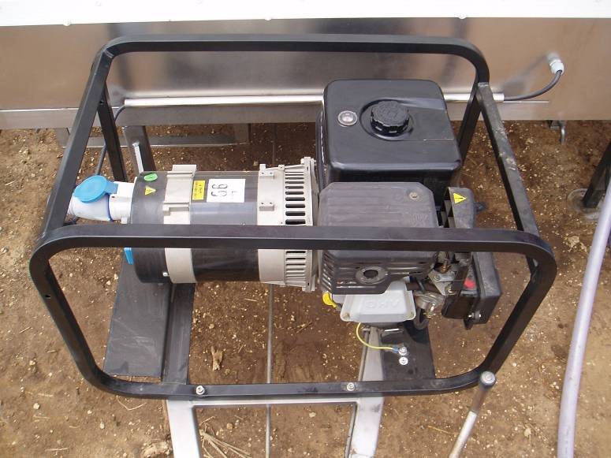

Figure 13. Generator

4.- STARTING THE PLANT
Step 1
Verify that all electrical switches are OFF. Place them on this position before stopping the generator and check them before starting. During the stoppage and the starting of the plant there are peaks of voltage in the system which can damage the electrical elements.

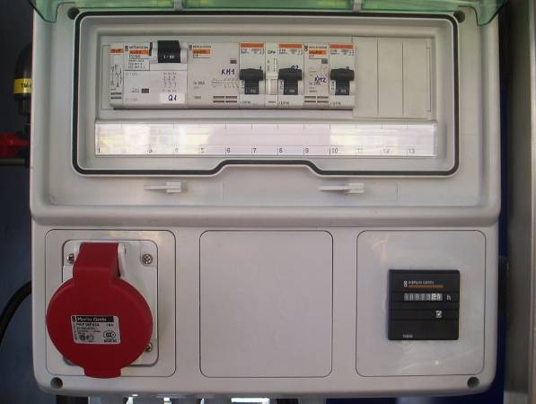
Figure 14. Electrical control panel
Step 2
To start the generator:
- Open the “starter”.
- Put the switch in “ON” position.
- Open the petrol valve. Check that it does not leak.
- Check that the electrical cable is plugged to the control panel.
- Pull strongly on the starting rope.
- The speed of the generator must be fixed on the slowest position (turtle). If the handle moves to the “rabbit” position, the generator would produce 260 V with the consequent damages to the electrical equipments.
- Let the generator works during 5 minutes to warm up and pull the starter handle to RUN position (in warm climates it can be done when the generator starts to work).
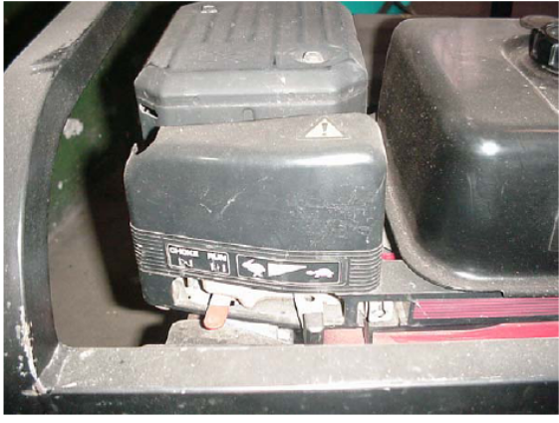
Figure 15. Generator: Speed regulator
Step 3
- Switch on the submergible pump at the control panel.
- Check the water is lifted to the flocculation chamber and then switch on the dosage pumps (first the chlorine solution and then the alum solution). Check they are working (green light on the dosage pumps control unit).
- Regulate the dosage pumps: 20% to chlorination in the flocculation tank, 6% to chlorination in the rapid mixer and 50% to the aluminium sulphate dosage system.
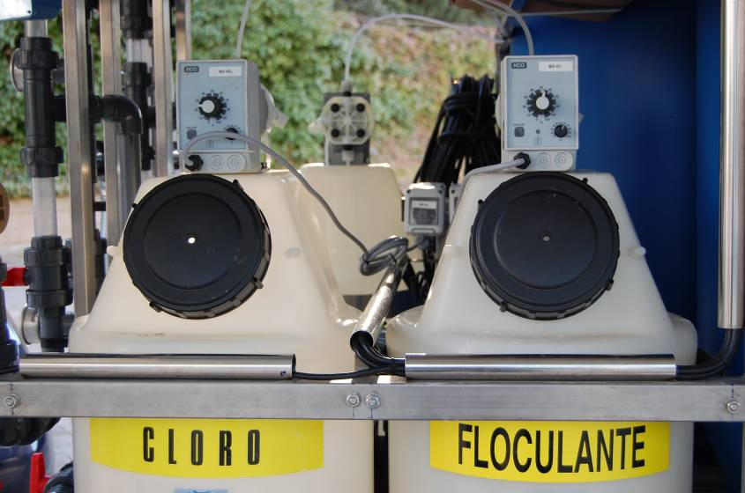
Figure 16. Dosage pump control unit

Step 4
When the water has reached the highest level in the third flocculation chamber:
- Switch on the second switch (electric pump). The electric pump should star working. The submersible pump stops until the level of the sedimentation tank is low enough.
- After 10 minutes (approx.) the filters (silex and carbon) will be full and the production of water will start. The four manometers at the front of both filters should be working between 2.5 and 2.9 bars.
- Switch ON the residual chlorine dosage pump. The green light should be on and regular pumping should be noticed. Adjust it at 6%.
- The switch on and off of the electric pump is regulated by sensors located at the head of the pump itself; therefore, it will start automatically depending on the water pressure.

5.- ADJUSTING THE PLANT
Step 1
Take a sample of water from the third chamber of the settlement tank. If the water is not clear enough (5 NTU or less), increase the dose of aluminium sulphate solution by operating the dosage pump regulator. Do it gradually (50%, 60%, 70%), allowing time to renovate the water in the sedimentation tank (about 30 minutes). Also you can close the outlet valve of the flocculation tank in order to increase the contact time in the flocculation chamber, but take into account that this will decrease the amount of water produced by the plant.
It is important to find the appropriate dose of flocculent (aluminium sulphate) needed to maintain turbidity at the correct level. If we add more flocculent than necessary, the lifespan of the carbon filter will reduce. Moreover, water quality will be worse as aluminium is neurotoxic.
If the outlet water is clear with the dosage pump at 50%, try the inverse operation: decrease progressively to 40%, 30 %, 20% etc., until you find the optimal dose.
Once we find the optimal dose of coagulant, record it in the field log book along with the turbidity conditions of the raw water (by means of a turbidity meter). It will help as a reference to adjust (increase or decrease) the aluminium solution volume when the raw water turbidity changes, which is very common in surface water (rivers) with intense rain.
Step 2
Take a sample of water from the 3rd chamber of the settlement tank. Measure with the pool-tester (chlorine meter) the chlorine level, the value should be between 0.1 mg/l – 0.3 mg/l. If the value is lower than 0.2 mg/l, increase gradually the dose of chlorine solution (30%, 40%, 50%, etc) until the chlorine concentration is at the correct level. If the value is higher than the previous range, do the inverse operation (10%). Record your measurements in the field log book.
The quantity of chlorine needed provides an idea of how polluted is the water source.
Step 3
Take a sample of residual chlorine at the outlet of the plant and measure it with the pool-tester, the value should be between 0.6 mg/l - 1 mg/l depending on the situation as mentioned above. If the value is lower or higher than expected, adjust the chlorine dosage pump regulator as in step 2. The residual chlorine in the water at the distribution taps should be between 0.3 mg/l – 0.6 mg/l. If the value is higher than, the taste is strong and if the value is lower, it does not guarantee protection against possible contamination. Record your measurements in the field log book. Nevertheless, the ruling of the local health authorities or the local water board is determinant when defining the chlorine values at the taps.
Step 4
Now you can connect the outlet hose to the water tank. After 30 min. you can start supplying water (if an emergency). Otherwise, it is recommended to wait to fill the tank and then start supplying water.
Step 5
Check that the manometers at the front of the filters work with a difference less than 0.7 bars. If the difference is higher check the valves position. If the position is correct that means that the filters need cleaning.

6.-DAILY MAINTENANCE
Before running the plant:
- Check raw water turbidity. If the value is higher or lower than the one of the previous day, adjust the aluminium sulphate dosage pump.
- Fill up the generator’s tank with petrol. Do it with the engine OFF.
- Check the quality and quantity of the oil tank of the generator.
- Check the water source level. Move the location of the submersible pump or the diesel pump if they are too near the water surface. Even move the whole plant if the hose length is not enough.

Never let the submersible pump run dry.

It will be damaged in a few minutes.

- Check the chemical solution tank levels. Do not allow the dosage pumps to run dry.
- Check the bolts, nuts, metal legs and pipe connections to be tighten. Check for water leeks.
When running the plant:
- Check for strange noises, especially coming form the generator or the pressure group.
- Check the manometers. If the difference between them is higher than 0.7 bars you should wash the filters.
Washing the filters:
The sludge generated by the particles that have not settled in the flocculation chamber will block the filters. This will cause a difference in water pressure which will produce the lost of material inside the filters. Therefore, back-wash and wash of both filters are needed. These processes are carried out by using the valves at the rear of the WTP. The processes inside the filters are as follows:
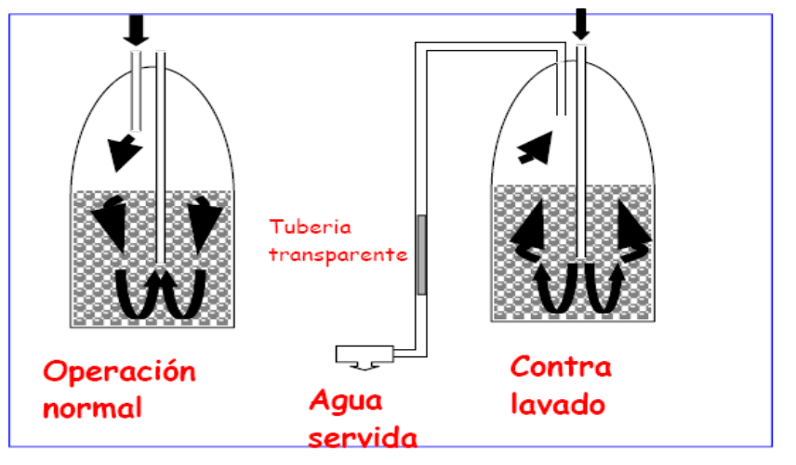
Regular operation waste water back-washing
Figure 17. Back-washing of filters

After back-washing both filters you will have to wash them to remove the sludge and drain it to the waster water. Through the transparent pipe you can check during the back-washing when the water is clear enough. That will mean that the operation is finished. Those transparent sections will let us know that we are not losing filter material during back-washing as well.
It might take between 10 to 20 minutes each back-washing and washing. Therefore, the total time to back-wash and wash the filters might take around 40 minutes. As a reference when the turbidity of raw water is less than 20 NTU it is enough to carry out the processes once a day. When the turbidity is higher than 20 NTU it might be necessary even every hour.
For the valve positions to back-wash and wash refer to the figures 18 to 23 that follow. Be careful when cleaning the filters as you can lose particles through the valve. To avoid that you should maintain half-close the valve and check through the transparent pipe that the water is not flowing with particles, particularly carbon particles.

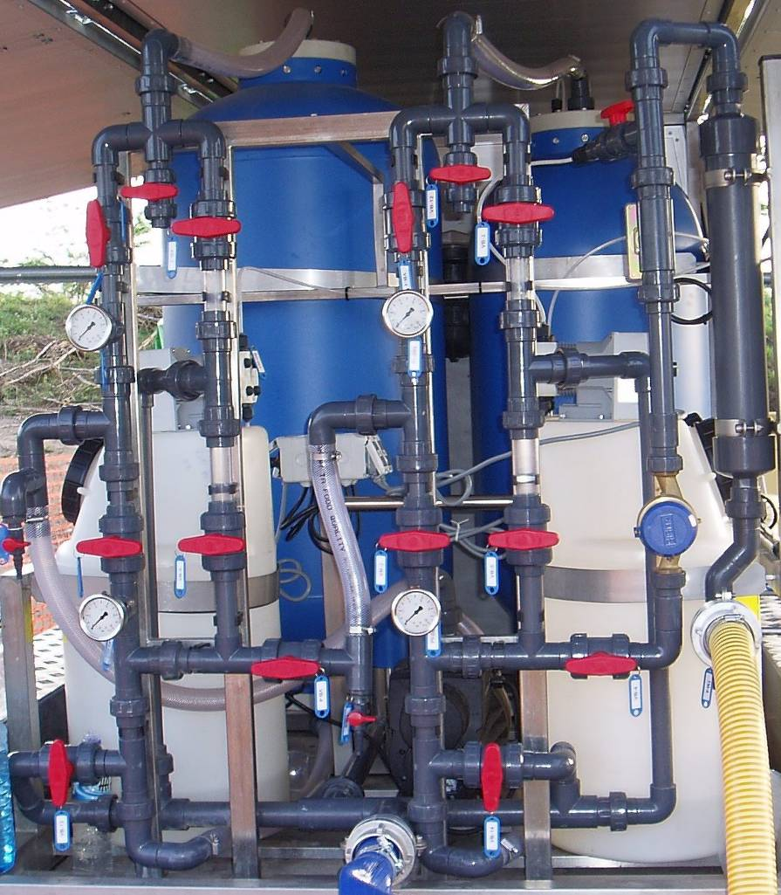
Figure 18. Valve positions: Regular operation

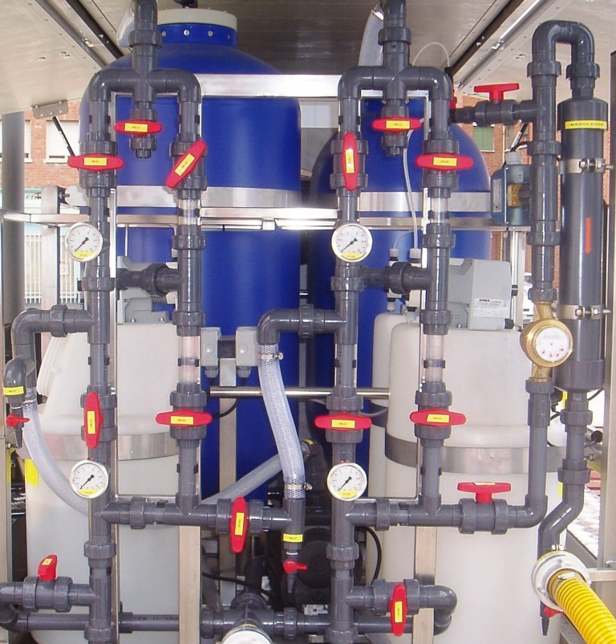
Figure 19 . Valve positions: Silex filter back washing

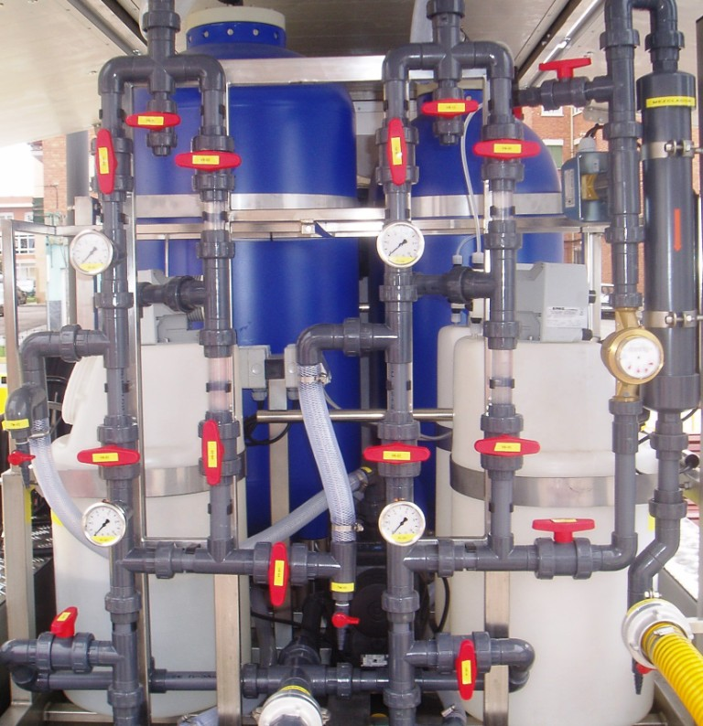
Figure 20 . Valve positions: Silex filter washing

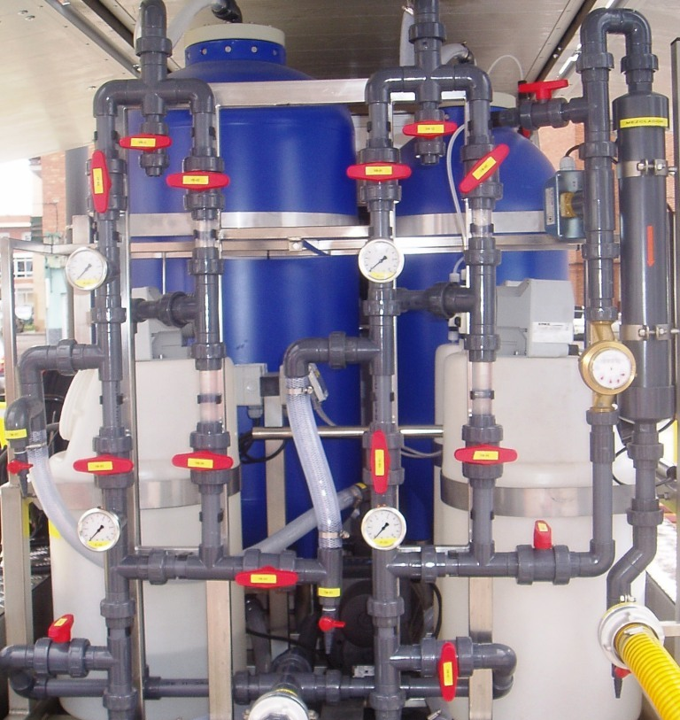
Figure 21 . Valve positions: Carbon filter back washing

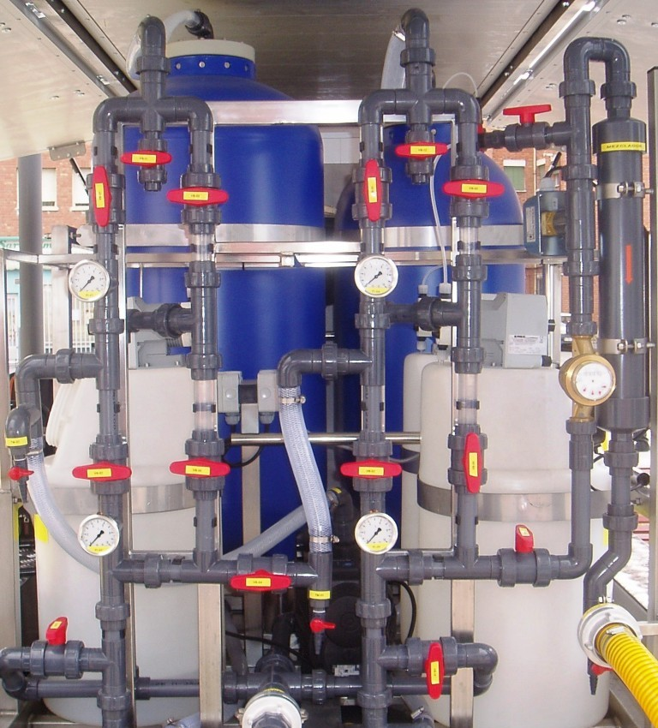
Figure 22. Valve positions: Carbon filter washing

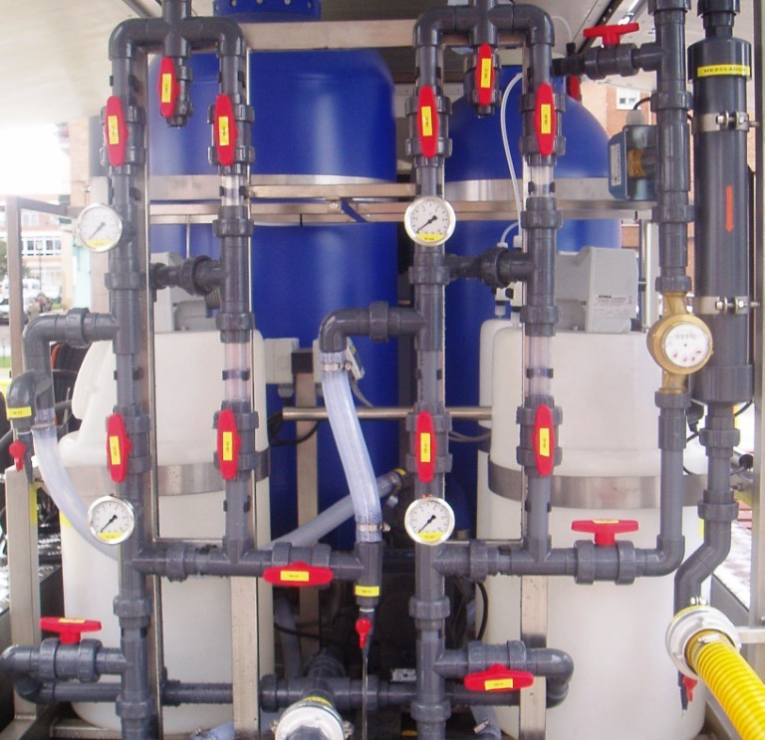
Figure 23. Valve positions: Emptying for transport and storage

7.- REGULAR MAINTENANCE
Flocculation-sedimentation tank
It is recommended to maintain a layer of 5 cm of sludge at the bottom of the tank to improve the flocculation process. It is not advisable to carry out a complete cleaning unless the plant is stored for a long period.
The frequency to clean the tank will depend on the amount of solids in the raw water. Nevertheless, from time to time you should remove excessive quantity of sludge from the bottom of the tank by opening the valves of the drainage pipes connected to the lower part of the tank and the drainage valve at the front of the WTP.
As part of the equipment there is a 10 m. flexible 2” hose to evacuate waste water safely. Take into account that the effluents of the sedimentation chamber could be toxic.

Submersible pump
It is free from maintenance.
Generator
Oil. Check the correct level and quality of the oil at the beginning of each working day and fill the tank if required.
When changing the oil remember that oil will drain more completely and quickly if the engine is warm and the filter cap is removed.
Inspect drained waste oil for the presence of the following:
- Metallic debris that indicates possible internal damage due to excessive wear.
- Water will appear as separate globules or as a creamy oil/water mix. This might indicate leakage inside the engine.
- Fuel (check smell) indicates fuel leakage from the fuel system.
Use the correct grade oil. The viscosity of oil is indicated by its S.A.E. number. The most suitable for the generator is S.A.E. 30.
Air filter. Restricted air flow caused by a blocked air filter might cause a lost of engine power, overheating, dirty exhaust and cylinder wear. Therefore, clean or change air elements frequently in dusty conditions.
- Foam element: Clean in warm soapy water, rinse and allow drying. Alternatively, clean in kerosene and allow drying. When dry soak the element in clean engine oil and squeeze to remove the excess oil before replacing.
- Paper element: Paper element filters may be for once-only use or reusable – see the engine manual. Tap reusable paper element filters on a hard surface to remove dust. Compressed air can be used to blow away dust but only from inside out. Do not brush the filter as dirt can become embedded in the element. Visual inspection of paper element cannot give a good indication of its condition as it is not always possible to see if the pores are blocked with dust.

Every 50 hours:
Change the oil of motor.
Clean or change the air-paper filter.
Clean or change the spark plug.
Check the holding screw of the jet pipe is tightened.

Every 200 hours:
Clean the fuel filter.
Check the state of the spark plug and change it if necessary.
Clean the air foam filter.

Every 500 hours:
Clean the petrol tank (you have to get it off)

Every 1000 hours in a specialised garage:
Rectify valves of the motor.
Check the screws are tightened again.
General revision of the electric components.

Chemical solution tanks
They have to be taken off and cleaned thoroughly every 500 hours or when we observe any sludge at the bottom of the tank that prevents the suction pipe of the dosage pump to work properly.

Dosing pumps
Weekly check the flow of the dosing pumps. It is easy to do by timing how long it takes to fill a bottle of 1 l. As the theoretical flow of the dosing pumps is of 5 l/h, it would take (with the regulator at 100%) 12 minutes to fill it. Try it also at 50% to check the regulator.

Trailer
Check brakes, welding, apparent corrosion (rust), bolts, pressure of the wheels etc.

Control levels
Maintenance free. It is possible to adjust the levels as indicated as follows the manual.

Carbon filter
It requires regular cleaning through washing and backwashing. It is necessary to substitute the carbon after 3,000 hours or a year of operation. There are caps to empty and fill the filter.

8.-TROUBLESHOOTING- POSSIBLE FAULTS & SOLUTIONS

Submersible pump

Possible fault | Possible problem | Solution
Pump does not start | No power | Check fuses and other protection devices. Check cable.
Pump does not start | Improper thermal protection | Switch thermal protection or wait until it is cooled.
Pump does not start | Stop by water level switch | Check the settling tank is not full. Bridge the level control to check if it is damaged.
Pump does not start | Obstruction in pipes or anti-return valve | Check hoses and valves
Pump does not start | Electric cable cut | Substitute
Pump works without raising water | Pump out of water or in the sludge | Relocate pump
Pump works without raising water | Pipe of the pump broken | Substitute
Pump works without raising water | Anti-return valve installed wrongly | Turn over the valve
Pump stops before the tank is full | Inadequate voltage | Verify voltage
Pump stops before the tank is full | The pump is out of water due to low water level | Move the pump
The flow of the pump is lower than expected | Plant location too high with regard to water source. | Search for new location of the plant.
The flow of the pump is lower than expected | Pre-filter obstructed | Clean filter
The flow of the pump is lower than expected | Pump malfunctioning | Substitute the pump

Pressure group

Possible fault | Possible problem | Solution
The pressure group does not start | Valves closed | Open
The pressure group does not start | Switches of the pump on OFF position | Adjust  Put on ON position
The pressure group does not start | Air in the system | Drain and seal joints
The pressure group does not start | Pump starts and water does not go out | Purge the pump
The pressure group does not start | CONTAX of the electric panel damaged | Make a bridge or substitute
The motor works but there is no water flow | Valve closed | Open
The motor works but there is no water flow | Air in the circuit | Repair
Insufficient pressure | Losses in the pipes | Repair
Insufficient pressure | Air in the system | Seal and drain
The group stops and starts constantly | Exit valve closed | Open
The pressure group does not start | Stopped due to level sensor | Wait for water level
The pressure group does not start | Pump blocked | Substitute
The pressure group does not start | Lack of power | Search short-circuit
The pressure group does not start | CONTAX damaged | Substitute

Dosage pumps
Possible fault | Solutions
The pump does not work and the green light is not on | Check whether there is power
The pump does not work and the green light is not on | Check if the voltage is correct
The pump does not work and the green light is not on | Check the fuse in the electric control panel
The pump does not work and the green light is not on | Substitute the internal fuse of the dosage pump
The pump works and the light is red | Check that the tank is not empty
The pump works and the light is red | Check that the intake of the dosage pump is not obstructed
The dosage pump works but does not pump the liquid | Intake obstructed. Clean.
The dosage pump works but does not pump the liquid | Air in the aspiration pipe. Drain.
The dosage pump works but does not pump the liquid | Aspiration pipe obstructed. Drain.
The dosage pump works but does not pump the liquid | If the problem is not solved, substitute.
The pump blows the fuse frequently | Check the voltage. Disconnect before starting and stopping the generator.

9.-PLANT STOPPAGE FOR STORAGE OR TRANSPORT

It is only necessary to empty the plant when it is going to be removed from its place or to be stored. It can remain loaded with water for the following day to make easier its next start-up.

It is extremely IMPORTANT to empty the plant before moving it, even if it has to be moved two meters away. This is due to the fact that the trailer on which it is assembled does not bear the load in movement (near to 5 Tm).

To proceed the emptying, open the drainage valves of the settlement tank and the filters. Wait until all water has gone out (around 30 minutes) before moving.

If the plant will also be stored for a long time, the following additional instructions have to be followed:

- Empty the chemical tanks and clean them with water. Wash with clear water the pipes of the dosage pump (letting it working with water without chemicals).
- Empty the petrol tank of the generator.
- Clean and store in order all the connecting pipes of the plant.
- Empty water of the pressure group (it has caps for that) and the submersible pump.
- Clean with clear pressure water and dry the transport cart to avoid corrosion.
- Clean the settlement tank thoroughly. Take into account to keep at least 1000 litres of water in the bladder tank to carry out the cleaning.

10.-LIST OF EQUIPMENT

- Submersible pump
25 m Transparent hose for the submersible pump
- Folding bladder tank with 2 mouths (10,000 l.)
- m Transparent hose for drinking water
- m Yellow hose water tank – taps, 2” storz connection
- Iron bar for electrical insulation
25 kg. Aluminium sulphate
10 kg. Calcium hypochlorite HTH

Box nº 1
- Tapstand (6 taps)
10 m Flexible drain hose, 2” storz connection

Box nº 2
- Chlorine test kit
- pH metre
- Conductivity metre
- Hardware gloves
- Safety gloves
- Safety glasses
- Fine dust filter mask
- Multipurpose Lederman tool
- Teflon tape
- PVC glue
3 Generator spark plugs
1 Generator air filter
1 Generator petrol filter

Box nº 3
3 Ball valves Ø 32
1 Ball valve Ø 40
1 m Pipe Ø 32
1 m Pipe Ø 40
2 Stake pocket Ø 32
3 Stake pocket Ø 40
2 m Transparent hose Ø 32
4 m Polyethylene pipe
2 Elbows Ø 40
4 Elbows Ø 32
2 T Ø 32
1 Manometer
1 Swimming pool filter
1 Socket
1 Regulator for 4 m³/h

Box nº 5
3 Turnbuckle (6 m.)
1 Set of screwdrivers
1 Universal pliers
1 Spark plug wrench
1 Set of Allen wrenches
1 Spanner
1 Pipe wrench for wheels
1 Mallet
1 File
1 Tape measure (3m.)
1 Spirit level
1 Cutter
1 Water-proof rope for submersible pump

Box nº 6
1 Water-proof sheeting for water tank
1 Saw

1 Pressure group (Grundfos) for every 5 WTP

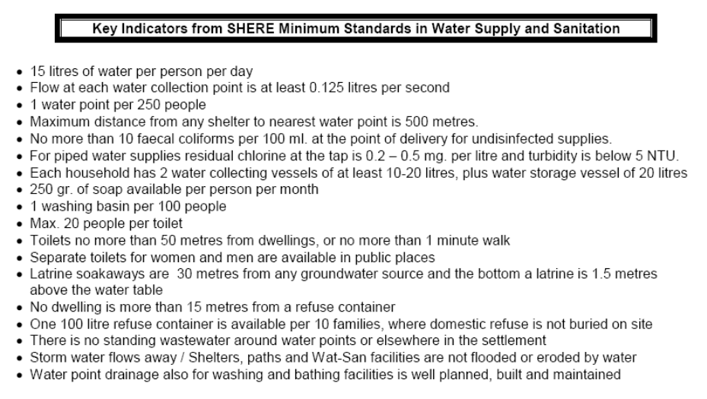

NOTES

NOTES

NOTES

NOTES

NOTES

NOTES

ANNEX 1

WATER ANALYSIS, PRODUCTION, STORAGE AND DISTRIBUTION DIAGRAMS

WATER ANALYSIS. SPANISH RED CROSS
6 < pH < 8
Nitrates < 50mg/l
Nitrites < 0.5 mg/l
Conductivity < 2,000 µS/cm
Turbidity = NTU as low as possible
Turbidity ≤ 20 NTU
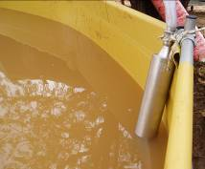
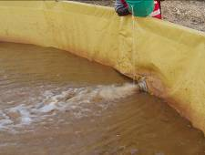
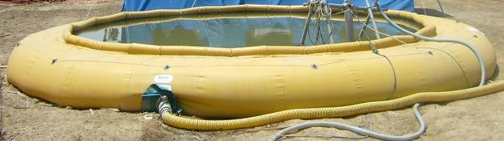
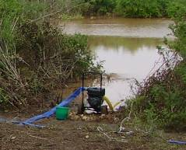

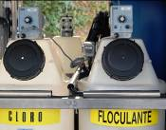
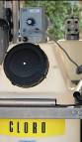
WATER TREATMENT PLANT
Chlorine = 0.1mg/l – 0.3 mg/l
Turbidity ≤ 5 NTU
Chlorine = 0.6 mg/l – 1.0 mg/l
Aluminium < 0.2 mg/l

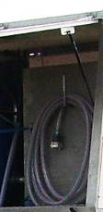
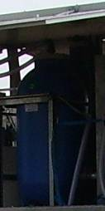
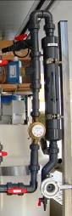
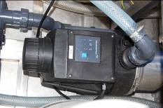

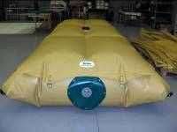
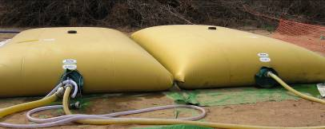
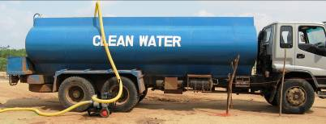

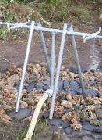
Chlorine = 0.3 mg/l – 0.6mg/l

WATER PRODUCTION PROCESS - SPANISH RED CROSS
Pumping water from
the water source
Water storage in an onion tank (30,000 litres)
Water pre-treatment with flocculent
Submersible pump

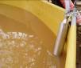
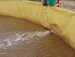
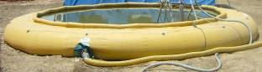
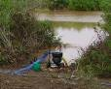

WATER TREATMENT PLANT

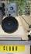
Chlorine & Alum
Residual Chlorine
Silex filter
Carbon filter
Rapid mixer

Pressure group
Flocculation tank

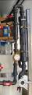
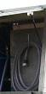
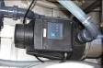

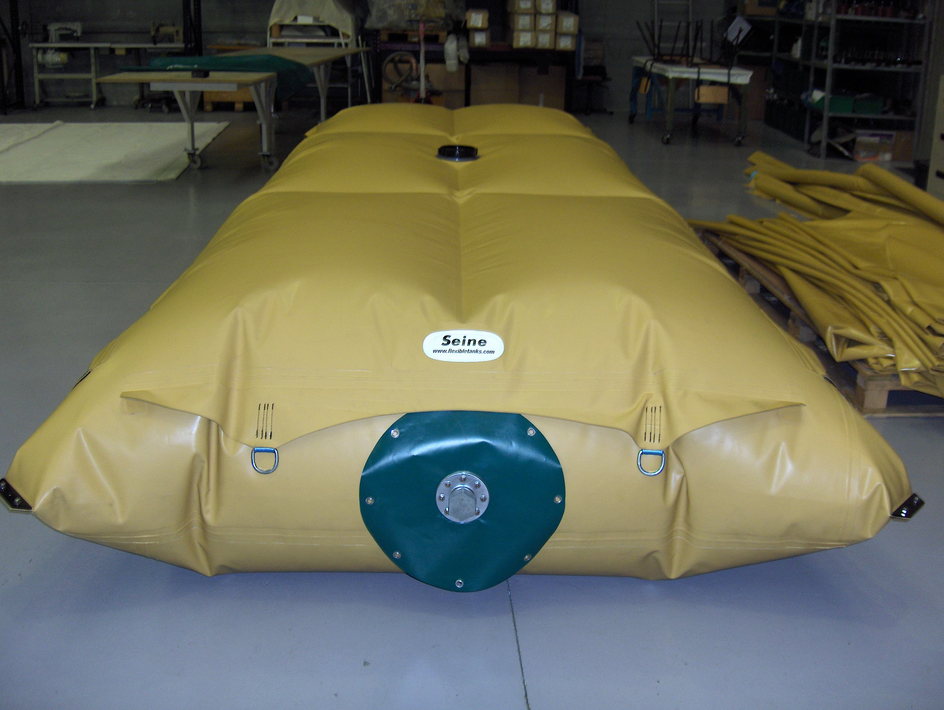
Water distribution: Screened bladders (5,000 l.)
Water distribution: Tanks
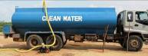
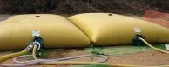

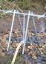
Bladder tanks (10,000 /5,000 l. )
to store drinking water
Water distribution: Taps
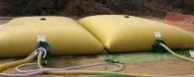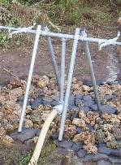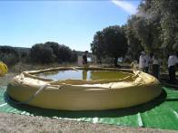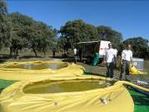
Bladders : Two of 5 m³ +
one of 10 m³ per line
+
NEW: Bladders for water trucking
Two of 5 m³ per line

SPANISH RED CROSS 15 MODULE. DISTRIBUTION TOOLS I

25 taps
30 m³
10 m³
1
2
4
3
Storage: Onions tanks
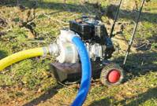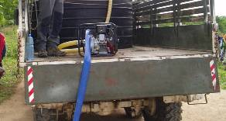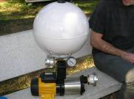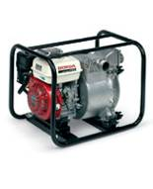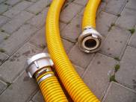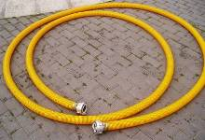
SPANISH RED CROSS 15 MODULE. DISTRIBUTION TOOLS II

Yellow hose: 2” and 3”
(Flexible & rigid)
Storz connections
for all pipes
Pressure pump (5 units) + polyethylene pipe (total = 1 km of pipe)
Lombardini pump: To be used for collection & distribution (5 units)
Tools for water trucking & distribution (5 units)

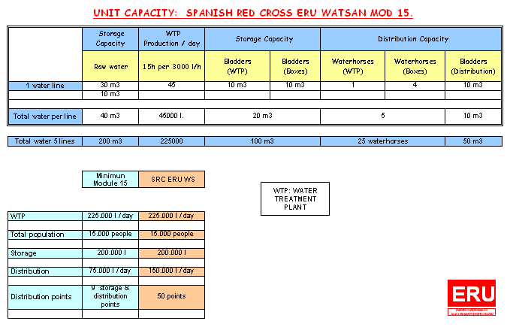

PUMPS FOR STORAGE & DISTRIBUTION
COLLECTION / DISTRIBUTION PUMP
L Lombardini 0,9 kW 220 v
50 HZ Diesel
Max Flow 40 m³ /Hour
Max Elevation: 45 m
Storz connection 3” (head & end)

PRESSURE GROUP
Power: 0.5 CV / 0.37 KW.
220 V , 50 Hz. Mod PRISMA 15.3 ESPA.
Pipe diameter 1”.
FEATURES:
- 0.6 m3/ h @ 32 head
- 1.2 m3/h @ 30 head
- 1.8 m3/h @ 26 head
- 2.4 m3/h @ 22 head
- 3 m3/h @ 17 head
- 3.6m3/h @ 10.5 head
- 3.9 m3/h @ 6 mca

DISTRIBUTION PUMP HONDA 2” Petrol . Motor GX120 3.1 lts, Autonomy 1.9 h. Height= 8 m
Max Elevation : 32 m. Max Flow: 36m3/h.
Measures: 470 x 350 x 380 mm. Weight 23 Kgs.

FEATURES:
- 36 m3/h @ 10 head
- 24 m3/h @ 20 head
- 9 m3/h @ 25 head

