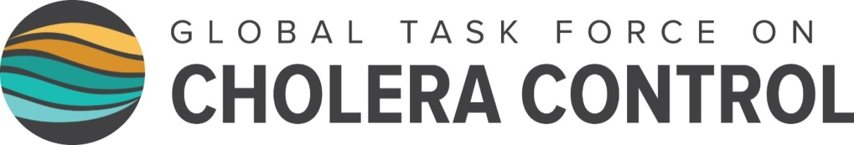
Declaration to Ending Cholera
4 October 2017
Annecy, France

We, GTFCC partners and concerned citizens, call for a commitment from all stakeholders to support cholera affected countries and align our energies, efforts, and resources to end cholera transmission. We affirm the vision of a world in which cholera no longer presents a threat to public health, and, through implementation of the cholera control strategy defined in Ending Cholera: A Roadmap to 2030, we commit to the target of a 90 percent reduction in cholera deaths by 2030.

We recognize that cholera is a disease of inequity – an ancient illness that today sickens and kills only the poorest and most vulnerable people on Earth. As such, controlling cholera is a moral obligation as well as a critical step to achieving the Sustainable Development Goals (SDGs), which call for the reduction of inequality, and good health and wellbeing for all. Access to safe water, sanitation, and hygiene (WASH) has been recognized by the United Nations as a human right, yet over 2 billion people still lack access to safe water, putting them at risk for cholera. Climate change, urbanization, and population growth will create an increased risk of cholera in the coming years if we don’t act now.
We acknowledge that every death from cholera is preventable with the tools we have today, putting the goal of ending cholera within our reach. The multi-sector approach to cholera control outlined in the Global Roadmap—including oral cholera vaccine (OCV) and WASH services—can prevent cholera outbreaks before they happen. By targeting highly endemic areas – “hotspots” – that experience cholera time and time again, we will not only reduce the burden of cholera, but also effectively prioritize the delivery of WASH solutions to those most in need, achieving maximum impact.
We avow that cholera outbreaks like the one in Yemen should not happen again, and commit to support countries preventing large outbreaks in crisis situations by detecting cholera outbreaks early, responding immediately, and containing them rapidly.
We pledge to invest in the prevention of cholera, which is not only affordable, but will ultimately allow significant cost savings compared with the average yearly cost of continuously responding to cholera outbreaks. Currently, cholera costs the world an estimated $2 billion per year in treatment and the related lost productivity. Providing access to basic WASH may cost as little as $40 per person, and, in addition to cholera, prevents a wide range of other water-related illnesses like typhoid and dysentery, as well as contributing to achieving goals related to poverty, malnutrition, and education.
We declare that now is the time to accelerate action against cholera at country and global levels. The GTFCC has become a highly energized network of organizations that can serve as an effective platform for implementation of the Global Roadmap. We agree to synchronize our efforts and investments toward a coordinated, multi-sectoral approach to cholera control at country level. We encourage a phased approach that takes into consideration the current conditions on the ground, encouraging each country to set a realistic and achievable goal for cholera control.
We commit to full support for the implementation of the Global Roadmap and agree to reconvene in 2019 to evaluate progress to date and confirm our path forward to 2030. We hold ourselves accountable for the targets outlined in the Global Roadmap monitoring framework—including a 90 percent reduction in deaths from cholera by 2030—and pledge to act with urgency to realize a world free from the threat of cholera.

