SPANISH RED CROSS

_________________________
(Host Society)

WATSAN M15 ERU

MASS WATER

(Name of the Operation)

(Name of the Site)

FIELD LOG BOOK Nº____

This field log book has been designed to record all the data originated during the operation period regarding the production of mass water. Another different book has the purpose to record specialised water data. The data include four main groups: water analysis, water treatment, water production and distribution, and engine maintenance. Therefore, the structure of this log book follows this order.

The frequency of recording depends on the type of data. For water analysis only one set of data should be sufficient when analysing sources of water other than the main source but for the water used at the site (main source) more than one analysis might be required. However, there are different frequencies for water treatment. It is necessary to distinguish two main types of treatment: water is physically and chemically treated in the plant (specialised water) or/and water is chemically treated only in tanks (mass water). Depending on the type of water different treatments require different frequencies. Production and distribution are recorded on daily basis. Maintenance is recorded when the different tasks are performed.

With regard to water analysis and jar tests some instructions have been included to remind how they should be conducted, facilitating their performance. Accordingly, accurate data should be produced.

Any obtained data must be recorded in this book and, at the end of the working day, appropriate data has to be transferred to the correct excel table in the computer. This transfer of data is of most importance as the book remains in the country once the equipment is donated to the Host Society when the operation finished. The transferred data to the computer are the data taken to Spanish Red Cross Headquarters. The book is designed to record data for a one month period. More books are available if the operation period extends longer than that.

Data produced in future operations should also be recorded in a similar book and all the log books should be kept in the same place.

WATER ANALYSIS

WATER TEST VALUES

These are the recommended values for drinking water for the following tests:

Turbidity ≤ 5 NTU
(When turbidity is ≥ 20 NTU raw water requires flocculation pre-treatment if treated in SETA plant)
Note: NTU (Nephelometric Turbidity Unit)

pH 6 < < 8

Coliforms = 0

Aluminum < 0.2 mg/l (WHO)

Nitrates < 50 mg/l (EU 98-83 Directive)

Nitrites < 0.5 mg/l (EU 98-83 Directive)

Hardness < 500 mg/l (WHO)

Conductivity < 2,000 µS/cm (Microsiemens/cm)

WHO: World Health Organisation

EU: European Union

TEST CHARACTERISTICS
Turbidity is the term given to the property of a water sample to scatter or absorb light. Turbidity in water is caused by suspended matter, such as plankton, silt, clay, organic and inorganic matter. High turbidity (higher than 5) will reduce the efficiency of disinfectants such as chlorine because the particles act as shields for the virus and bacteria. Similarly suspended solids can protect bacteria from UV sterilisation of water.
Turbidity in open water is often caused by phytoplankton and the measurement of turbidity is a key test of water quality. The higher the turbidity, the higher the risk of the drinkers developing gastrointestinal diseases, especially for immune-compromised people, because contaminants like virus or bacteria can become attached to the suspended solid.
Turbidity values, before and after treatment, should be tested with a weekly frequency as well as dosage in the dosing pump in the plant.
pH is a measure of the acidity or alkalinity of a solution. Aqueous solutions at 25°C with a pH less than seven are considered acidic, while those with a pH greater than seven are considered basic (alkaline). When a pH level is 7.0, it is defined as 'neutral' at 25°C. The effective pH range of the raw water has to be between 6 and 8 in order for the aluminium sulphate to work efficiently.
Aluminium. It is important to determine that the amount of aluminium sulphate added to the water pre-treatment process or to the WTP is not excessive. Otherwise, higher concentrations than those recommended above might be harmful.
It has to be taken into account that aluminium might present in raw water (before treatment) due to leaching through soils and rocks, particularly in areas with acid soft waters. Continuous consumption (over months/years) of water with high concentrations of aluminium might be linked to the extended appearances of neurological-related illnesses and might cause blisters, mouth ulcers, diarrhoeas and other symptoms.

Nitrates. Despite being a compound unclassified as toxic, the concentration of nitrates is an indicator of contamination caused by fertilizers. It also shows the possibility of the presence of other elements more dangerous such as nitrites.
Nitrites. If high concentrations of nitrites are found in raw water that indicates the possibility of industrial contamination or household sewage. Nitrites are harmful to health. They might cause the appearance of cancer-related compounds.
Water hardness. Hardness does not appear related to health problems to consumers although it causes very unpleasant taste when values are higher than those recommended by the WHO.
Conductivity. Electric conductivity is the capacity of a water solution to carry electricity. Conductivity increases with higher concentration of electrolytes. Underground water conductivity ranges between 100 and 2,000 µS/cm (Microsiemens/cm) and sea water conductivity has a reference value of 45,000 µS/cm. In emergencies a value of 3,000 µS/cm can be acceptable although salty taste is perceptible.

WATER ANALYSIS

Date
Source Nº
Date
Source Nº
Date

Source Nº
Date
Source Nº
 | Coliforms  (Nº x 100ml) | Hardness  (mg/l) | Conductivity  (µS/cm) | pH | Nitrates  (mg/l) | Nitrites  (mg/l) | Turbidity  (NTU)

WATER ANALYSIS

Date
Source Nº
Date
Source Nº
Date

Source Nº
Date
Source Nº
 | Coliforms  (Nº x 100ml) | Hardness  (mg/l) | Conductivity  (µS/cm) | pH | Nitrates  (mg/l) | Nitrites  (mg/l) | Turbidity  (NTU)

WATER ANALYSIS

Date
Source Nº
Date
Source Nº
Date

Source Nº
Date
Source Nº
 | Coliforms  (Nº x 100ml) | Hardness  (mg/l) | Conductivity  (µS/cm) | pH | Nitrates  (mg/l) | Nitrites  (mg/l) | Turbidity  (NTU)

WATER ANALYSIS

Date
Source Nº
Date
Source Nº
Date

Source Nº
Date
Source Nº
 | Coliforms  (Nº x 100ml) | Hardness  (mg/l) | Conductivity  (µS/cm) | pH | Nitrates  (mg/l) | Nitrites  (mg/l) | Turbidity  (NTU)

PHISYCAL CHARACTERISTICS OF WATER SOURCES

Water source Nº:_______ Date:__________________

Type of source (River, stream, canal, well, borehole, etc)

Current uses of the water source

Current uses of water upstream or above the source

Current quantity of flow

Colour and odour of water

Is the water source seasonal?
Specify the periods when flow is higher and lower

Average walking distance to households

Are the surroundings used for defecation?

Type of surrounding vegetation

Type of surrounding fauna

PHISYCAL CHARACTERISTICS OF WATER SOURCES

Water source Nº:_______ Date:__________________

Type of source (River, stream, canal, well, borehole, etc)

Current uses of the water source

Current uses of water upstream or above the source

Current quantity of flow

Colour and odder of water

Is the water source seasonal?
Specify the periods when flow is higher and lower

Average waking distance to households

Are the surroundings used for defecation?

Type of surrounding vegetation

Type of surrounding fauna

PHISYCAL CHARACTERISTICS OF WATER SOURCES

Water source Nº:_______ Date:__________________

Type of source (River, stream, canal, well, borehole, etc)

Current uses of the water source

Current uses of water upstream or above the source

Current quantity of flow

Colour and odour of water

Is the water source seasonal?
Specify the periods when flow is higher and lower

Average walking distance to households

Are the surroundings used for defecation?

Type of surrounding vegetation

Type of surrounding fauna

PHISYCAL CHARACTERISTICS OF WATER SOURCES

Water source Nº:_______ Date:__________________

Type of source (River, stream, canal, well, borehole, etc)

Current uses of the water source

Current uses of water upstream or above the source

Current quantity of flow

Colour and odder of water

Is the water source seasonal?
Specify the periods when flow is higher and lower

Average waking distance to households

Are the surroundings used for defecation?

Type of surrounding vegetation

Type of surrounding fauna

NAMES OF WATER SOURCES

SOURCE Nº________ (MAIN SOURCE)

NAME________________________________________________

______________________________________________________

SOURCE Nº________ (MAIN SOURCE)

NAME________________________________________________

______________________________________________________

SOURCE Nº________

NAME_______________________________________________

______________________________________________________

SOURCE Nº________

NAME_______________________________________________

______________________________________________________

NAMES OF WATER SOURCES

SOURCE Nº________

NAME_______________________________________________

_____________________________________________________

SOURCE Nº________

NAME_______________________________________________

_____________________________________________________

SOURCE Nº________

NAME_______________________________________________

_____________________________________________________

SOURCE Nº________

NAME_______________________________________________

_____________________________________________________

NAMES OF WATER SOURCES

SOURCE Nº________ (MAIN SOURCE)

NAME________________________________________________

______________________________________________________

SOURCE Nº________ (MAIN SOURCE)

NAME________________________________________________

______________________________________________________

SOURCE Nº________

NAME_______________________________________________

______________________________________________________

SOURCE Nº________

NAME_______________________________________________

______________________________________________________

NAMES OF WATER SOURCES

SOURCE Nº________

NAME_______________________________________________

_____________________________________________________

SOURCE Nº________

NAME_______________________________________________

_____________________________________________________

SOURCE Nº________

NAME_______________________________________________

_____________________________________________________

SOURCE Nº________

NAME_______________________________________________

_____________________________________________________

NOTES

NOTES

NOTES

NOTES

WATER TREATMENT

JAR TEST

Object: To determine the amount of flocculent (aluminium sulphate) necessary to decrease water turbidity to ≤ 20 NTU for specialised water and to ≤ 5NTU for mass water. The jar test can be also used to determine the amount of chlorine necessary to add to raw water in order to disinfect it when producing mass water.

Specialised water:
This water is produced in a WTP (water treatment plant). It is necessary to carry out a water pre-treatment process when raw water turbidity is higher than 20 NTU. Through this pre-treatment process the incoming water in the WTP is clearer with the result of the following advantages:
- The production of sludge at the bottom of the settlement tank will be lower.
- The frequency of backwashing and washing will be lower.
- The lifespan of the filters will increase.
- The amount of flocculent used in the plant will decreased.

Mass water:
This water is produced without a WTP but by using only tanks and dosage units, if available, to inject the chemicals (aluminium sulphate and chlorine) in those tanks.

Equipment and chemicals
- 7 vases or jars of 1 litre capacity. If these are not available we can use empty water bottles but marked with 1 litre capacity.
- Turbidity metre
- Watch o chronometer
- Vase or measuring syringe
- Wand or spoon to stir
- Scale (or spoon) to prepare the mother solution.
- Raw water from the water source (5 litres aprox.).
- Aluminium sulphate (alum)
- 1 litre of clean water

Process

1) To prepare the mother alum solution

1 % = 10 g aluminium sulphate/ 1 litre of clean water
(10.000 mg/litre = 10.000 ppm)

If a scale is not available we can prepare the mother solution by using a spoon as the measuring unit (1 spoon ≈ 10 gr.)

1% ≈ 1 spoon aluminium sulphate / 1 litre of clean water
Pour 1 litre of clean water into a jar. Weigh 10 gr. or fill a spoon with Aluminium Sulphate (10 g.)

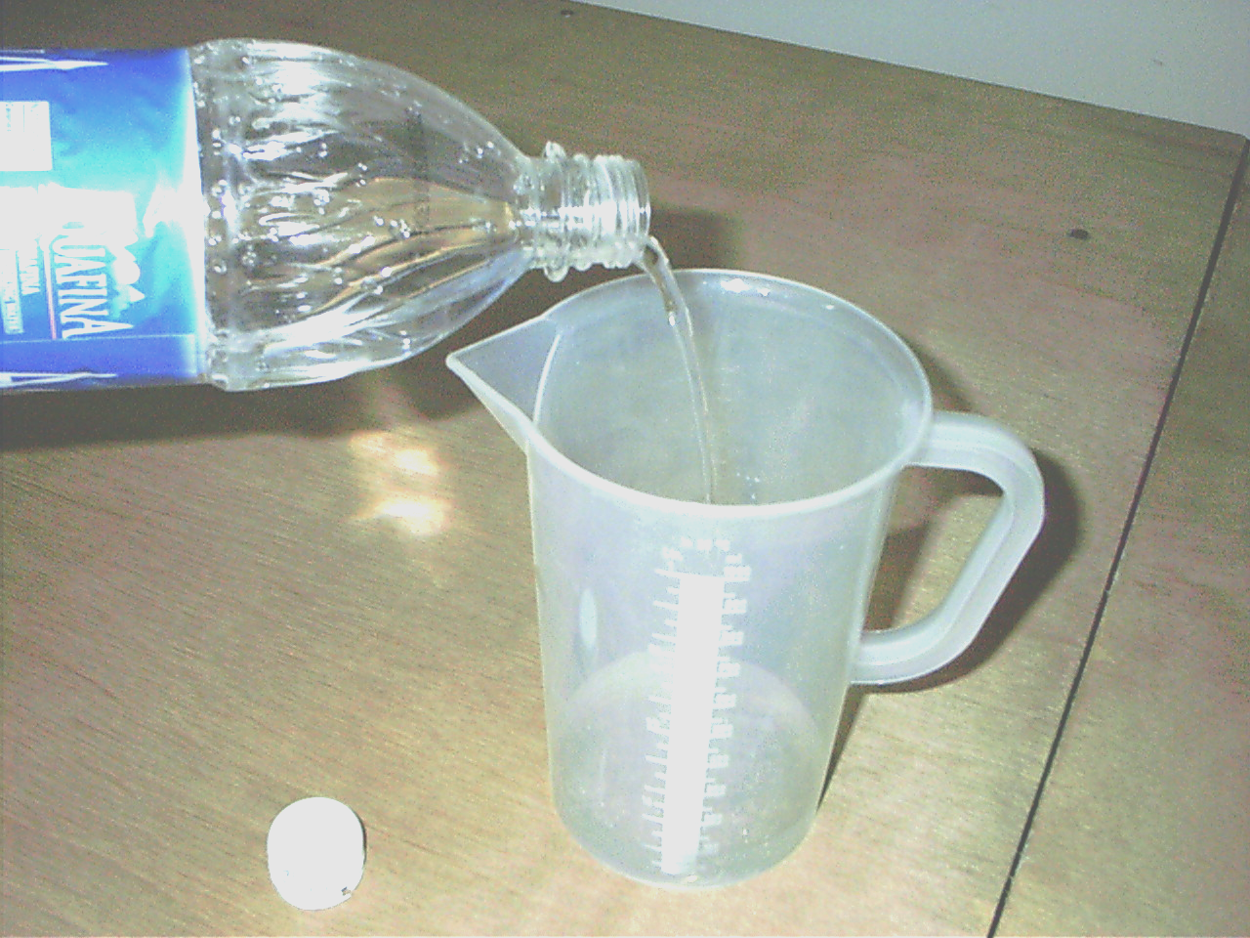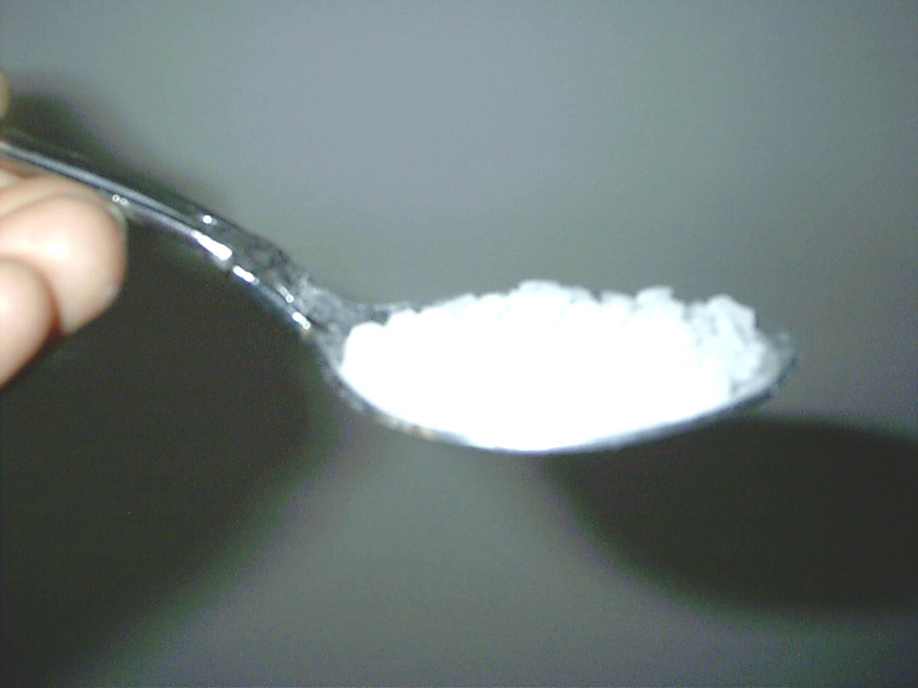

Put the Aluminium Sulphate in the jar with clean water and vigorously stir until the complete dissolution of the chemical. This solution is named
Mother Solution (MS) 1% (1 part of Aluminium Sulphate per 100 parts of water)

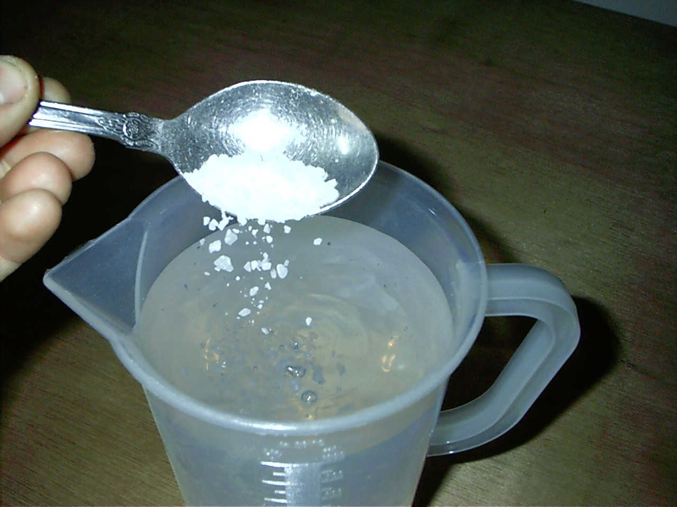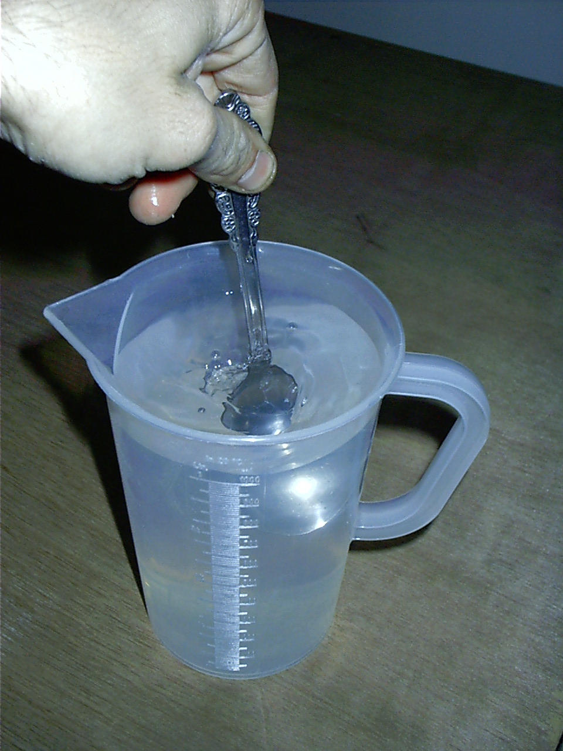

- To prepare the jars with solutions

- Fill 6 jars or bottles with 1litre of raw water per jar.

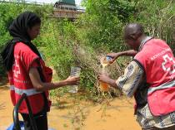

- Prepare the 5 jars or bottles with different quantities of mother solution.
The other jar will be used for comparison at the end of the process.

1 jar (or bottle): 1 litre raw water (RW) + X ml mother solution (MS)

- Use a syringe to pour the MS into the jars.

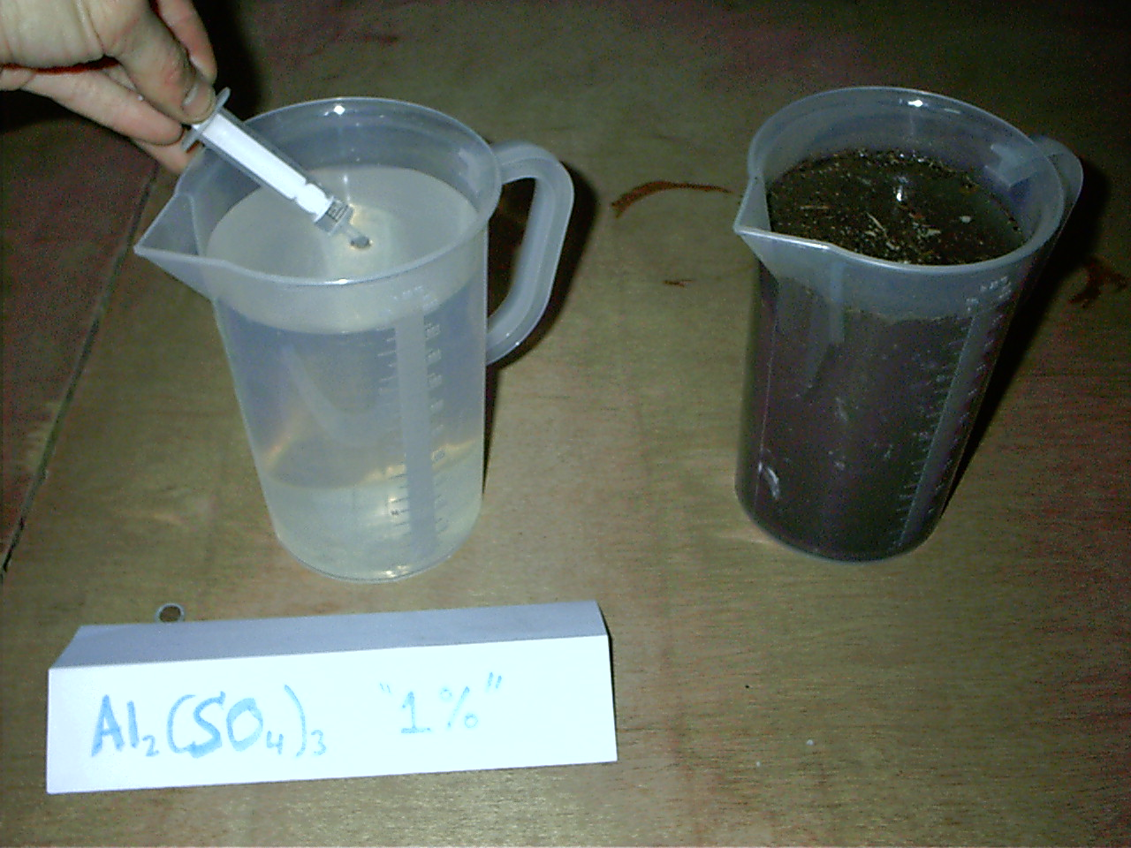

- Pour growing quantities.
Example: 1ml, 2ml, 4 ml, 8 ml, 16 ml
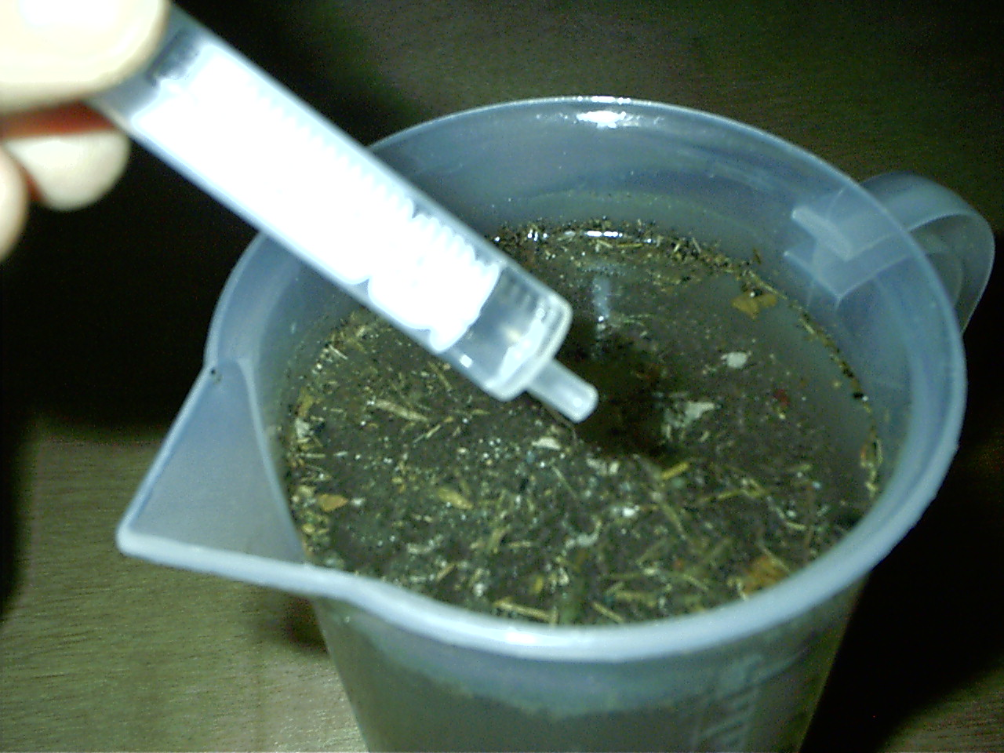

3) To choose the correct solution

After a vigorously initial stir to favour coagulation, stir very gently in the same direction for 10 min and leave to settle for 30 min.

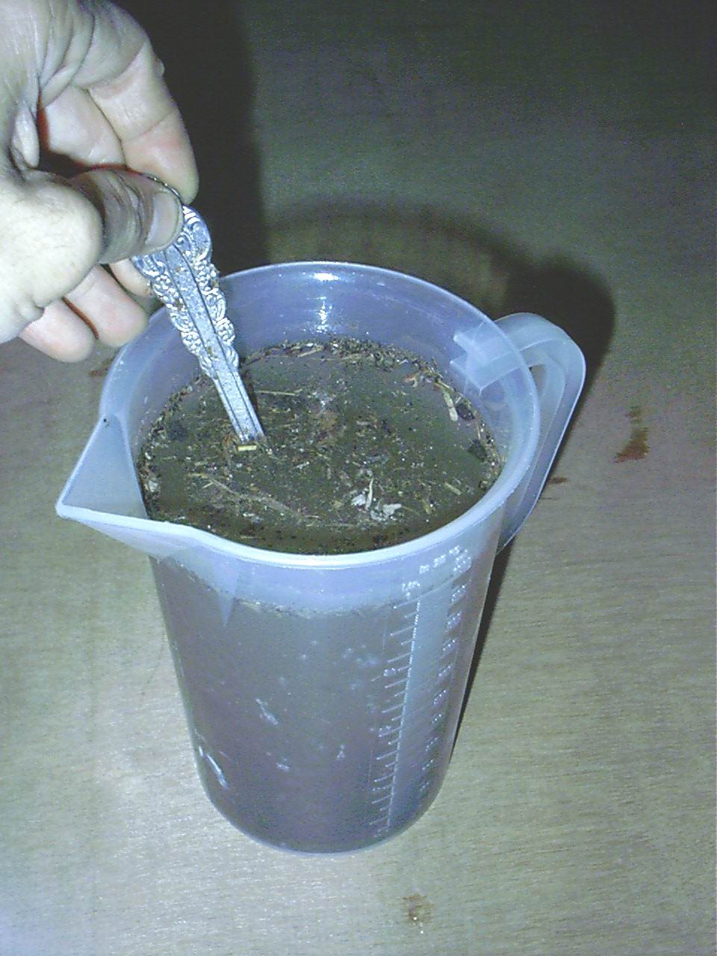
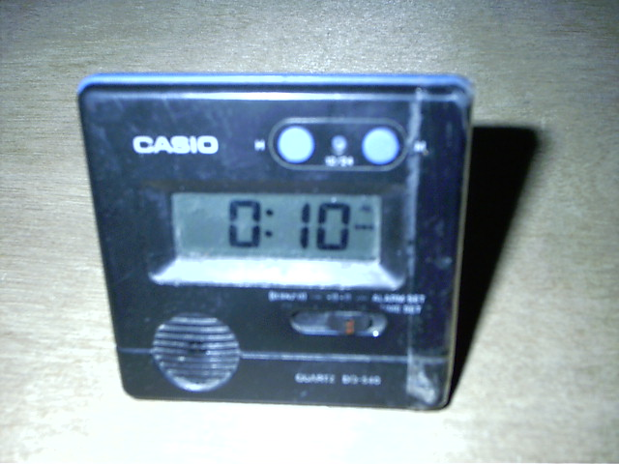

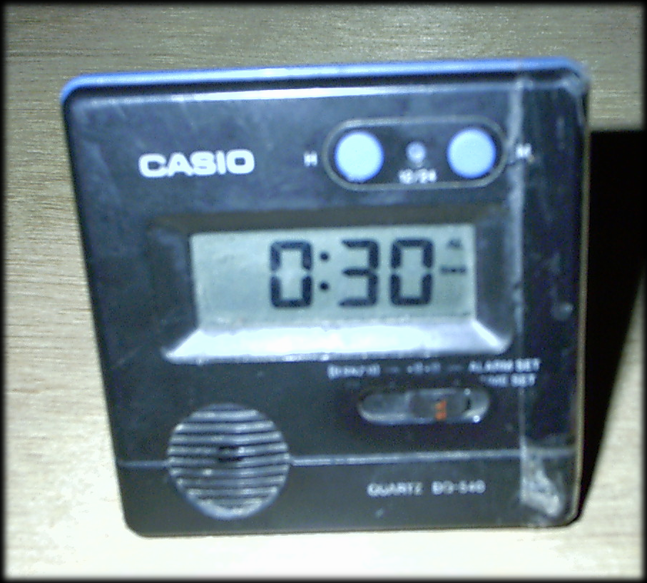

When 30 minutes, or the agreed time, have elapsed we will observe a colour gradient. We will not select the clearest jar, but the jar where less mother solution was added among those sufficiently clear.

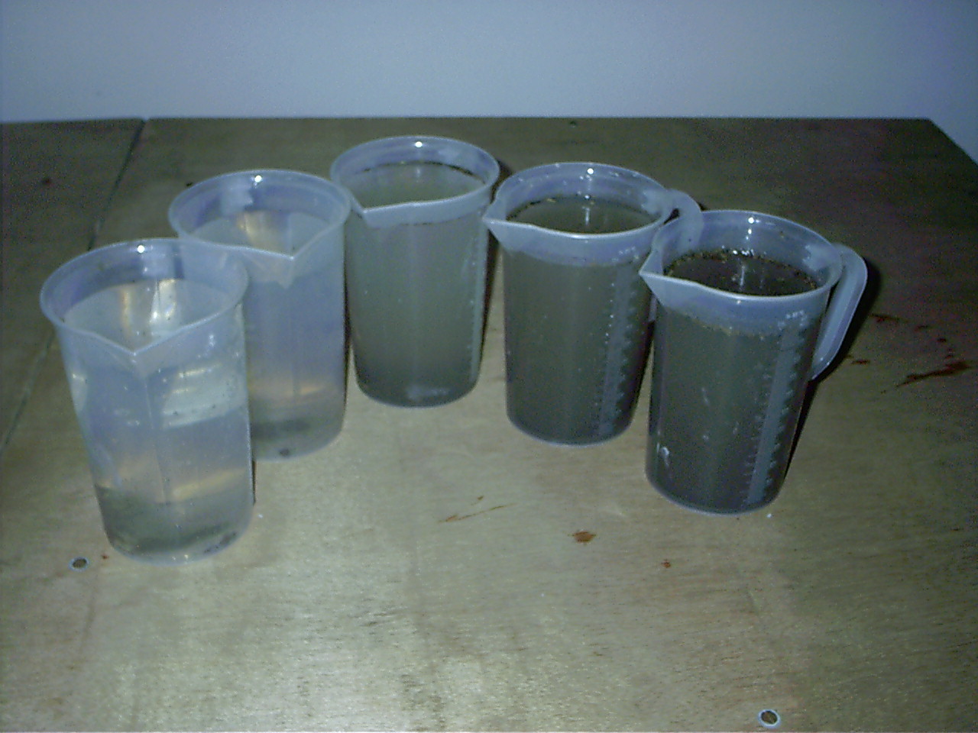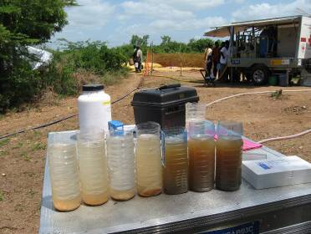

It is recommended to leave one jar (bottle) without mother solution as a comparative reference to asses how water colour changes and also to check whether particles settle in a natural manner without coagulant.

We chose the lowest possible concentration that achieves turbidity lower than 5 NTU or 20 NTU depending on mass water or specialised water. If possible we can draw the graphic that allows choosing the optimal concentration. Attention: Take the water above the sludge and avoid the dissolution of the solids. Record the data in the table Jar Test Flocculation of this book.

Try to draw a graph to more accurately assess the concentration of MS to use.

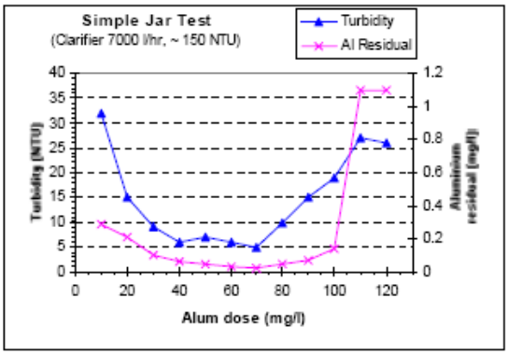

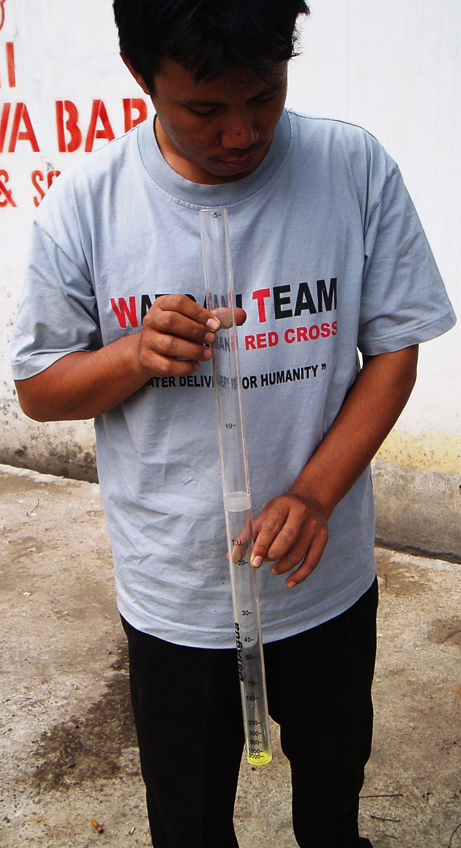
If none of the jars comes up with clear water, after checking the turbidity as explained above, we shall repeat all the process although adding 24, 34, 46, 60 and 76 ml. Only after checking again that a cleaner source is still not available.

If all are sufficiently clear, we shall repeat all the process with smaller amounts 0.1, 0.2, 0.5, 0.75 y 1 ml. Only after checking again that the source still does not meet turbidity requirements without any treatment.

4) To calculate the appropriate amount of alum to add in the pre-treatment 30,000 litre tank.

As the optimal concentration of mother solution to add in 1 litre of raw water is X ml, we calculate the amount of aluminium sulphate necessary to add in the 30,000 litre tank.

X ml jar x 30,000 litres tank volume x 1/100 = Y gr. aluminium sulphate

If we have prepared the mother solution by using spoons as the measuring unit:

X ml jar x 30,000 litre tank volume x 1/1.000 = 240 spoons of aluminium sulphate

MASS WATER CHLORINATION
To calculate the amount of chlorine to add when producing mass water we follow a similar process to the jar test, the only difference being the capacity of the containers or buckets instead of jars or bottles. We prepare several solutions with raw water (for example 1 ml, 1.5 ml, 2ml and 3 ml in 10 litres of raw water) based on a 1% chlorine mother solution (14gr. HTH 70% per litre) . We measure the residual chlorine after a contact time of 30 minutes. The solution with a residual chorine of approximately 0.6 mg/l is the most appropriate. The calculation to dose the solution in the tank is similar to that described above for aluminium sulphate.
ATTENTION: We must take all possible cautions when manipulating calcium hypochlorite (HTH).

JAR TEST FLOCCULATION

DATE__________________ SITE_____________________________________________ | Jar 6  ____ ml | ____NTU |  | DATE__________________ SITE_____________________________________________ | Jar 6  ____ ml | ____NTU
 | Jar 5  ____ ml | ____ NTU |  |  | Jar 5  ____ ml | ____ NTU
 | Jar 4  ____ ml | ____ NTU |  |  | Jar 4  ____ ml | ____ NTU
 | Jar 3  ____ ml | ____ NTU |  |  | Jar 3  ____ ml | ____ NTU
 | Jar 2  ____ ml | _  ____ NTU |  |  | Jar 2  ____ ml | _  ____ NTU
 | Jar 1  ____ ml | ______ NTU |  |  | Jar 1  ____ ml | ______ NTU
 | Solution | Turbidity |  |  | Solution | Turbidity

JAR TEST FLOCCULATION

DATE__________________ SITE_____________________________________________ | Jar 6  ____ ml | ____NTU |  | DATE__________________ SITE_____________________________________________ | Jar 6  ____ ml | ____NTU
 | Jar 5  ____ ml | ____ NTU |  |  | Jar 5  ____ ml | ____ NTU
 | Jar 4  ____ ml | ____ NTU |  |  | Jar 4  ____ ml | ____ NTU
 | Jar 3  ____ ml | ____ NTU |  |  | Jar 3  ____ ml | ____ NTU
 | Jar 2  ____ ml | _  ____ NTU |  |  | Jar 2  ____ ml | _  ____ NTU
 | Jar 1  ____ ml | ______ NTU |  |  | Jar 1  ____ ml | ______ NTU
 | Solution | Turbidity |  |  | Solution | Turbidity

JAR TEST FLOCCULATION

DATE__________________ SITE_____________________________________________ | Jar 6  ____ ml | ____NTU |  | DATE__________________ SITE_____________________________________________ | Jar 6  ____ ml | ____NTU
 | Jar 5  ____ ml | ____ NTU |  |  | Jar 5  ____ ml | ____ NTU
 | Jar 4  ____ ml | ____ NTU |  |  | Jar 4  ____ ml | ____ NTU
 | Jar 3  ____ ml | ____ NTU |  |  | Jar 3  ____ ml | ____ NTU
 | Jar 2  ____ ml | _  ____ NTU |  |  | Jar 2  ____ ml | _  ____ NTU
 | Jar 1  ____ ml | ______ NTU |  |  | Jar 1  ____ ml | ______ NTU
 | Solution | Turbidity |  |  | Solution | Turbidity

JAR TEST FLOCCULATION

DATE__________________ SITE_____________________________________________ | Jar 6  ____ ml | ____NTU |  | DATE__________________ SITE_____________________________________________ | Jar 6  ____ ml | ____NTU
 | Jar 5  ____ ml | ____ NTU |  |  | Jar 5  ____ ml | ____ NTU
 | Jar 4  ____ ml | ____ NTU |  |  | Jar 4  ____ ml | ____ NTU
 | Jar 3  ____ ml | ____ NTU |  |  | Jar 3  ____ ml | ____ NTU
 | Jar 2  ____ ml | _  ____ NTU |  |  | Jar 2  ____ ml | _  ____ NTU
 | Jar 1  ____ ml | ______ NTU |  |  | Jar 1  ____ ml | ______ NTU
 | Solution | Turbidity |  |  | Solution | Turbidity

CHLORINE DEMAND TEST CHLORINATION

DATE__________________ SITE_____________________________________________ | Bucket 6  ____ ml | ____mg/l |  | DATE__________________ SITE_____________________________________________ | Bucket 6  ____ ml | ____mg/l
 | Bucket 5  ____ ml | ____ mg/l |  |  | Bucket 5  ____ ml | ____ mg/l
 | Bucket 4  ____ ml | ____ mg/l |  |  | Bucket 4  ____ ml | ____ mg/l
 | Bucket 3  ____ ml | ____ mg/l |  |  | Bucket 3  ____ ml | ____ mg/l
 | Bucket 2  ____ ml | _  ____ mg/l |  |  | Bucket 2  ____ ml | _  ____ mg/l
 | Bucket 1  ____ ml | ______ mg/l |  |  | Bucket 1  ____ ml | ______ mg/l
 | Solution | Residual chlorine |  |  | Solution | Residual chlorine

CHLORINE DEMAND TEST CHLORINATION

DATE__________________ SITE_____________________________________________ | Bucket 6  ____ ml | ____mg/l |  | DATE__________________ SITE_____________________________________________ | Bucket 6  ____ ml | ____mg/l
 | Bucket 5  ____ ml | ____ mg/l |  |  | Bucket 5  ____ ml | ____ mg/l
 | Bucket 4  ____ ml | ____ mg/l |  |  | Bucket 4  ____ ml | ____ mg/l
 | Bucket 3  ____ ml | ____ mg/l |  |  | Bucket 3  ____ ml | ____ mg/l
 | Bucket 2  ____ ml | _  ____ mg/l |  |  | Bucket 2  ____ ml | _  ____ mg/l
 | Bucket 1  ____ ml | ______ mg/l |  |  | Bucket 1  ____ ml | ______ mg/l
 | Solution | Residual chlorine |  |  | Solution | Residual chlorine

CHLORINE DEMAND TEST CHLORINATION

DATE__________________ SITE_____________________________________________ | Bucket 6  ____ ml | ____mg/l |  | DATE__________________ SITE_____________________________________________ | Bucket 6  ____ ml | ____mg/l
 | Bucket 5  ____ ml | ____ mg/l |  |  | Bucket 5  ____ ml | ____ mg/l
 | Bucket 4  ____ ml | ____ mg/l |  |  | Bucket 4  ____ ml | ____ mg/l
 | Bucket 3  ____ ml | ____ mg/l |  |  | Bucket 3  ____ ml | ____ mg/l
 | Bucket 2  ____ ml | _  ____ mg/l |  |  | Bucket 2  ____ ml | _  ____ mg/l
 | Bucket 1  ____ ml | ______ mg/l |  |  | Bucket 1  ____ ml | ______ mg/l
 | Solution | Residual chlorine |  |  | Solution | Residual chlorine

CHLORINE DEMAND TEST CHLORINATION

DATE__________________ SITE_____________________________________________ | Bucket 6  ____ ml | ____mg/l |  | DATE__________________ SITE_____________________________________________ | Bucket 6  ____ ml | ____mg/l
 | Bucket 5  ____ ml | ____ mg/l |  |  | Bucket 5  ____ ml | ____ mg/l
 | Bucket 4  ____ ml | ____ mg/l |  |  | Bucket 4  ____ ml | ____ mg/l
 | Bucket 3  ____ ml | ____ mg/l |  |  | Bucket 3  ____ ml | ____ mg/l
 | Bucket 2  ____ ml | _  ____ mg/l |  |  | Bucket 2  ____ ml | _  ____ mg/l
 | Bucket 1  ____ ml | ______ mg/l |  |  | Bucket 1  ____ ml | ______ mg/l
 | Solution | Residual chlorine |  |  | Solution | Residual chlorine

COLIFORMS AND HARDNESS
(Outlet of water treatment)

SITE_______________________________________________

Hardness
(mg/l)

Coliforms
(Nº x 100ml)

Date

SITE_______________________________________________

Hardness
(mg/l)

Coliforms
(Nº x 100ml)

Date

COLIFORMS AND HARDNESS
(Outlet of water treatment)

SITE_______________________________________________

Hardness
(mg/l)

Coliforms
(Nº x 100ml)

Date

SITE_______________________________________________

Hardness
(mg/l)

Coliforms
(Nº x 100ml)

Date

COLIFORMS AND HARDNESS
(Outlet of water treatment)

SITE_______________________________________________

Hardness
(mg/l)

Coliforms
(Nº x 100ml)

Date

SITE_______________________________________________

Hardness
(mg/l)

Coliforms
(Nº x 100ml)

Date

COLIFORMS AND HARDNESS
(Outlet of water treatment)

SITE_______________________________________________

Hardness
(mg/l)

Coliforms
(Nº x 100ml)

Date

SITE_______________________________________________

Hardness
(mg/l)

Coliforms
(Nº x 100ml)

Date

DATE____________ SITE____________________________

RESIDUAL CHLORINE (Contact time in the tank 30 min.)

Time | Tank nº | Outlet of the tank
Residual chlorine at the end of treatment: 0.6 mg/l – 1.0 mg/l

TURBIDITY (Contact time of flocculant in the tank 30 min.)
(Turbidity after flocculation must be ≤ 5 NTU)
Time | Tank nº | Before flocculation  (NTU) | After flocculation  (NTU)

ALUMINIUM ( < 0.2 mg/l)
Time | Tank nº | After treatment  ( mg/l)

DATE____________ SITE____________________________

RESIDUAL CHLORINE (Contact time in the tank 30 min)
Time | Tank nº | Outlet of the tank
Residual chlorine at the end of treatment: 0.6 mg/l – 1.0 mg/l

TURBIDITY (Contact time of flocculant in the tank 30 min.)
(Turbidity after flocculation must be ≤ 5 NTU)
Time | Tank nº | Before flocculation  (NTU) | After flocculation  (NTU)

ALUMINIUM ( < 0.2 mg/l)
Time | Tank nº | After treatment  ( mg/l)

DATE____________ SITE____________________________

RESIDUAL CHLORINE (Contact time in the tank 30 min.)

Time | Tank nº | Outlet of the tank
Residual chlorine at the end of treatment: 0.6 mg/l – 1.0 mg/l

TURBIDITY (Contact time of flocculant in the tank 30 min.)
(Turbidity after flocculation must be ≤ 5 NTU)
Time | Tank nº | Before flocculation  (NTU) | After flocculation  (NTU)

ALUMINIUM ( < 0.2 mg/l)
Time | Tank nº | After treatment  ( mg/l)

DATE____________ SITE____________________________

RESIDUAL CHLORINE (Contact time in the tank 30 min)
Time | Tank nº | Outlet of the tank
Residual chlorine at the end of treatment: 0.6 mg/l – 1.0 mg/l

TURBIDITY (Contact time of flocculant in the tank 30 min.)
(Turbidity after flocculation must be ≤ 5 NTU)
Time | Tank nº | Before flocculation  (NTU) | After flocculation  (NTU)

ALUMINIUM ( < 0.2 mg/l)
Time | Tank nº | After treatment  ( mg/l)

NOTES

NOTES

NOTES

NOTES

WATER DISTRIBUTION

DATE___________SITE_____________________________

MASS WATER PRODUCTION SITE (in litres)
Stop
Start
Total today

TOTAL WATER DISTRIBUTION SITE (in litres)
(Name of the site where water is transported and supplied by us or the organization that supplies water from us)
Name | Litres
Total today
Total operation yesterday
TOTAL OPERATION

DATE___________SITE_____________________________

MASS WATER PRODUCTION SITE (in litres)
Stop
Start
Total today

TOTAL WATER DISTRIBUTION SITE (in litres)
(Name of the site where water is transported and supplied by us or the organization that supplies water from us)
Name | Litres
Total today
Total operation yesterday
TOTAL OPERATION

DATE___________SITE_____________________________

MASS WATER PRODUCTION SITE (in litres)
Stop
Start
Total today

TOTAL WATER DISTRIBUTION SITE (in litres)
(Name of the site where water is transported and supplied by us or the organization that supplies water from us)
Name | Litres
Total today
Total operation yesterday
TOTAL OPERATION

DATE___________SITE_____________________________

MASS WATER PRODUCTION SITE (in litres)
Stop
Start
Total today

TOTAL WATER DISTRIBUTION SITE (in litres)
(Name of the site where water is transported and supplied by us or the organization that supplies water from us)
Name | Litres
Total today
Total operation yesterday
TOTAL OPERATION

WATER DISTRIBUTION. RESIDUAL CHLORINE

This table records the residual chlorine data obtained in the different places where the treated water from the SRC site is supplied. Samples should be taken from the taps. It is also convenient to specify where the water is supplied from a static tank or from a tanker directly to the users. The samples can be taken daily or randomly in different days.

Location | Date & Time | Chlorine
Residual chlorine at the taps: 0.3 mg/l – 0.6 mg/l

WATER DISTRIBUTION. RESIDUAL CHLORINE

This table records the residual chlorine data obtained in the different places where the treated water from the SRC site is supplied. Samples should be taken from the taps. It is also convenient to specify where the water is supplied from a static tank or from a tanker directly to the users. The samples can be taken randomly or in different days.

Location | Date & Time | Chlorine
Residual chlorine at the taps: 0.3 mg/l – 0.6 mg/l

WATER DISTRIBUTION. RESIDUAL CHLORINE

This table records the residual chlorine data obtained in the different places where the treated water from the SRC site is supplied. Samples should be taken from the taps. It is also convenient to specify where the water is supplied from a static tank or from a tanker directly to the users. The samples can be taken daily or randomly in different days.

Location | Date & Time | Chlorine
Residual chlorine at the taps: 0.3 mg/l – 0.6 mg/l

WATER DISTRIBUTION. RESIDUAL CHLORINE

This table records the residual chlorine data obtained in the different places where the treated water from the SRC site is supplied. Samples should be taken from the taps. It is also convenient to specify where the water is supplied from a static tank or from a tanker directly to the users. The samples can be taken randomly or in different days.

Location | Date & Time | Chlorine
Residual chlorine at the taps: 0.3 mg/l – 0.6 mg/l

WATER DISTRIBUTION POINTS

This table records all the water points where the treated water from the SRC site is supplied. The type of storage should also be recorded (static, 5,000 l. bladder tank, static 10,000 l. Oxfam tank, 7,000 l. tanker, etc). The table also includes the date when the tank was set up or the tanker started delivering water and the date when the service finishes or the tank was dismantled.

Location, type of storage & No. taps | Starting date | Finishing date

WATER DISTRIBUTION POINTS

This table records all the water points where the treated water from the SRC site is supplied. The type of storage should also be recorded (static, 5,000 l. bladder tank, static 10,000 l. Oxfam tank, 7,000 l. tanker, etc). The table also includes the date when the tank was set up or the tanker started delivering water and the date when the service finishes or the tank was dismantled.

Location, type of storage & No. taps | Starting date | Finishing date

WATER DISTRIBUTION POINTS

This table records all the water points where the treated water from the SRC site is supplied. The type of storage should also be recorded (static, 5,000 l. bladder tank, static 10,000 l. Oxfam tank, 7,000 l. tanker, etc). The table also includes the date when the tank was set up or the tanker started delivering water and the date when the service finishes or the tank was dismantled.

Location, type of storage & No. taps | Starting date | Finishing date

WATER DISTRIBUTION POINTS

This table records all the water points where the treated water from the SRC site is supplied. The type of storage should also be recorded (static, 5,000 l. bladder tank, static 10,000 l. Oxfam tank, 7,000 l. tanker, etc). The table also includes the date when the tank was set up or the tanker started delivering water and the date when the service finishes or the tank was dismantled.

Location, type of storage & No. taps | Starting date | Finishing date

NUMBER OF BENEFICIARIES

This table records the estimated number of beneficiaries of the water produced and distributed by SRC. The table records the name of the location and the number of beneficiaries for each location as well as the period when they benefit from the water supply.

Location & estimated No. of beneficiaries | Starting  date | Finishing  date

NUMBER OF BENEFICIARIES

This table records the estimated number of beneficiaries of the water produced and distributed by SRC. The table records the name of the location and the number of beneficiaries for each location as well as the period when they benefit from the water supply.

Location & estimated No. of beneficiaries | Starting  date | Finishing  date

NUMBER OF BENEFICIARIES

This table records the estimated number of beneficiaries of the water produced and distributed by SRC. The table records the name of the location and the number of beneficiaries for each location as well as the period when they benefit from the water supply.

Location & estimated No. of beneficiaries | Starting  date | Finishing  date

NUMBER OF BENEFICIARIES

This table records the estimated number of beneficiaries of the water produced and distributed by SRC. The table records the name of the location and the number of beneficiaries for each location as well as the period when they benefit from the water supply.

Location & estimated No. of beneficiaries | Starting  date | Finishing  date

NOTES

NOTES

NOTES

NOTES

LOGISTICS

FUEL SITE____________________________

DATE____________
PETROL (in litres)
Total op. yesterday
Today
TOTAL OPERATION

DIESEL (in litres)
Total op. yesterday
Today
TOTAL OPERATION

DATE____________
PETROL (in litres)
Total op. yesterday
Today
TOTAL OPERATION

DIESEL (in litres)
Total op. yesterday
Today
TOTAL OPERATION

DATE____________
PETROL (in litres)
Total op. yesterday
Today
TOTAL OPERATION

DIESEL (in litres)
Total op. yesterday
Today
TOTAL OPERATION

FUEL SITE____________________________

DATE____________
PETROL (in litres)
Total op. yesterday
Today
TOTAL OPERATION

DIESEL (in litres)
Total op. yesterday
Today
TOTAL OPERATION

DATE____________
PETROL (in litres)
Total op. yesterday
Today
TOTAL OPERATION

DIESEL (in litres)
Total op. yesterday
Today
TOTAL OPERATION

DATE____________
PETROL (in litres)
Total op. yesterday
Today
TOTAL OPERATION

DIESEL (in litres)
Total op. yesterday
Today
TOTAL OPERATION

FUEL SITE____________________________

DATE____________
PETROL (in litres)
Total op. yesterday
Today
TOTAL OPERATION

DIESEL (in litres)
Total op. yesterday
Today
TOTAL OPERATION

DATE____________
PETROL (in litres)
Total op. yesterday
Today
TOTAL OPERATION

DIESEL (in litres)
Total op. yesterday
Today
TOTAL OPERATION

DATE____________
PETROL (in litres)
Total op. yesterday
Today
TOTAL OPERATION

DIESEL (in litres)
Total op. yesterday
Today
TOTAL OPERATION

FUEL SITE____________________________

DATE____________
PETROL (in litres)
Total op. yesterday
Today
TOTAL OPERATION

DIESEL (in litres)
Total op. yesterday
Today
TOTAL OPERATION

DATE____________
PETROL (in litres)
Total op. yesterday
Today
TOTAL OPERATION

DIESEL (in litres)
Total op. yesterday
Today
TOTAL OPERATION

DATE____________
PETROL (in litres)
Total op. yesterday
Today
TOTAL OPERATION

DIESEL (in litres)
Total op. yesterday
Today
TOTAL OPERATION

NOTES

NOTES

NOTES

NOTES

