Menstrual Hygiene Management (MHM) in Emergencies
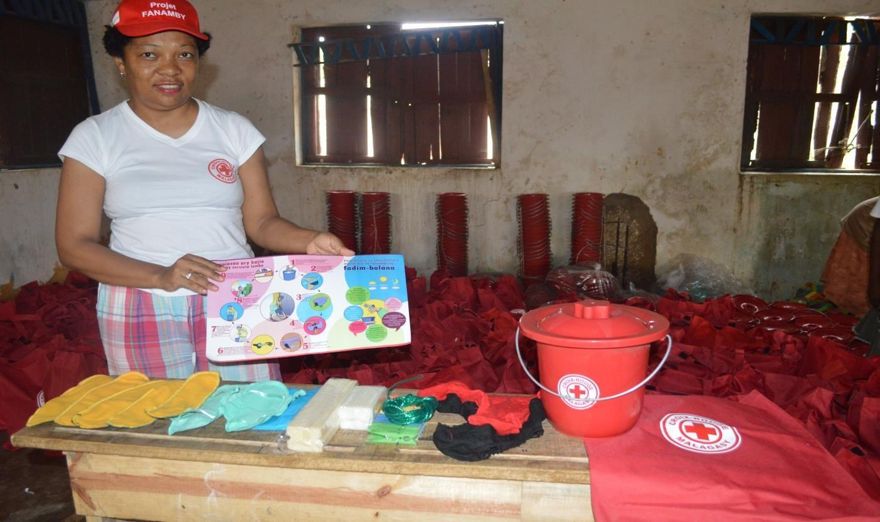

Types and content of IFRC Menstrual Hygiene Management Kits (A, B and C)

Type of MHM Kit | Items
Kit A (Disposable) | 2 Packs of Disposable sanitary pads, normal (8 pads per pack)
 | Plastic bucket, 6 Litres, with lid
 | Bio-degradable plastic bags, 8 - 10 Litre size, non-transparent, black
 | 220 grams personal bathing soap
 | Underwear, 100% cotton, not white, Medium size
 | Underwear, 100% cotton, not white, Large size
 | Use, care and disposal instructions (Kit A - disposable)
 | Polyethylene storage bag, with drawstring
Kit B (Washable) | 1 pack of reusable sanitary pads (e.g. AFRIpads) which included 5 absorbing liners (3 winged pads + 2 straight pads)
 | Plastic bucket, 6 Litres, with lid
 | 4-meter length plastic coated rope
 | Plastic pegs, pack of 8
 | 350 grams laundry soap
 | 220 grams personal bathing soap
 | Underwear, 100% cotton, not white, Medium size
 | Underwear, 100% cotton, not white, Large size
 | Use, care and disposal instructions (Kit B - reusable)
 | Polyethylene storage bag, with drawstring
Kit C (Disposable & Washable) | Plastic bucket, 7 Litre capacity, with lid, solid color
 | Disposable sanitary pads, regular absorbency, pack of 10
 | Small plastic bags (bio-degradable), 1 - 2 L capacity, thin with handles, non-transparent, black
 | 1 Pack of reusable/washable sanitary pads (e.g. AFRIpads)
 | Plastic coated rope, 4-meter length
 | Plastic pegs, pack of 8
 | 350 grams laundry soap, bar
 | 220 grams personal bathing soap, bar
 | Underwear, 100% cotton, not white, Medium size, with elastic waistband
 | Underwear, 100% cotton, not white, Large size, with elastic waistband
 | Use, care and disposal instructions (Both Type A Disposable and Type B Reusable/Washable)

