JAR TEST PROCEDURE

Object: To determine the amount of flocculent (aluminium sulphate) necessary to decrease water turbidity to ≤ 20 NTU for specialised water and to ≤ 5NTU for mass water. The jar test can be also used to determine the amount of chlorine necessary to add to raw water in order to disinfect it when producing mass water.

Specialised water:
This water is produced in a WTP (water treatment plant). It is necessary to carry out a water pre-treatment process when raw water turbidity is higher than 20 NTU. Through this pre-treatment process the incoming water in the WTP is clearer with the result of the following advantages:
- The production of sludge at the bottom of the settlement tank will be lower.
- The frequency of backwashing and washing will be lower.
- The lifespan of the filters will increase.
- The amount of flocculent used in the plant will decreased.

Mass water:
This water is produced without a WTP but by using only tanks and dosage units, if available, to inject the chemicals (aluminium sulphate and chlorine) in those tanks.

Equipment and chemicals
- 7 vases or jars of 1 litre capacity. If these are not available we can use empty water bottles but marked with 1 litre capacity.
- Turbidity metre
- Watch o chronometer
- Vase or measuring syringe
- Wand or spoon to stir
- Scale (or spoon) to prepare the mother solution.
- Raw water from the water source (5 litres aprox.).
- Aluminium sulphate (alum)
- 1 litre of clean water

Process

1) To prepare the mother alum solution

1 % = 10 g aluminium sulphate/ 1 litre of clean water
(10.000 mg/litre = 10.000 ppm)

If a scale is not available we can prepare the mother solution by using a spoon as the measuring unit (1 spoon ≈ 10 gr.)

1% ≈ 1 spoon aluminium sulphate / 1 litre of clean water
Pour 1 litre of clean water into a jar. Weigh 10 gr. or fill a spoon with Aluminium Sulphate (10 g.)

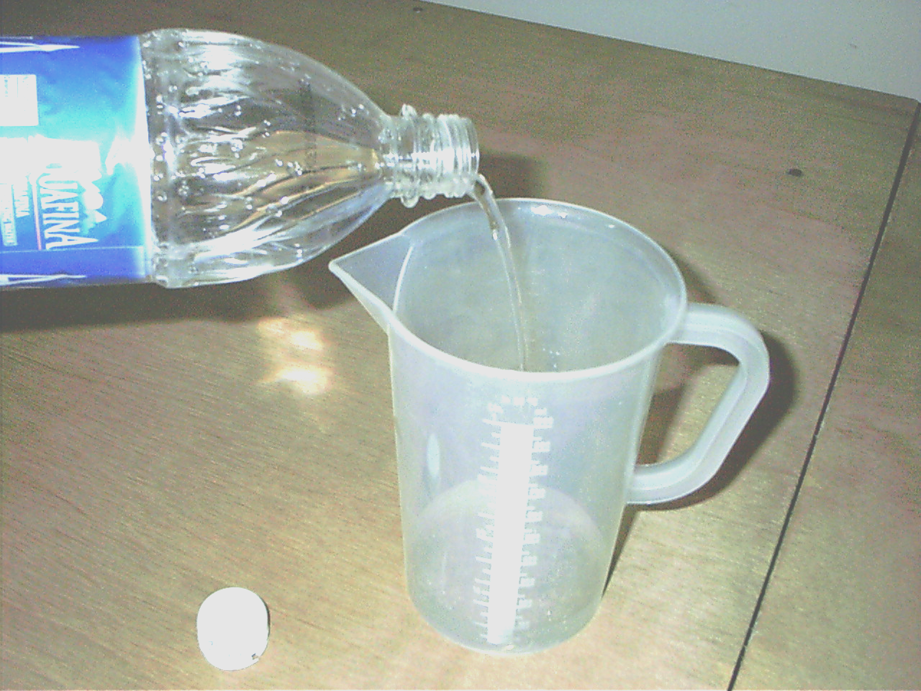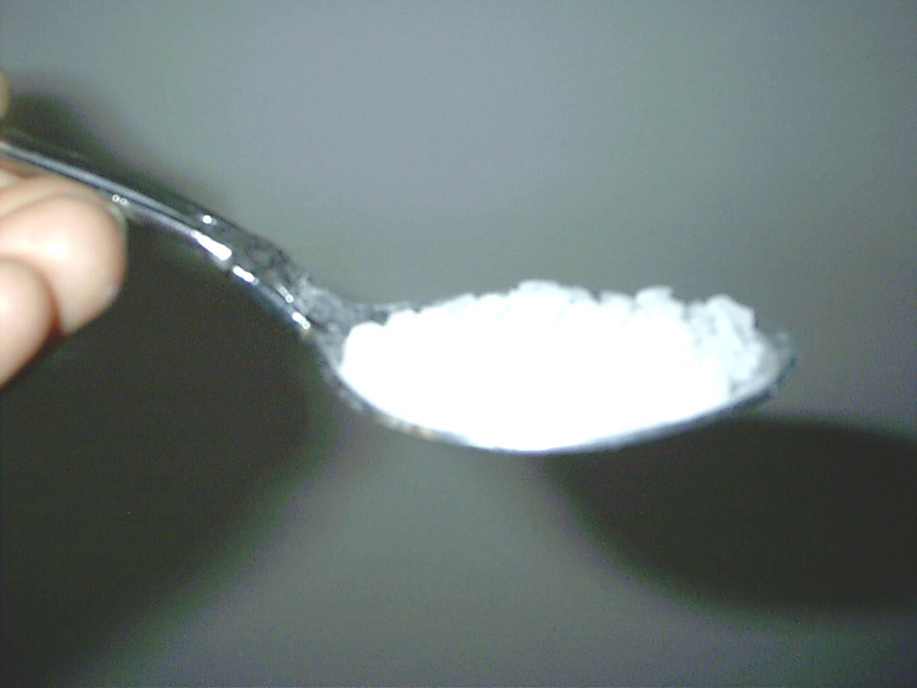

Put the Aluminium Sulphate in the jar with clean water and vigorously stir until the complete dissolution of the chemical. This solution is named
Mother Solution (MS) 1% (1 part of Aluminium Sulphate per 100 parts of water)

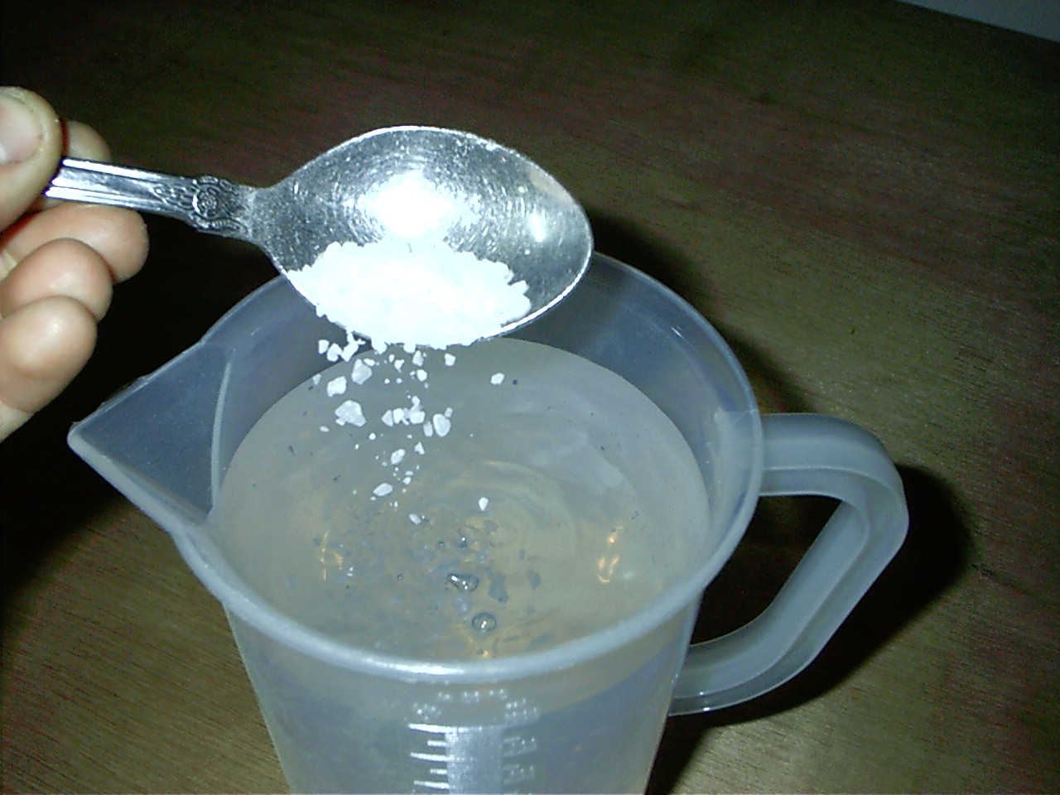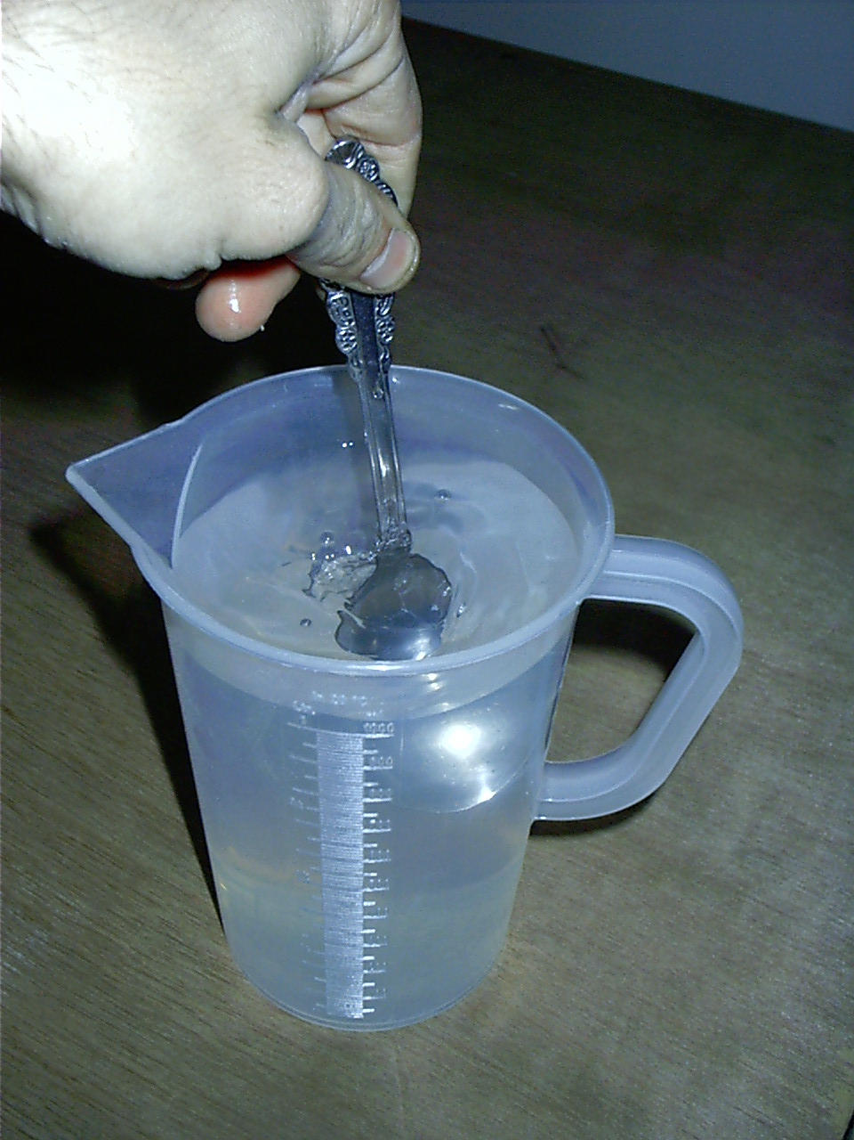

- To prepare the jars with solutions

- Fill 6 jars or bottles with 1litre of raw water per jar.

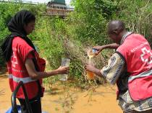

- Prepare the 5 jars or bottles with different quantities of mother solution.
The other jar will be used for comparison at the end of the process.

1 jar (or bottle): 1 litre raw water (RW) + X ml mother solution (MS)

- Use a syringe to pour the MS into the jars.
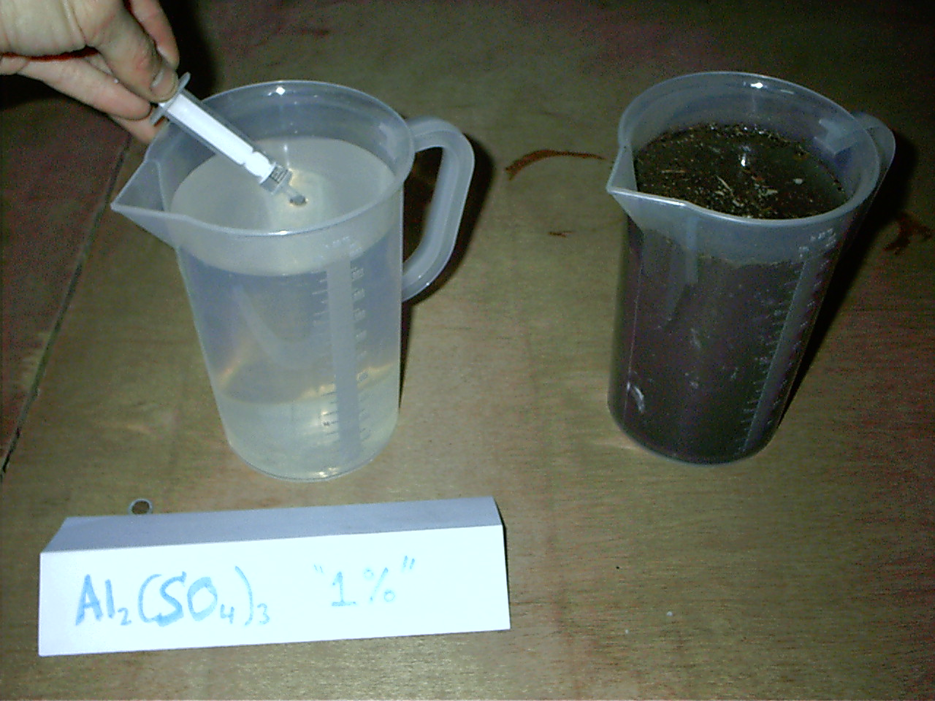

- Pour growing quantities.
Example: 1ml, 2ml, 4 ml, 8 ml, 16 ml

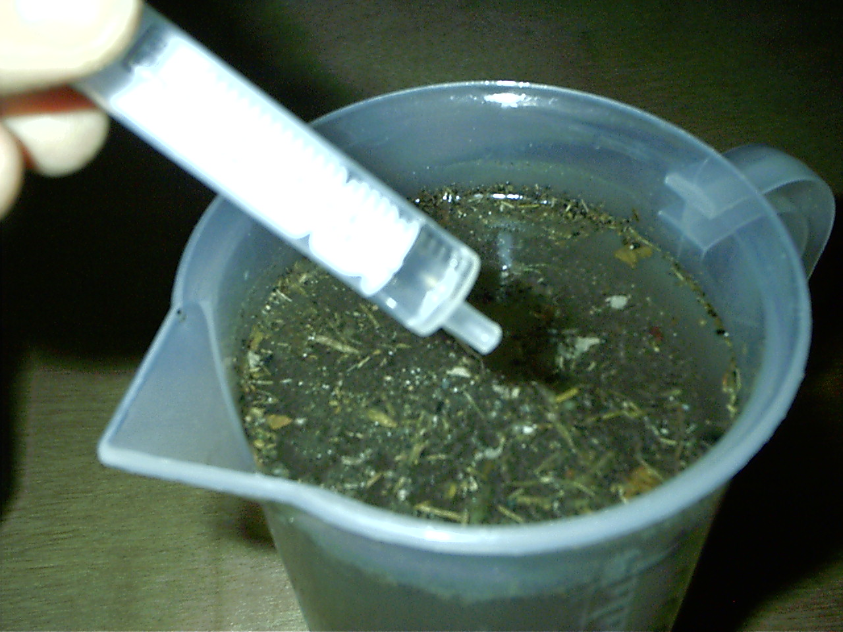

3) To choose the correct solution

After a vigorously initial stir to favour coagulation, stir very gently in the same direction for 10 min and leave to settle for 30 min.

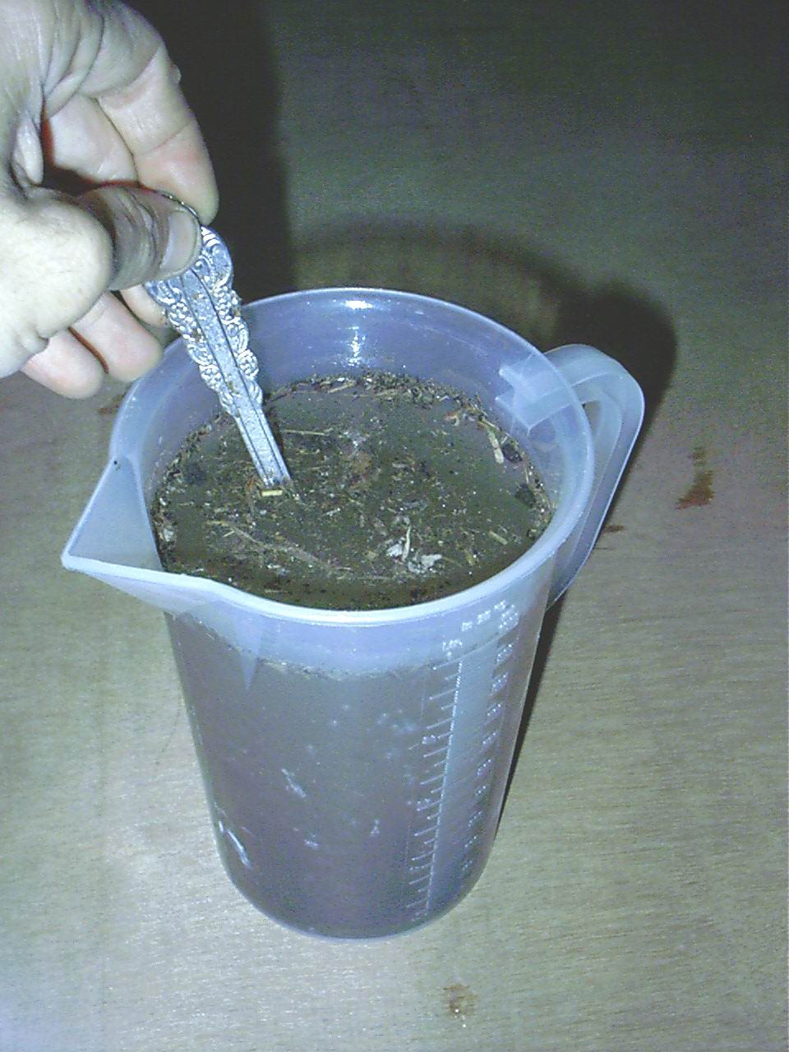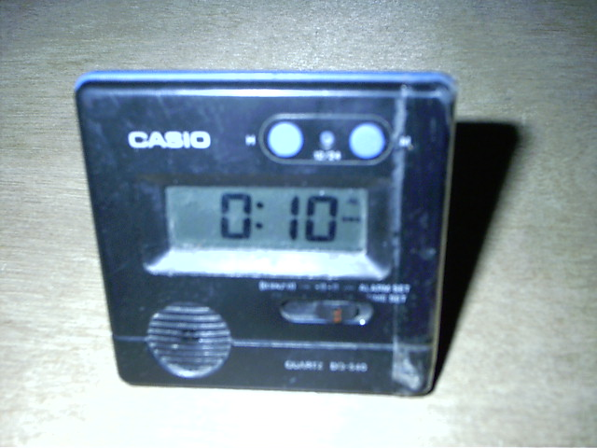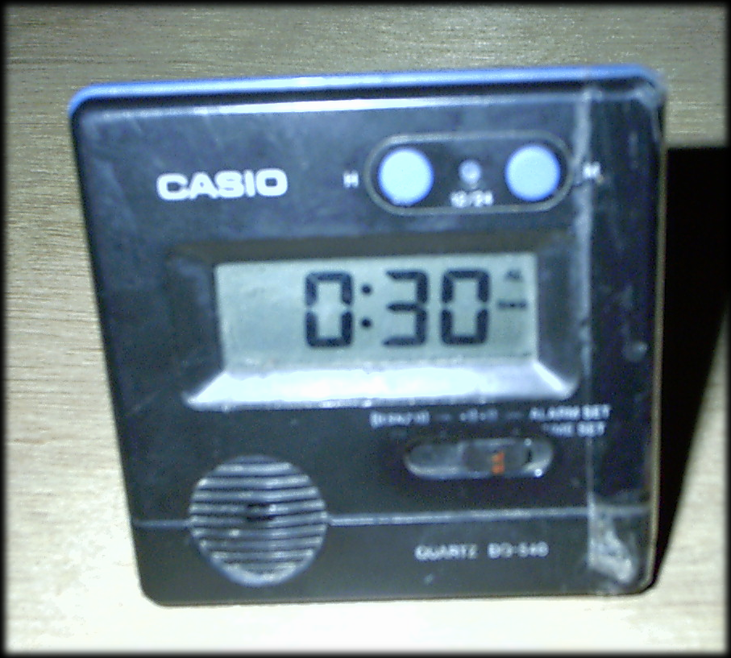

When 30 minutes, or the agreed time, have elapsed we will observe a colour gradient. We will not select the clearest jar, but the jar where less mother solution was added among those sufficiently clear.

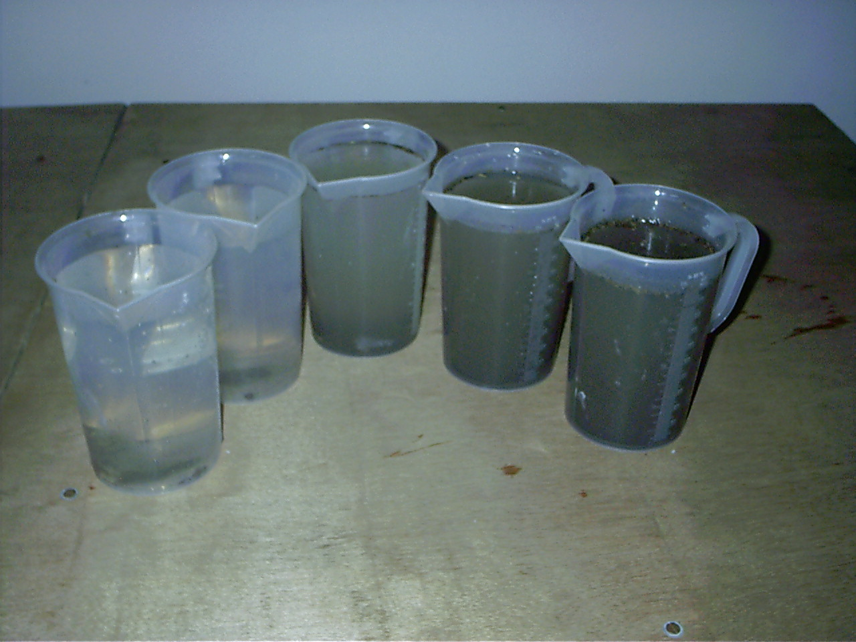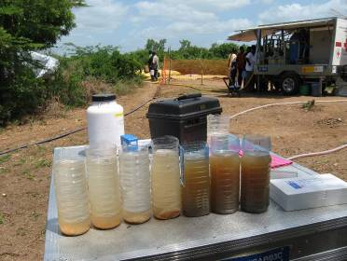

It is recommended to leave one jar (bottle) without mother solution as a comparative reference to asses how water colour changes and also to check whether particles settle in a natural manner without coagulant.

We chose the lowest possible concentration that achieves turbidity lower than 5 NTU or 20 NTU depending on mass water or specialised water. If possible we can draw the graphic that allows choosing the optimal concentration. Attention: Take the water above the sludge and avoid the dissolution of the solids. Record the data in the table of the Field Log Book.

Try to draw a graph to more accurately assess the concentration of MS to use.

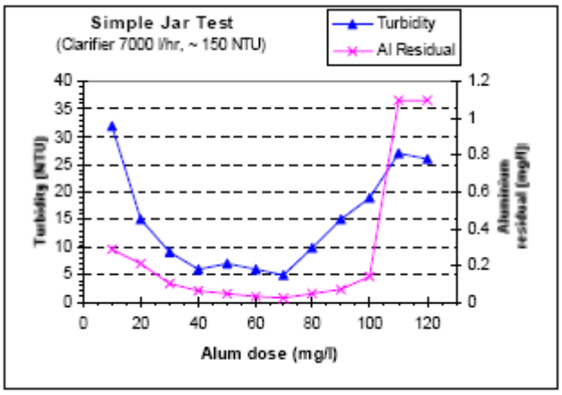

DATE__________________ SITE_____________________________________________ | Jar 6  ____ ml | ____NTU |  | DATE__________________ SITE_____________________________________________ | Jar 6  ____ ml | ____NTU
 | Jar 5  ____ ml | ____ NTU |  |  | Jar 5  ____ ml | ____ NTU
 | Jar 4  ____ ml | ____ NTU |  |  | Jar 4  ____ ml | ____ NTU
 | Jar 3  ____ ml | ____ NTU |  |  | Jar 3  ____ ml | ____ NTU
 | Jar 2  ____ ml | _  ____ NTU |  |  | Jar 2  ____ ml | _  ____ NTU
 | Jar 1  ____ ml | ______ NTU |  |  | Jar 1  ____ ml | ______ NTU
 | Solution | Turbidity |  |  | Solution | Turbidity

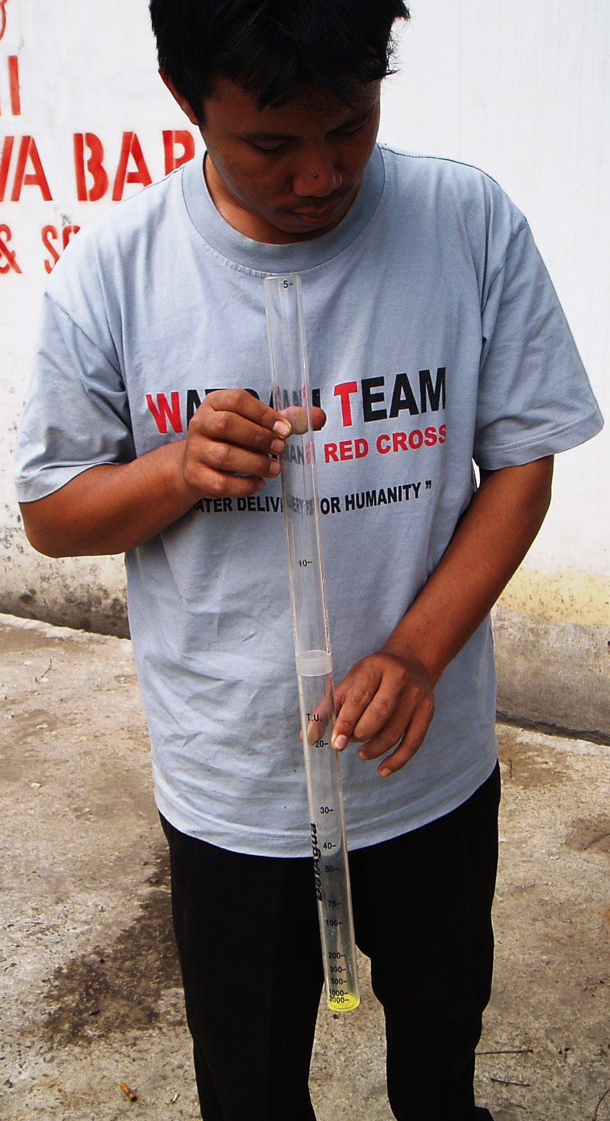

If none of the jars comes up with clear water, after checking the turbidity as explained above, we shall repeat all the process although adding 24, 34, 46, 60 and 76 ml. Only after checking again that a cleaner source is still not available.

If all are sufficiently clear, we shall repeat all the process with smaller amounts 0.1, 0.2, 0.5, 0.75 y 1 ml. Only after checking again that the source still does not meet turbidity requirements without any treatment.

4) To calculate the appropriate amount of alum to add in the pre-treatment 30,000 litre tank.

As the optimal concentration of mother solution to add in 1 litre of raw water is X ml, we calculate the amount of aluminium sulphate necessary to add in the 30,000 litre tank.

X ml jar x 30,000 litres tank volume x 1/100 = Y gr. aluminium sulphate

If we have prepared the mother solution by using spoons as the measuring unit:

X ml jar x 30,000 litre tank volume x 1/1.000 = 240 spoons of aluminium sulphate

