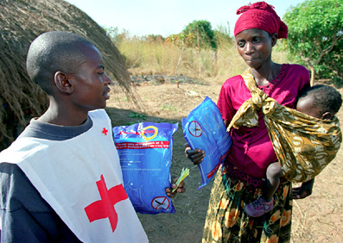
Important facts for distribution of Insecticide Treaded Nets (LLITNs/ITNs) in RC/RC operations
Attention: Head of delegations, regional relief and health co-ordinators and delegates.

Background
Malaria kills approximately one million people every year and affects 3.2 billion. It affects the most vulnerable populations with pregnant women and small children at highest risk. Malaria can be prevented by sleeping under an insecticide treated net (ITN). Since 2003, long lasting insecticidal nets (LLINs) have been more widely used and distributed. These nets give effective prevention for a minimum of three to five years and protect people sleeping in the same room. The Federation recommends distribution of LLINs whenever possible, as regular ITNs require regular re-treatment every 6 months to give full protection.

Target population
- Children under the age of 5 years
- Pregnant women

General Considerations for planning and delivery
- Always involve the national society from the beginning of the process.
- Assess local coverage rate and availability of ITNs/LLITNs to avoid duplication and parallel efforts.
- If nets already in area, it may be that the wealthier population has them (ability to buy them). Check to see if the most vulnerable have nets.
- Use national plans as basis for RC involvement and planning for community based interventions.
- Promote and distribute LLINs, try to avoid ITNs if possible as this will require continued re-treatment.
- Register all beneficiaries to avoid overlapping with other planned distributions and to facilitate for reporting on ITN/LLIN coverage rates.
- Calculate one ITN/LLIN per household and not more than 2 LLINs unless extraordinary circumstances. It is assumed that the mother sleeps together with the newborn.
- If feasible, integrate the distribution with other health interventions like vaccination campaigns, routine maternity and vaccination activities etc.
- Federation distribution of ITNs/LLINs is always free of charge.
- Distribution of ITN should always include a follow up “re-treatment” kit which can be used 6 months post delivery. These are bundled ITN + re-treatment packet.
- ITN/LLINs deliveries should be followed up with house-to-house visits to ensure proper hanging and usage. This activity can be integrated in ongoing community health programmes which include health prevention/ education activities.
- The Federation has a RC/RC malaria policy, approved January 2005.

Relief Specific Considerations
- All RC/RC distributions must be carefully co-ordinated and planned together with the health co-ordinator or the health delegate and the national society.
- Co-ordinate mapping of needs, identification and registration of target population and distribution with other partners like MoH/WHO/RBM/UNICEF and other operating NGOs.

Others
- In special and urgent situations, support for indoor residual spraying (IRS) is an acceptable activity provided it is directed by the MoH.
- The Federation is part of a global network, with weekly conference calls which ensure that all information is shared regularly about country LLIN distributions and campaigns.
- The Federation is an active partner in the Roll Back Malaria (RBM) partnership.

