

Case Study: Southern Sudan (Upper Nile)

Feedback Mechanism (1)

Introduction
In an accountable programme, beneficiaries systematically inform programme choices and implementation throughout the lifetime of the project, and are the most important judges of programme impact. The Oxfam Accountability Matrix outlines how we can achieve this. One of the areas we focus on is feedback mechanisms. Feedback mechanisms are a contextual, effective, accessible and safe way for beneficiaries to provide feedback to Oxfam. Feedback can include complaints, but can also be positive. Oxfam must ensure that feedback is recorded, reviewed and acted upon.
Feedback mechanisms can take many forms, according to what suits the community. However, ways of feeding back do not have to be complicated, as this case study shows.

Background to southern Sudan Programme

Though often seen as a post- conflict programme working with returnees insecurity & conflict has been increasing…tribal clashes, episodes of incursion by the Lord’s Resistance Army (LRA) from Uganda, & increasing tension between the north & south Sudan, which is likely to increase with the country’s financial crisis. Infrastructure is poor to non-existent, & illiteracy is very high. Funding is extremely limited, mostly through pooled funding mechanisms, which are hard to access. Oxfam Southern Sudan faces a need to continue provision of basic services & respond to more emergencies, with limited access to funds. In the last year, two out of three programmes have been threatened with closure due to lack of funds, one was saved at last minute, & the other runs out of funds in two months.

Oxfam’s Upper Nile programme is a public health programme working on – provision of clean drinking water, provision of sanitation, & hygiene promotion through community promoters. In Udier Oxfam is the only organisation in a remote location. Everything has to be flown in by small, chartered planes. Occupying a compound next to a small airstrip (below) and surrounded by a small village. Semi nomadic people occupy land nearby (right). Access to and from other villages is challenging and some villages are cut off for 4 to 8 months, as is the office if planes are unable to land.

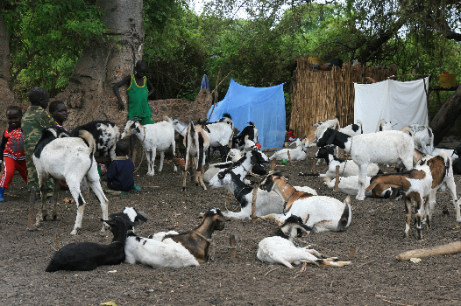

What do people do if they want to make a complaint?

‘They come to the office. They all know where the office is and come there to see us. Illiteracy is high so they can’t write…people prefer to go to Oxfam’s compound and talk to someone directly.’

Joyce Poggo, Public Health promoter

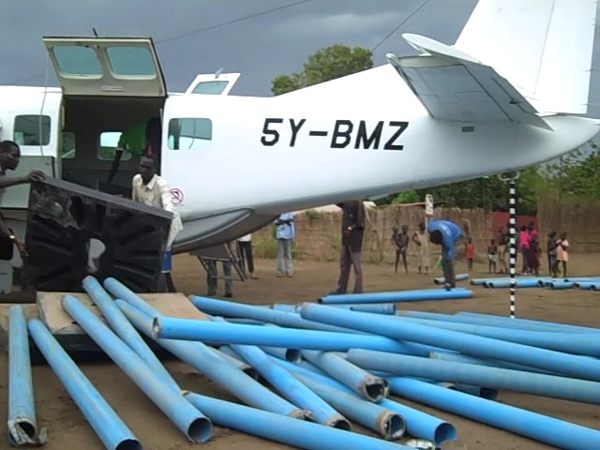

The Community living near the office in Udier

Nyancharlul (left) is a member of a semi-nomadic group camped near the Oxfam office.

What would you do if you wanted to make a complaint?
‘I can go myself to the Oxfam office and sit and tell them. I know where they are and I don’t think they can refuse me entry.’

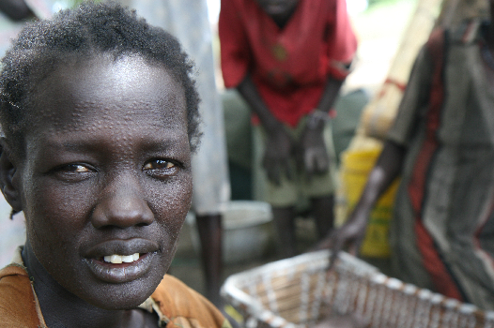

During a monitoring and evaluation advisor’s visit people were observed arriving at the Oxfam gate, being let in and waiting under a shady tree before being seen by an Oxfam member of staff.

Other related material
- Video re: women complaining when far from Oxfam office. (Cross ref: women’s empowerment/traditional means of complaining)
- Case study 04: Southern Sudan feedback mechanism (2) - Western Equatoria

