HYGIENE PROMOTION IN EMERGENCIES

A BRIEFING PAPER

This briefing paper is aimed at all those involved in facilitating hygiene improvement in an acute emergency context, especially WASH co-ordinators and programme managers. It aims to provide an overview of the focus and content of Hygiene Promotion interventions and why they must be integrated with hardware provision. More information on how to do Hygiene Promotion can be found in the resource documents listed in the appendix.

Water and Sanitation related diseases cause significant deaths and sickness in emergencies. Even without the disruption of an emergency, diarrhoea kills over 30,000 children per week worldwide. During protracted war and conflict in particular, simple diarrhoeal diseases can often kill more people than the fighting itself.

Hygiene Promotion is pivotal to a successful WASH intervention. Effective Hygiene Promotion is based on dialogue and interaction with affected communities; working in partnership with them forms the basis of accountable programming.

What is Hygiene Promotion?
Hygiene Promotion is the planned, systematic attempt to enable people to take action to prevent or mitigate water, sanitation, and hygiene related diseases and provides a practical way to facilitate community participation and accountability in emergencies.
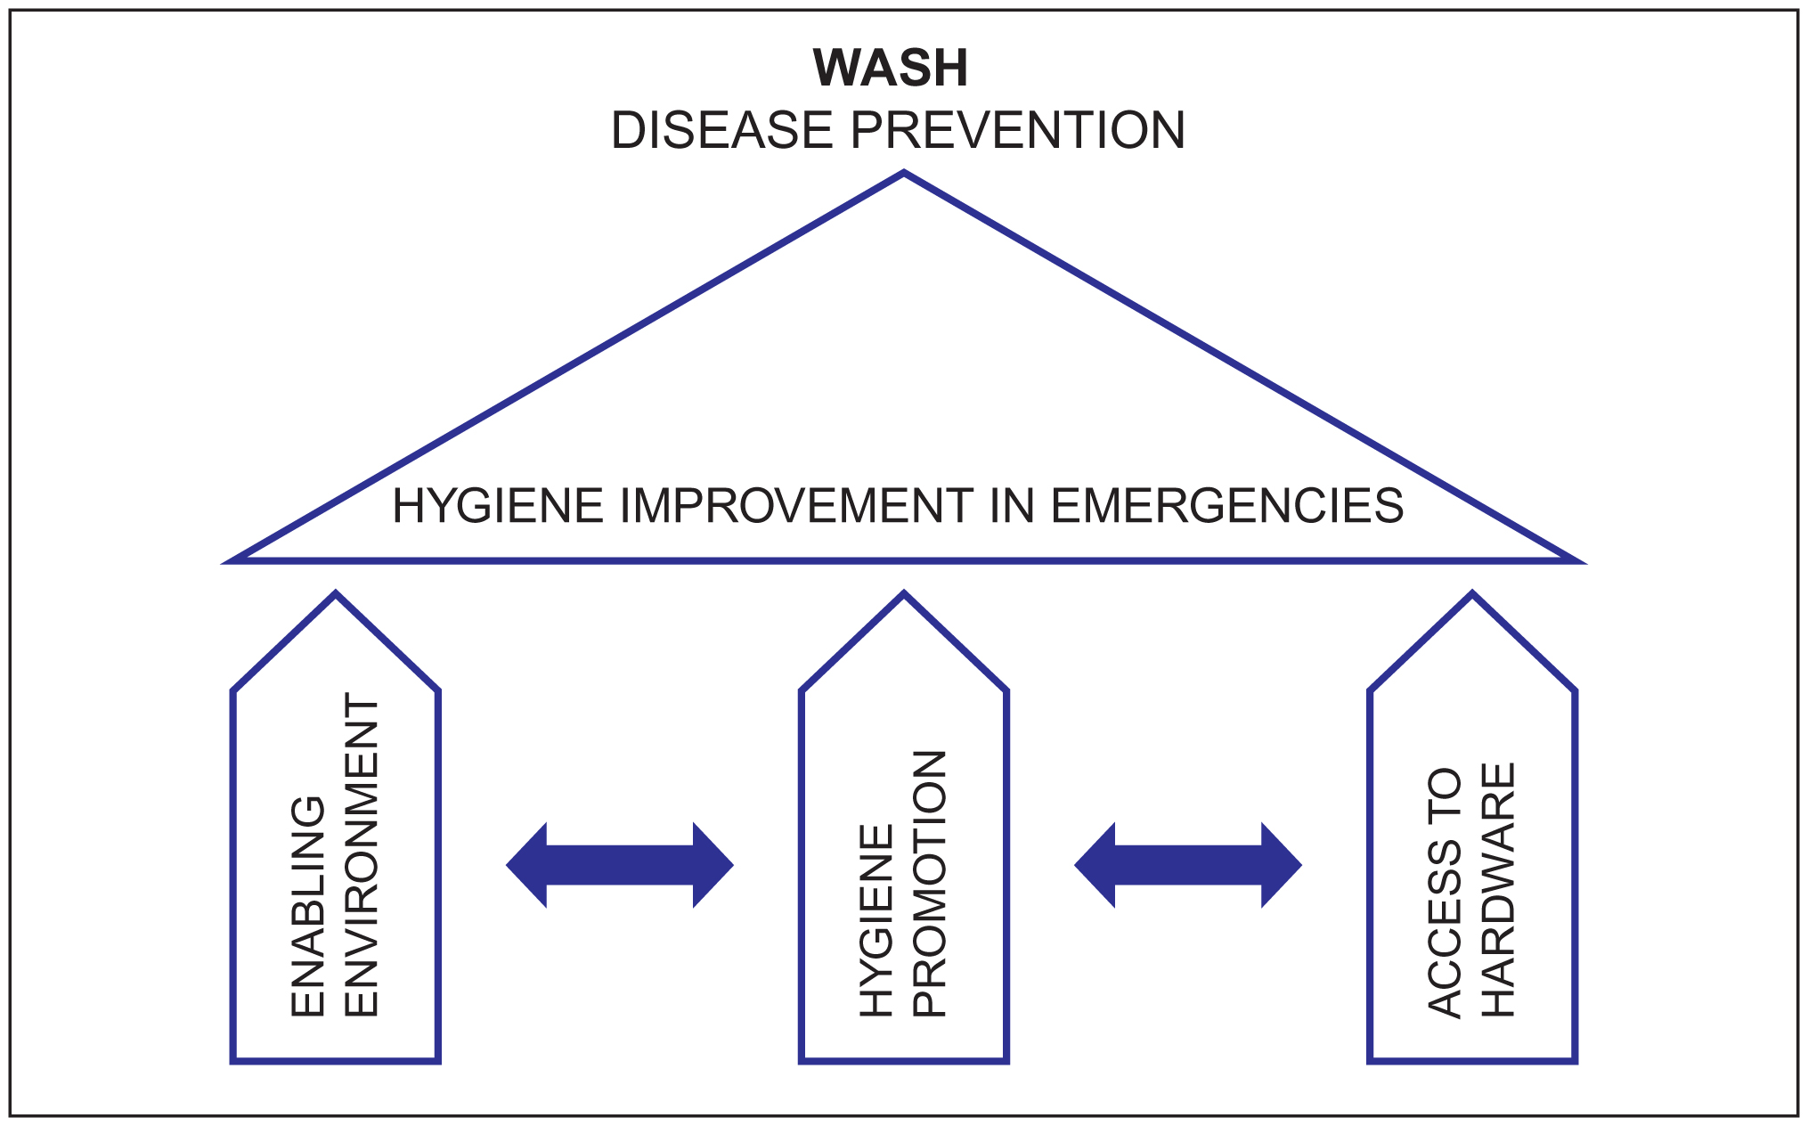

Hygiene Promotion also involves ensuring that optimal use is made of the water, sanitation and hygiene enabling facilities that are provided. Previous experience has shown that facilities are frequently not used in an effective and sustainable manner unless Hygiene Promotion is carried out. Access to hardware combined with an enabling environment AND Hygiene Promotion make for hygiene improvement as shown in the model of the Hygiene Improvement Framework for Emergencies (see below left). The overall aim of hygiene improvement is to prevent or mitigate WASH related diseases. Examples of each box in the HIF are given in the appendix.

The priority focus of Hygiene Promotion in an emergency is the prevention of diarrhoea through:
- Safe disposal of excreta
- Effective handwashing.
- Reducing the contamination of household drinking water
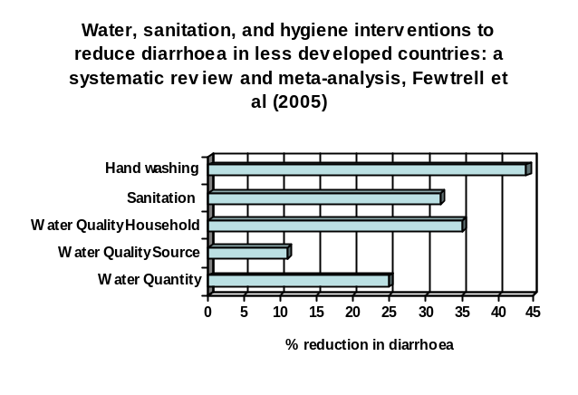The diagram below shows the relative importance of different WASH interventions and the need for Hygiene Promotion.

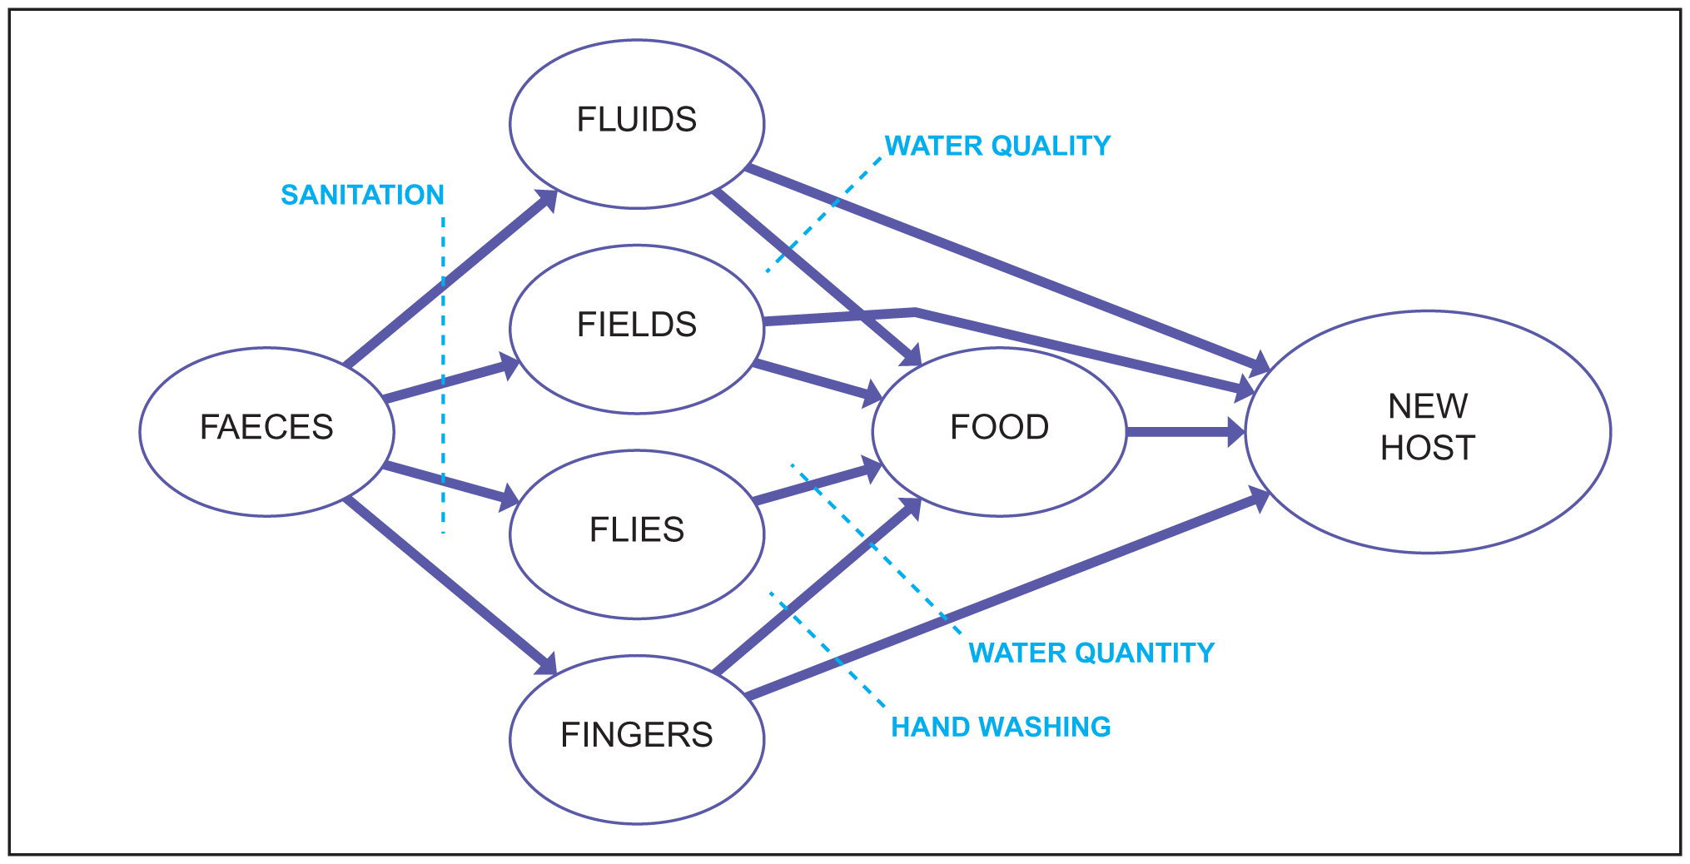
The ‘F’ diagram (left) illustrates the transmission routes of most diarrhoeal diseases and how the transmission routes can be interrupted. Although the main focus of Hygiene Promotion should be the prevention or reduction of diarrhoea, the methods employed may also be used to address other public health issues such as malaria or other water and sanitation related diseases.
Depending on the context, it may be more appropriate to focus on an environmental clean up, where the key priorities are already well managed.

Components of Hygiene Promotion

The diagram below represents the different components of Hygiene Promotion in an emergency situation and examples of the specific activities related to each component are then provided.

Community Participation e.g.:
  - Consult with affected men, women, and children on design of facilities, hygiene kits, and outreach system
  - Identify and respond to vulnerability e.g. the elderly or those with disabilities
  - Support and collaborate with existing community organisations, organisers, and communicators
Communica-tion with WASH stakeholders
Selection and distribution of hygiene items
Community Participation
Monitoring
Use & Maintenance of facilities
Community & Individual Action

Hygiene
Promotion in
Emergencies
Use and Maintenance of facilities e.g.:
- Feedback to engineers on design and acceptability of facilities
- Establish a voluntary system of cleaning and maintenance
- Encourage a sense of ownership and responsibility
- Lay the foundations for longer term maintenance by identification, organisation and training of water and sanitation committees

Selection and distribution of hygiene items e.g.:
- Decide on content and acceptability of items for hygiene kits
- Ensure the optimal use of hygiene items (including insecticide-treated bed nets where used)

Community and Individual Action e.g.:
- Apply principles of Behaviour Change Communication and Social Mobilisation
- Train outreach system of hygiene promoters to conduct home visits
- Organise community dramas and group activities with adults and children
- Use available mass media e.g. radio to provide information on hygiene

Communication with WASH stakeholders e.g.:
- Collaborate with and/or orientate government workers
- Train women’s groups/co-operatives and national NGOs

Monitoring:

Collect, analyse and use data on:
- Appropriate use of hygiene items
- Optimal use of facilities
- Community satisfaction with facilities

Whatever the focus of Hygiene Promotion, the emphasis must be on enabling and mobilising women, men, and children to take ACTION to mitigate health risks (by adhering to safe hygiene practices) rather than simply raising awareness about the causes of ill health.

Contrary to popular belief, changes in practices or behaviour do not always take a long time to occur and even short term changes can be important where the risks to public health are high. If change is enabled it can happen very quickly e.g. if handwashing facilities are provided to make it easier to wash hands. If people feel themselves to be at risk then they are also more likely to change their behaviour quickly (Rosenstock, Strecher and Becker, 1994)

How do you do Hygiene Promotion in an emergency?

A simplified model of the Project Cycle

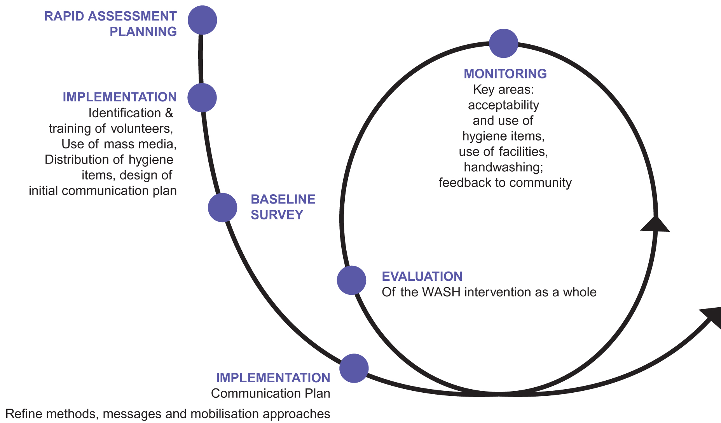

In any emergency intervention, be it chronic or acute, the hygiene promotion aspect of the programme should follow the project cycle and include assessment, planning, implementation and monitoring as shown in the diagram above.
However, in a situation where the public health risks are acute, the stages or steps in the project cycle may be condensed or may take place in parallel with each other.

Hygiene Promotion in different phases and contexts of an emergency

Emergency contexts are very varied and the specific approach to Hygiene Promotion will depend on the existing situation and what is feasible in terms of population customs, culture, and resources. The key difference between Hygiene Promotion interventions in different phases of the emergency or different contexts will usually relate to the intensity and scale of the intervention, which is dependent on the level of public health risk. In general, the early stages of the emergency will be characterised by the need to at least provide information to the affected population but as soon as possible a more interactive approach should be used. At all times the emphasis should be on mobilising people to take action.

Team Integration
Water and Sanitation personnel, be they engineers, technicians or hygiene promoters, need to work together to achieve an impact on public health and every intervention needs to address both ‘hardware’ and ‘software’ requirements. Joint work planning, field visits, and training as well as shared monitoring and reporting mechanisms will help with this.

Hygiene Promotion steps

Step | Collaboration  required | Key issues/activities | WASH resources (ensure use of government resources also)
Step 1 Assessment  Conduct rapid assessment to identify risk practices and get an initial idea of what the community knows, does, and understands about water, sanitation, and hygiene. | Government WASH team | Which specific practices allow diarrhoeal microbes/other diseases to be transmitted?  Which practices are the most harmful? | See Information Management Guidelines (WASH Cluster 2008)
Step 2  Consult women, men, and children on contents of hygiene kit | Logisticians | What specific hygiene needs do men, women, and children have e.g. sanitary towels, razors, potties? | See WASH-related Non Food Items Briefing Paper
Step 3 Planning  Select practice(s) and hardware for intervention (define objectives and indicators) | All WASH team | Which risk practices are most widespread?  Which will have the biggest impact on public health?  Which risk practices are alterable?  What can be done to enable change of risky practice? | See List of Indicators
Step 4  Define target audiences (this may be all the affected community with priority focus on those who care for young children) and stakeholders |  | Who employs these practices?  Who influences the people who employ these practices? E.g. teachers, community leaders, Traditional Birth Attendants etc. | See Annotated Bibliography
Step 5  Define initial mode of intervention  Determine initial key messages and channels of communication  Determine advocacy and training needs for stakeholders |  | What mass media methods are available? E.g. 60% of people have radios but they are often used only by men  What methods do the target audiences trust? E.g. traditional healer, discussions at women’s group meetings  Where/how can men and women be accessed? E.g. distribution queue, water point | See Annotated Bibliography
Step 6  Recruit/identify and start to train fieldworkers and outreach system | Government System/national NGOs | What capacity (systems, skills, and approaches) already exists in government/national NGOs? | See Training Modules for Fieldworkers and Mobilisers(2008)  See WASH HP Visual Aids Library  (planned 2008)
Step 7 Implementation  Begin implementation and continue assessing situation | Logisticians  Government  Engineers | Distribute hygiene kits  Emphasis initially on providing information and use of mass media e.g. radio spots, campaigns, and home visits by volunteers  Organise group meetings/interviews and discussions with key informants and stakeholders to initiate a more interactive approach. | See Annotated Bibliography  See WASH HP Visual Aids Library (planned 2008)
Step 8 Ongoing assessment  Develop baseline  Understand motivational factors/ refine key messages | Engineers | Obtain quantitative data where feasible.  Carry out systematic collection of qualitative data using participatory methods (co-ordinate with others and be careful not to overwhelm communities with over questioning)  What motivates those who currently use safe practices?  What are the advantages of the safe practices? | See Information Management Guidelines (WASH Cluster 2008)
Step 9  Monitor | Engineers | Are hygiene kits being used/are people satisfied with them?  Are toilets being used/are people satisfied with them?  Do men and women feel safe when accessing facilities?  Are people washing their hands?  Is drinking water in the home free from contamination? | See List of Indicators  See Sphere (summary in WASH HP Orientation Workshop Supplementary Materials or www.sphereproject.org)
Step 10 Implementation  Refine communication plan  Rapidly adapt intervention according to outcome of monitoring  Continue training  Continue monitoring | WASH team | Emphasis more on interactive methods e.g. group discussions using mapping, three pile sorting etc.  Identify and train (with engineers) longer term structures e.g. committees
* Adapted from Guidance Manual on Water Supply and Sanitation: LSHTM/WEDC 1998

Hygiene Promotion approaches and methods

The most commonly used approach to access the population in emergencies is that of identifying and training community outreach workers (volunteers/mobilisers/animators). If the health risks are very acute e.g. high risk of a cholera outbreak, it may be unrealistic to ask people to work for long hours for little remuneration. Payment in kind e.g. bicycle, tee shirts, hygiene items etc. may be an option but some agencies e.g. the government may not have the resources to provide financial or other incentives and unilateral decisions by incoming agencies may undermine efforts to ensure future sustainability. The issue is complex and needs to be addressed through the co-ordination mechanism. (See summary of advantages and disadvantages of paying volunteers in ‘Generic job descriptions’ paper.)
A cascade system, where outreach workers (at least 1:500 per population or more if intensive work is required or if populations are spread out), are supervised by trained hygiene promoters who are supported by skilled professionals, is the most common model used, but others are possible. A network of peer educators might also be established e.g. teenagers or young mothers. Hygiene clubs could also be established in each affected area. A key aspect of the initial Hygiene Promotion assessment is to identify existing local capacity and skills.

Cascade Outreach System

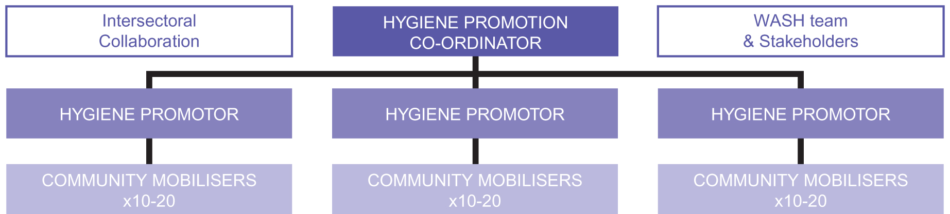

It is recommended that both the available mass media (e.g. radio or leaflets) AND other more interactive methods are employed (see orientation workshop). Even in an acute emergency some initial discussions with individuals and community groups can take place and as the emergency evolves more widespread use of methods that foster discussion should be encouraged.

Participatory methods that focus on interaction with the affected community are often the most successful in achieving changes in practice. However, there is a trade off between ‘reach’ and effectiveness and the more participatory approaches are often time consuming and labour intensive whereas the dissemination of messages via the mass media will reach more people, more quickly, but may be less effective in achieving the desired outcomes.

Among the most useful participatory methods are ‘community mapping’ exercises, focus group discussions, exercises using visual aids to stimulate discussion and mobilisation activities such as three pile sorting, chain of contamination, and pocket chart voting. An assessment of the existing resources available for hygiene promotion is important as this will help to ensure that culturally appropriate methods and tools are employed.

It is important to note that health benefits are not always the main motivating factor for changes in behaviour. The need for privacy and safety, convenience, social status, and esteem may sometimes be stronger driving forces than health arguments.

Appendix 1: Supporting materials

- A rapid staff orientation package focusing on how to engage women, men, and children in WASH interventions, with materials for individual or group inductions and an outline for the content of a half-day workshop for managers, health promoters, and engineers. These materials aim to create awareness and commitment to WASH interventions. This includes an outline, handouts, facilitator’s resources and a powerpoint.

- Menu of indicators for monitoring hygiene promotion, for use by field practitioners and promoted by WASH coordinators.

- Annotated Bibliography A list of hygiene promotion tools and resources, (books, manuals, training modules, audio visual materials) as reference materials for WASH coordinators and others.

- List of Essential Hygiene Promotion Equipment for Communication to inform WASH coordinators and guide field implementing agencies.

- Hygiene related Non-Food Items Briefing Paper A briefing paper that aims to ensure that the distribution of hygiene related non-food items (NFIs) achieves maximum impact.

- Generic job descriptions and overview for field hygiene promoters and community level mobilisers that aim to inform and guide WASH coordinators and implementing agencies to encourage consistency and minimum standards.

Appendix 2: Example Hygiene Improvement Framework for emergencies
Below is an example of how the Hygiene Improvement Framework might look in an emergency context. As with any model it is not perfect and is open to interpretation. However, it provides a useful overall framework that can help to set the hygiene promotion work within the context of the integrated WASH intervention.

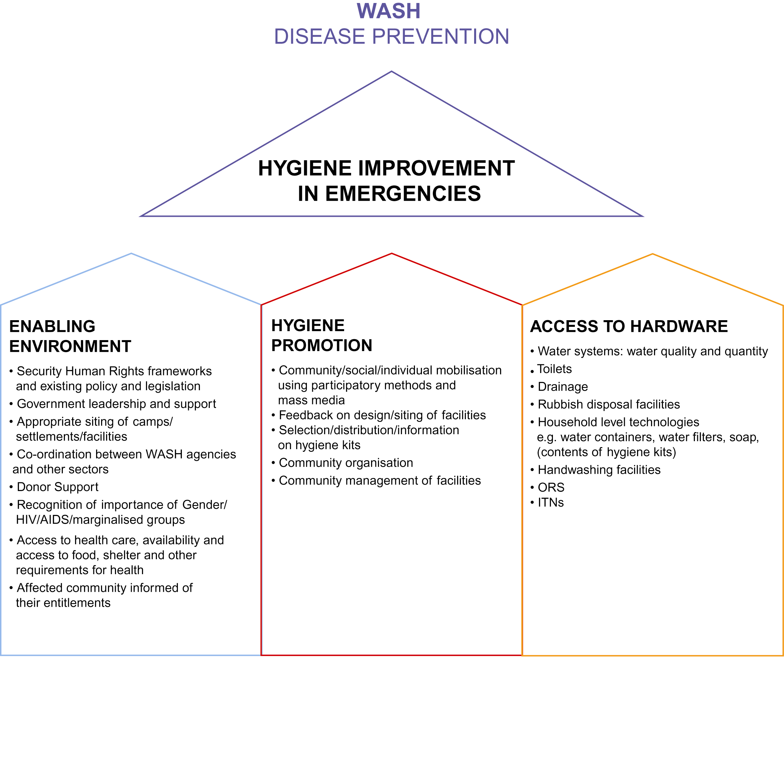

*NB In some agencies, different sectors will take primary responsibility for the provision of Oral Rehydration Sachets (ORS) and Insecticide-treated Nets (ITNs).

December 2007

See Sphere Standards
Example indicators for these objectives can be found in the List of Indicators
The ratio of 1:500 people is suggested as the minimum level of intervention by Sphere

