‘Look-Back’ Study
Executive Summary
Water supply, sanitation and hygiene promotion (WASH) programming in Ivory Coast under the Nestle/IFRC Partnership
By
A multi-sectoral team from CICR; IFRC and an external Observer.
December 2017

Acknowledgements

To all CICR volunteers and staff from field to HQ level, our IFRC WASH Team in Ivory Coast and from Geneva, Nestle and our external observer. Thanks especially to CICR HQ and Branch level who supported all the logistic arrangements for the field mission and ensured the timely access to essential document’s,

Our sincere gratitude to all those respondents, participants, key informants and stakeholders who made a positive contribution towards the study at household and community level and with Government officials.

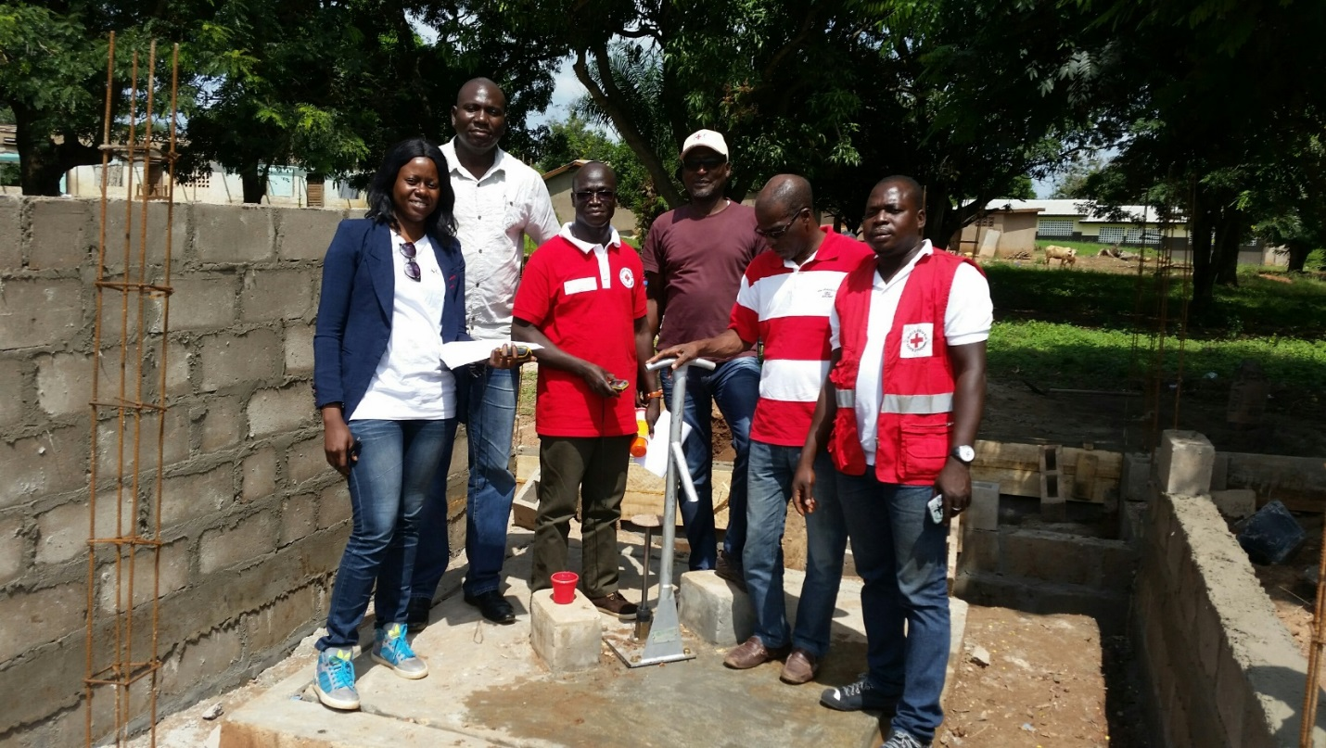

Some members of the study team at a Nestle sponsored school and new water supply donated by Nestle staff.

Note: The study collected a significant amount of data that needs to be further elaborated and analysed, this executive summary provides a snapshot at this stage, but captures the major findings and recommendations,

Acronyms

CBM Community Based Management
CICR Red Cross Society of Ivory Coast
CLTS Community Led Total Sanitation
FGD Focus Group Discussion
GWSI Global Water and Sanitation Initiative
HH Household
HQs Headquarters
IFRC International Federation of Red Cross and Red Crescent Societies
JMP Joint Monitoring Programme
MDG Millennium Development Goals
SDG Sustainable Development Goals
O&M Operation & Maintenance
PHAST Participatory Hygiene and Sanitation Transformation
WASH Water, Sanitation and Hygiene promotion
WPC Water Point Committee

Background

- Look-back methodology

The International Federation of Red Cross and Red Crescent Societies (IFRC) has supported the implementation of Water, Sanitation and Hygiene (WASH) projects for many years in different parts of the world within the framework of the Global Water and Sanitation Initiative (GWSI). Past evaluations of those programmes have been undertaken immediately after an intervention so it has been in most of the cases difficult to assess in detail the changes and impact associated to the project since they may take many months or even years to become apparent. It has also been challenging to assess, right after project completion, at what extent communities and local authorities are truly self-sufficient in operating and managing the facilities provided by the intervention, and how changes in access to safer water sources and hygienic (improved) sanitation services are sustained in the target area.

With the ‘look-back’ methodology, the IFRC intends to provide a framework for a post-project evaluation. The purpose of the methodology is to facilitate, through a set of standard tools and guidance, a better understanding of the long-term impact of a WASH intervention and the sustainability aspects of that intervention after at least 3-4 years after project completion. Through the look-back study, the assessment of impact examines the longer-term consequences of achieving or not achieving the general (immediate) objective, linked often to health impact but also covering issues of wider socio-economic and socio-cultural change. The assessment of sustainability looks at the long-lasting structures and resources that help the community to become less dependent on external assistance.

The ‘Look Back’ team in this case visited 87% of all known Nestle funded water points and 95% of all school latrines constructed by the Nestle project. The team all in all spent over 28 days in the field.

- The Nestle/IFRC partnership

Vulnerable, mostly rural farming communities in Ivory Coast have benefited from a long term (ten year) commitment by Nestle and the CICR/IFRC consortium to improving sustainable WASH access, initially during a time of social, economic and political unrest and subsequently as the country recovered from that period and up to the present time. Despite overall improvements in the country many people still face the daily drudgery of obtaining water from long distances that is often not safe, have no or very limited sanitation which combined with poor hygiene practices are the second highest contributor to morbidity and mortality (especially in children under five). Apart from the health impact, the consequences reduce productivity, erode developmental efforts, have a negative impact on women and children especially while undermining human dignity. Access to WASH services are therefore a globally accepted human right. The Sustainable Development Goals (building upon the Millennium Development Goals gains up to 2015) therefore have set a clear target of universal access to WASH by 2030, one which the partnership is committed to continue contributing to in a sustainable, relevant and replicable manner.

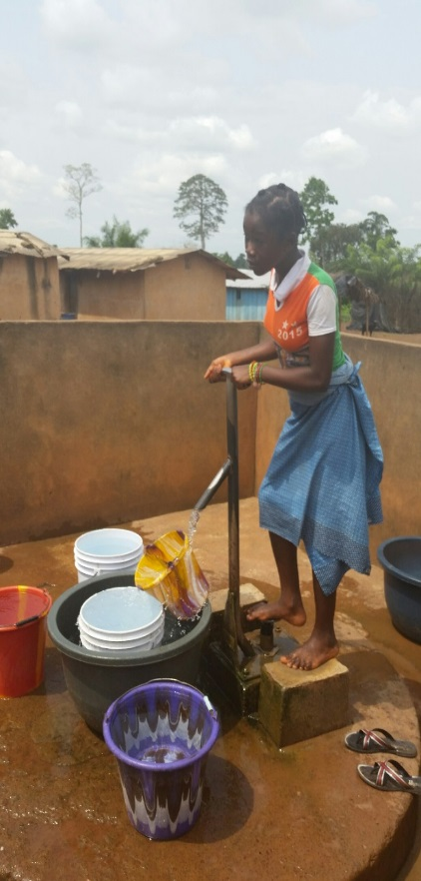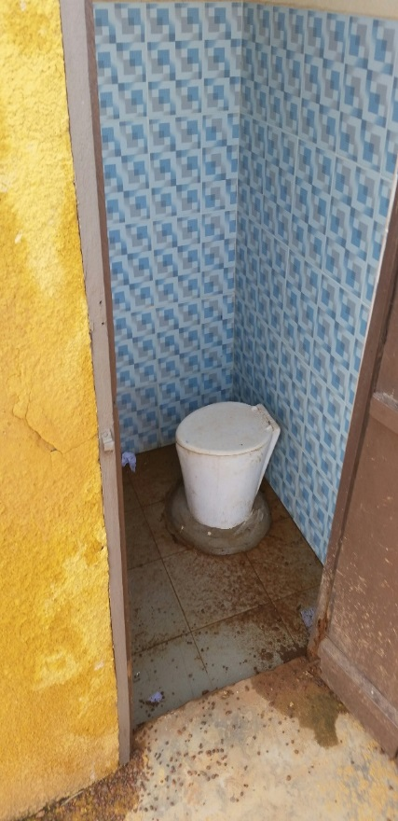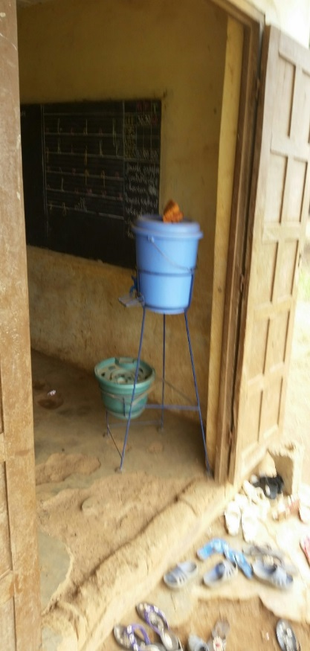

Water Sanitation Hand Washing

What did the ‘Look Back’ study focus upon?

- Verifying location, quality of construction, present condition and use, and degree of sustainability since construction (water supplies and school latrines).
- Referencing project documentation and reports against actual physical outcomes.
- Measuring the effectiveness of community structures in achieving sustainability.
- Meeting and gaining insight from community members, leaders and staff of schools and health centres.
- Meeting and gaining insight from Government officials.
- Visiting, meeting and observing CLTS communities.
- Identification of project successes and failures leading to general and specific recommendations
- Consideration of sustainability options for the overall investment in the long term.

Executive summary

4.1 WATER SUPPLY SUSTAINABILITY: The community/village level water points constructed/rehabilitated by the project (Phase 3 and 4) totalled 126 water points of which 109 were inspected. The finding was that 87% of the water points were functional and being used of which 36% may need maintenance soon. This is well above the GWSI minimum target of 70% and shows a significantly high sustainability rate. Water Points recorded in documentation and mapping during the project period showed very few anomalies, for the most part anomalies were related to some cases of place names being unclear (e.g. different ethnic groups having different names for the same location). The finding was that project data was over 97% accurate.
Post implementation period follow-up and monitoring at community level by CICR and IFRC was very limited during 2017 (although over 80% of communities had been visited at least once by CICR/IFRC, for the most part these very brief visits only monitored the WASH infrastructure condition, without taking any remedial, if needed, action). In a sense this encouraged communities to undertake their own operation and maintenance activities when it was clear that approaching the CICR for assistance was not feasible. During the implementation period it was more common for communities to seek assistance from us.
KEY SUCCESS FACTORS:
- The finding was that the Government decision to standardise handpumps (‘Vernier’ type) though relatively expensive was the correct decision, the pumps so far have proven hardy, well accepted and with a low repair and maintenance demand.
- It was also a crucial success factor that the project adhered to Government standards not just in pump type but in construction methodology and quality. Water Points were inspected by Government to ensure such standards were met the finding therefore that close cooperation/collaboration with Government brings dividends and raises standards.
- Aprons inspected apart from very few (less than 5%) were sound and did not allow surface water pollution of the aquifer. This underlines other studies that have shown water quality at point of collection is high and indeed contamination is almost certainly during or post collection.

KEY CHALLENGES and RECOMMENDATIONS:
- Through FGD’s and meetings with community members and leaders it was found that smaller and less densely populated communities generally found it harder to operate and maintain water points due to the smaller pool of motivated community members also having a lower existing or potential economic capacity. These criteria were noted where water points had failed for one reason or another and in the few cases (less than 5%) where water points had been out of operation for long periods (more than 3 months).
- The geographic spread and logistic costs and challenges of the chosen target areas suffered much from a lack of centralisation. This reduced significantly cost effectiveness and impact measurement also hindering (especially in the wet season due to poor road conditions) the regular follow-up required to reinforce both hardware maintenance (CBM community based management) and hygiene related activities including CLTS efforts.
- As water pumps age we can expect more failure or need to repair however, reinforcing preventative maintenance should be considered as follow-on sustainability activity.
- More wealthy, larger and peri-urbanised or fast-growing communities in future should move to centralised systems being potentially more efficient and cost-effective, such as proposed for Ghana Phase 2.
- Future projects must reduce target areas geographically or significantly increase the investment level or seek partnership opportunities with other WASH-actors to increase scale of intervention.
- The continued sustainability project in Ivory Coast which we recommend has a no cost extension to end of June 2018 should visit those few sites where we were unable to reach due to poor roads and weather conditions and continue general monitoring and evaluation of previous inputs to the target areas,

  - SCHOOL LATRINES; HAND WASHING; SOLID WASTE MANAGEMENT; HYGIENE CLUBS.

The project constructed/rehabilitated 104 school latrine blocks of which 99 were inspected. It was observed that out of those inspected 69% were in use, in acceptable sound construction or condition and with an acceptable level of cleanliness. Very few were not constructed well initially (less than 5%) but a higher number were in poor repair (cases of doors being damaged 24%) and this linked to some cases where latrine use was restricted to teachers only. It was a clear finding that in many communities visited the only well-constructed and permanent latrines were those constructed by this project located at the schools. Some cases were noticed that the school latrines were overused by the whole community rather than just pupils and teachers.
KEY SUCCESS FACTORS:
- The introduction of permanent latrines be that for the schools or the communities around the school was well appreciated but their impact is somewhat lessened by the fact that latrine coverage is still woefully low to have a long-term impact. Some schools where the latrine use was strictly restricted to pupils and teachers were for the most part kept clean or well maintained. However, increased latrine coverage in schools will be needed in any case as the school population in most schools is well above the available latrine coverage.
- Though using local contractors was perhaps the best way forward in a project with a large geographic spread which could be replicated, it does have cost implications making latrines more expensive than they need to be if we had reduced the geographic spread.
- For the most part the latrines were seen by school bodies as a real step upwards in the sanitation ladder and for the most part have been looked after and are used well. This combined with hygiene clubs and activities, the provision of handwashing facilities, solid waste disposal and ‘clean up ‘campaigns have in some school environments showed overall impact. This was especially evident at Nestle sponsored schools that were almost invariably having a high standard in sanitation and hygiene.

Hygiene Club Leader and members. Latrines under inspection,
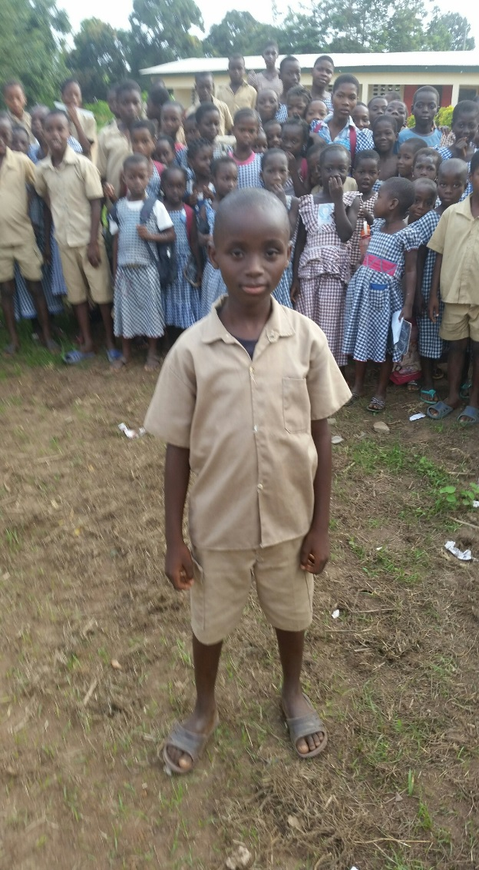
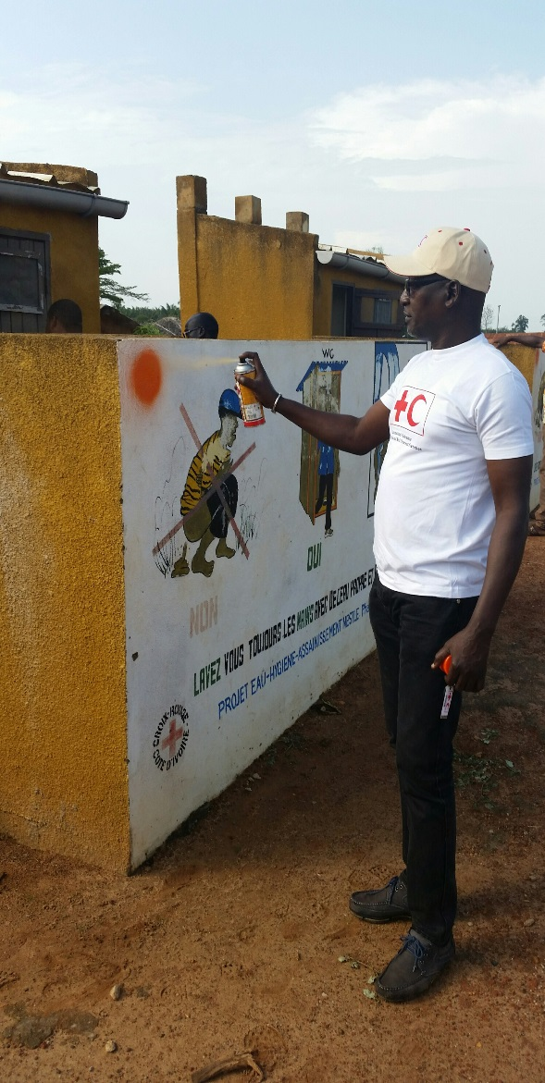

- Solid waste containers and pits were observed in over 80% of schools visited and for the most part regular ‘clean-up’ campaigns are carried out.
- The study team, arriving at schools unannounced, were pleased to see in many cases good environmental conditions.

KEY CHALLENGES and RECOMMENDATIONS:
- Where Latrines were open to use by anybody at any time, the repair and cleanliness conditions were generally lower, even to the extent they were not used at all. School latrines must be managed and controlled by the teachers and/or pupils to avoid this happening.
- Where water supply is not available in or near to the school, hand washing is limited. Future projects should ensure water supply preferably within school premises if handwashing is really to take hold. This again may lead us to consider more centralised water supply systems in future.
- Hygiene clubs and activities are popular but only work effectively when teachers are empowered and active in supporting pupils on a regular basis,
- CLTS for the most part appears to have limited medium or longer-term impact. Those communities where the Nestle project triggered CLTS need to be revisited and a more in-depth study undertaken to determine what is best in future, however, Government is still committed to CLTS and despite advocacy and lobbying by CICR, IFRC and other WASH actors there seems to be no change in Government policy at present.

5.0 OVERALL CONCLUSIONS:
- Water supply relevance and sustainability was successful, though still challenging for the poorest or remotest communities. For those communities increasingly urbanised, future projects should move to centralised systems.
- School interventions must include a dedicated water supply or at least a water supply near the school to encourage hand washing.
- Sanitation is still a major concern and even if safe water supply coverage increases, post collection contamination due to poor sanitation and hygiene will continue to undermine water development activities and health benefits.
- Projects must be comprehensive WASH projects, inclusive of all three WASH components, and with increased emphasis on sanitation and hygiene.
- Geographic area must be reduced in future projects to maximise impact and cost-efficiency.

Road conditions restrict access and makes access more time consuming and costly:

