ORAL
CHOLERA VACCINE (OCV) FIELD MANUAL FOR
VOLUNTEERS

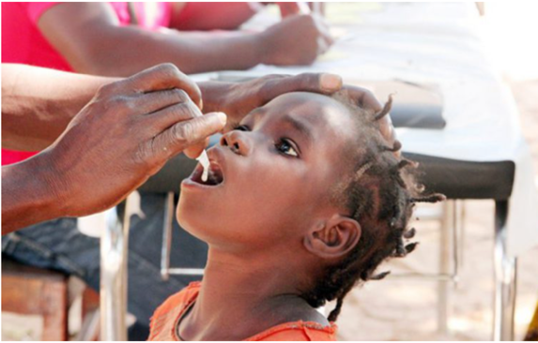

WHAT CAN YOU FIND IN THIS FIELD MANUAL ?

1. What is the Oral Cholera Vaccine and what does it do?....................... 1
2. Eligible population…………………………………………………………………………………… 1
3. The vaccine................................................................................................................ 2
A. Euvichol-Plus: key information………………………………………………………. 2
B. Shanchol: key information………………………………………………………………. 2
4. Effectiveness and duration of protection…………………………………………… 3
5. Vaccine safety ………………………………………………………………………………………….. 3
6. Oral Cholera Vaccine Campaigns ………………………………………………………… 4
7. Before the campaign………………………………………………………………………………. 4
8. During the campaign …………………………………………………………………………….. 6
9. After the campaign…………………………………………………………………………………. 9
10. Frequently Asked Questions........................................................................... 10

WHAT IS CHOLERA?

Cholera is an acute diarrhoeal infection caused by ingestion of food or water contaminated with the bacterium Vibrio cholerae. Its main symptom is acute watery diarrhoea and severe dehydration (loss of liquid). Not everybody that gets infected with cholera develops symptoms but still, they can contaminate other people. The majority of people can be treated successfully through prompt administration of oral rehydration solution. However, people with severe dehydration are at risk of shock and require the rapid administration of intravenous fluids in a health care facility. Good hygiene practices and water treatment is key in the prevention and containment of cholera.

1. What is Oral Cholera Vaccine (OCV) and what does it do?

- OCV protects people from getting and developing severe forms of cholera and from spreading cholera to others.
- OCV consists of inactivated (killed) bacterial cells which cannot become virulent or cause cholera.
- OCV is not part of normally scheduled vaccination. In response to or in the prevention of a cholera outbreak, a massive OCV campaign occurs when authorities vaccinate as many people over one year of age as possible in a short period of time.
- OCV offers direct protection to those who have been vaccinated. People vaccinated with OCV can provide also indirect protection for those people that cannot be vaccinated. The risk of getting cholera in unvaccinated people decreases the more people get vaccinated because it reduces the amount of V. cholerae in the community. In a vaccination campaign, usually, the most vulnerable and most exposed people will receive first a vaccine. This includes medical staff treating patients, children under the age of 5 years, pregnant women and people with pre-existing medical conditions. Indirect protection is especially important for those who cannot take the vaccine, mainly those under the age of 1 year.
- The OCV is taken orally (by mouth), which means that the vaccine sites itself in the intestine which is where V. cholerae locate themselves and multiply. This way, the vaccine helps to repel the V. cholerae entering the body.

2. Eligible population

- EVERYONE aged 1 year and above. [for Euvichol-PLus and Sanchol]
- The intestine of babies under one year is not yet strong enough to cope with the vaccine.
- Pregnant and lactating women can be given the vaccine safely. The OCV remains in the intestine of the mother and does not pass into the blood, the placenta, or the milk.
- [Dukoral is allowed to individuals over the age of 2 years].

Not recommended to vaccinate
- Individuals who have an acute illness (not limited to cholera) should not be vaccinated.
- OCV vaccination must occur at least 14 days apart from COVID-19 vaccination.
- Although it is safe, some countries recommend not to vaccinate pregnant women.

ALWAYS FOLLOW THE RECOMMENDATION OF THE Ministry Of Health.

3. The vaccine

To date, there are three eligible cholera oral vaccines (Euvichol-Plus, Sanchol and Dukoral) but only two form part of the OCV stockpile. Be informed which vaccine will be given in your district/country.
Oral cholera vaccines are easy to administer and have a reduced risk of transmitting blood-borne infections.

A. Euvichol: key information

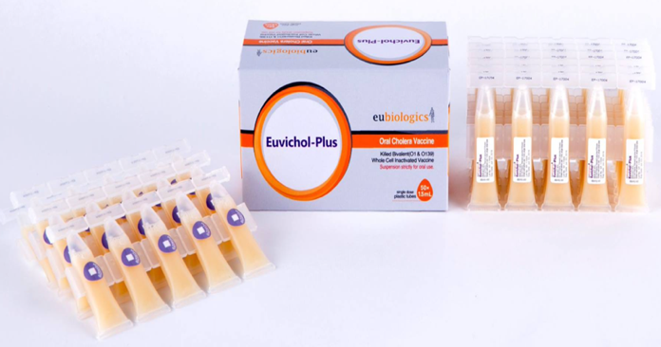

- Can be given orally to anyone above the age of 1 year.
- It is packed in a plastic tube of 1.5ml (monodose). The vaccinated person has to drink all the content – not drops like polio!
- 2 doses are needed, with a minimum of 2 weeks and up to 6 months between each dose.
- No fasting is needed before vaccination.
- No need to administer the vaccine with water, although some people prefer to take it with a sip of water.
- The vaccine should be stored between 2 and 8 degrees Centigrade and should not be taken if frozen.
- Those taking the vaccine should remain under medical supervision for the time indicated by the Ministry of Health after administration.

More info: “2017 WHO Position Paper on Cholera Vaccines” http://apps.who.int/iris/bitstream/10665/258763/1/WER9234.pdf?ua=1

B. Shanchol: key information

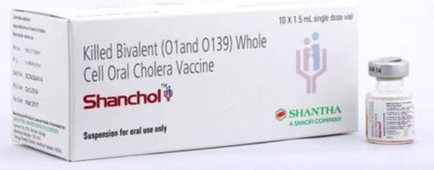

- Can be given to those of 1 year or older.
- It is packed in a glass vial of 1.5 ml (single dose). The vaccinated person has to drink all the content – not drops like polio!
- Consists of 2 doses, given a minimum of 2 weeks and up to 6 months between each dose.
- No fasting is needed before vaccination.
- No buffer solution. Swallow and follow with ingestion of water if desired.
- Store OCV vials between 2/8°c but it allows storing at room temperature (up to 37°c) during 14 days (2 weeks).

- It will be discontinued beginning in 2023 !

4. Effectiveness and duration of protection

- 1 dose provides protection for up to 6 months.
- 2 doses are recommended for the longest protection up to 3 years.
- The second dose should be given at least 2 weeks and not more than 6 months from the first dose.
  - If the second dose cannot be delivered within 6 months, a total of three rounds of vaccination will need to be conducted to obtain the protection of up to 3 years.
- It tends to be more effective in those over 5 years old.
- The vaccine needs 7 to 10 days until the onset of protection.
- The protection is not full, and does not cover other causes of diarrhea, so hygiene guidelines around water treatment, handwashing and food hygiene should always be followed.
- Single dose effectiveness in individuals older than or equal to 1 year old was:
- 40% against all cholera episodes
- 63% against severely dehydrating cholera episodes
- If a vaccinated person gets cholera, they will not develop a severe form of the disease.

5. Vaccine safety

- OCVs are very safe vaccines. No one has become ill with cholera from the vaccine.
- No serious adverse events were reported from various mass vaccination campaigns (around 25 million doses used globally).
- Sometimes there is a minor side effect to the vaccine, in about 4 in 100 people (3-4%) who experience:
  - Vomiting
  - Mild gastrointestinal discomfort
  - Mild diarrhea
These symptoms are very rare and only experienced for a short time.
- Sometimes children do not like the taste and spit it out (adults don’t like it either!), but this is not considered an adverse event.
In such an event, seek your supervisor for guidance!

6. Oral Cholera Vaccine campaigns

A vaccination campaign refers to the process and the set of activities that will lead to the vaccination of the targeted population at the appropriate time.

There are two sorts of OCV campaigns:
- “Reactive” campaigns (during an emergency). To help fight cholera where there is an outbreak.
- “Preventive” campaigns (prevention). In anticipation of an outbreak to stop it from happening.

OCV campaigns typically happen in 2 rounds of vaccination (2 doses) separated by 2 weeks and up to 6 months. They are rolled out in hotspots of cholera, and the MOH decides where, based on the number of cholera cases and deaths due to cholera in past and current outbreaks. If someone misses the vaccine, there will not be an opportunity to take it next year, as OCV campaigns rarely revisit a district and certainly not for many years.

Key moments in a campaign
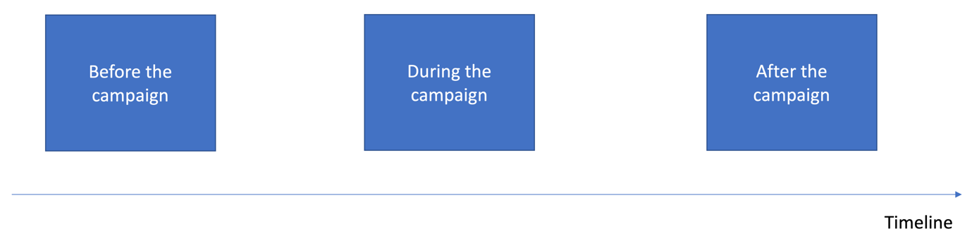

7. Before the campaign

Prepare well in order to maximize vaccine coverage.

Barriers to high vaccine coverage are:
- Availability of vaccines and or access to vaccination sites
- Population understanding and trust (vaccine acceptancy)
- The complexity of the vaccine series/process (for example vaccines must be kept cold, two rounds are needed)

How to address the vaccine hesitancy issue
Reasons for vaccine hesitancy include:
- The belief that the OCV is actually the covid vaccine in disguise.
- Associate with sterilization.
- Concerns about vaccine safety.
- People do not consider the vaccination necessary for themselves because they had cholera and survived.
- People do not consider the vaccination necessary for themselves because they have not contracted cholera in past outbreaks.
- Beliefs that vaccines do not work.
- Beliefs around other means of protection. (Such as buying in a store and drinking any strong drink that boosts the immune system).

Social mobilization, messaging and community engagement
- The most important task for volunteers is SOCIAL MOBILIZATION
- Coordinate with the health authorities.
- Familiarize yourself with the habits and beliefs of members of your community and how they normally deal with vaccinations
- Meet community leaders and discuss the campaign with them; discuss with them the ideas they have about the vaccine and the campaign and get them to help reach the community.
- Talk to members of the community and explain how important vaccination is to protect the whole community, children and especially those under one year of age who cannot be vaccinated.
- If some members of the community are afraid of vaccinations, assist community workers to calm and remove their fears.
- Listen to the rumours and misinformation about OCV. Discuss with community members and respond with the appropriate information.
- Use information, education and communication materials.

Start at least one week before the first round and continue throughout and between both vaccination rounds.
How to address the vaccine rollout complexity
Problem: Vaccine delivery in 2 rounds may lead to lower final vaccination coverage – because some individuals may only come to the first round and receive only one dose out of the two doses that are recommended. Or may only come to the second round without having previously received the first dose.
- Early communication on the process (2 rounds) with clarity on the vaccination calendar (dates of the 2 rounds)
- Stress the importance of receiving 2 doses – inefficacy of receiving one dose only (protection not long-lasting)
- Possible incentive to ensure higher attendance for the second dose if low attendance for the 2nd round expected
(for. Ex. Certificate of vaccination; soap or disinfectant, aqua tabs, etc.)
Disseminate well in advance the location, vaccination site hours, the number of vaccination days and age groups targeted.

8. During the campaign

What does an OCV vaccination campaign look like?

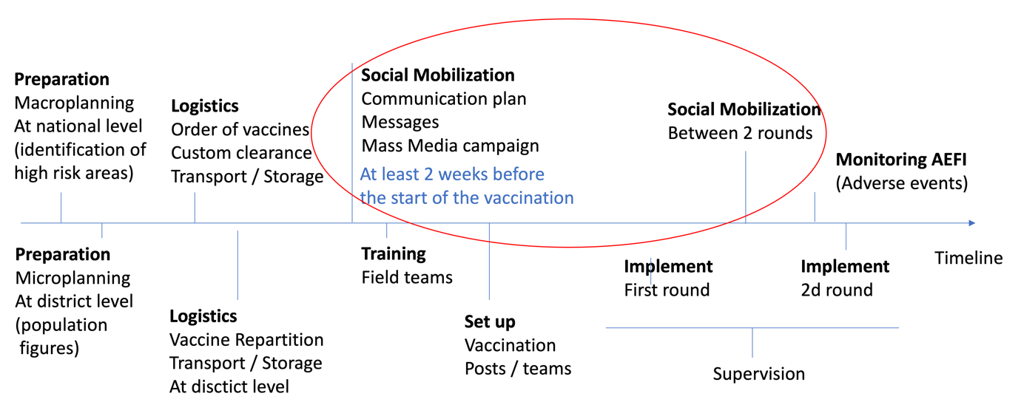

SOCIAL MOBILIZATION, which is one of the most important tasks for volunteers occurs at two key moments: Before the first round, throughout the vaccination and between the two rounds.

- A mass vaccination campaign involving more than 50 000 people may be implemented in as little as 3 weeks.
If the campaign has been well planned, all elements are in place, and the population is willing to support it.
- The 2 doses of vaccine must be administered strictly between a minimum of 2 and a maximum of 6 months apart.
Not respecting this timing jeopardizes the protective efficacy of the vaccine.
- The majority of people come for vaccination during the first 2 days, weekends and the last day.
It is preferable to plan vaccination rounds not exceeding 6 days (2 days before the weekend + 2 days of weekend + 1 or 2 days after)
- Only people that have received the 1st dose are authorized to receive the 2nd dose of the vaccine during the 2nd round.
Authorizing people to get their first dose during the second-round session will oblige organizing a third round within 2 weeks/6 months to permit these people to receive their second dose.
Vaccination Strategy
Two strategies can be combined:
- Fixed Post: Permanent, located in health centres and non-permanent located in strategic locations such as markets, workplaces, places of worship, food distribution centres in refugee camps, and other locations where adults can be easily found.
- Door-to-door

Fixed Vaccination Post Floor Plan (Example)

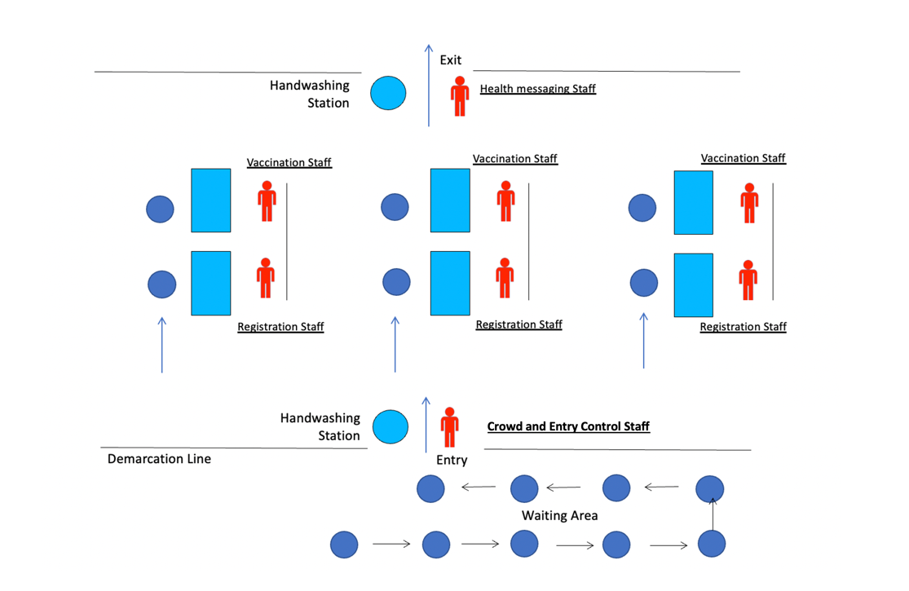

Fixed Vaccination Post Layout (Example)

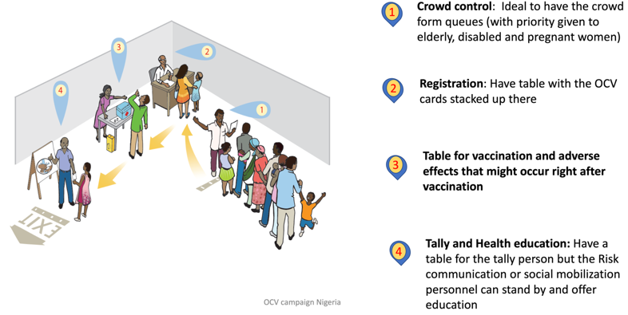

Patient Flow

- Waiting area – queuing is organized with signage and a crowd controller and people are informed about the need for handwashing upon arrival, only one caretaker is allowed for people who need assistance. People are explained where to go next (registration desk).

- Registration – the patient is given a vaccination card and explained to keep it for the second round in 2-4 weeks. Double-check the vaccination card, name and age of the taker.
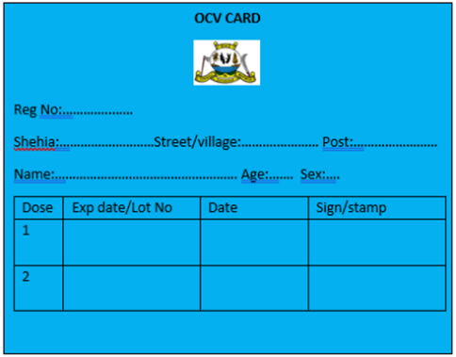
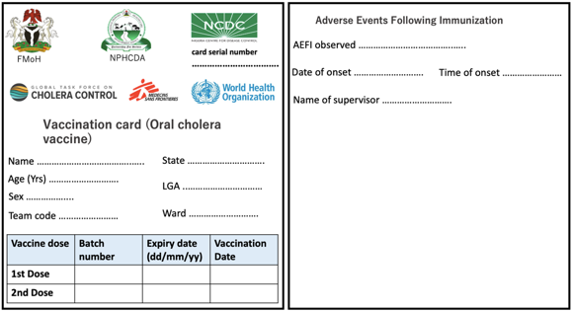

Examples of OCV cards

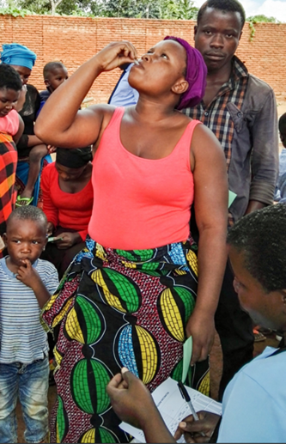
- Vaccination – the patient is given an opened vial and asked to drink it under the vaccinator's supervision (self-administration).
Vaccinator wash hands with alcoholic hand rub between each patient.

- Health messaging & handwashing before exit. Key messages include:
- Message 1 = Vaccines are efficient AGAINST cholera, but do not protect you against other diarrheal diseases – continue to follow standard WASH precautions (safe water, handwashing at key times, safe food preparation and handling, use of latrine)
- Message 2 = Vaccines are very safe, but we want to follow up on any adverse event – so please report to health centers if vomiting, diarrhea, or any other unusual reaction is observed between today and 2 weeks.
- Message 3 = Vaccine protects you well if 2 doses are taken. Please come back with the vaccination card for the second dose. (If the volunteer knows when the second round will take place, clearly say the date.)
Patients can ask any question about the vaccine or cholera.
Team Composition for a Fixed Vaccination Post

A vaccination team consists of a minimum of 4 people:
Person 1: Controlling the crowd and giving out information and explanation on the process, asking people to respect physical distancing
Person 2: Registration. Responsible for screening for eligibility and filling out the immunization card.
Person 3: Vaccinator, responsible for opening the vaccine and checking the full ingestion of the vaccine, filling in tally sheets and stamping (or signing) the immunization card.
Person 4: Communicates health education messages and explains to come back for a second round.

Team Composition for a Door-to-door Campaign

Vaccination teams are composed for at least 3 persons (one vaccinator, one mobilizer, and one registrar).
The same steps, registration, vaccination and messaging as above need to take place.
Challenges for the managers of a door-to-door campaign:
- Decide the appropriate number of teams.
- The teams will carry enough vaccines to cover 30/50 households (approximately 250/300 people per day)
- The vaccine cold chain needs to be maintained and the vaccines transported using a sufficient number of vaccine carriers, ice packs and waste bags.
These decisions will be made based on population to reach, population spread and logistics. Ministry of Health decides and the Red Cross follow guidelines.

9. After the campaign

Monitoring AEFI - Adverse Events Following Immunization
What is an AEFI?
An adverse event after immunization is a symptom or disease that follows immunization.
In general, AEFI may be due to:
- A reaction to the vaccine itself–most being mild or short-term
- An error in how the vaccine is administered
- Fear or distress on the part of the vaccine recipient
- Something different from the vaccination but that coincides with taking the vaccine

OCVs ARE VERY SAFE:
- Only about 1 in 50 people taking the vaccine report any side effects and are mainly gastrointestinal upset.
- OCV side effects are generally mild, last only a few hours, and do not require treatment.
Most common complaints after taking OCV:
- Upset stomach
- Diarrhoea
- Vomiting
- Nausea

Estimating vaccination coverage from data collected during vaccination
What is Vaccination coverage?
Vaccine coverage is a measure of the success of the vaccination campaign.
It is the estimated percentage of the population who have received the vaccine (or have received the required number of vaccine doses that are recommended for giving protection)

Vaccination coverage should be calculated for each round to determine the percentage of people who received a single dose and of those who received two doses.

10. Frequently Asked Questions

Why would I want to swallow cholera bacteria? It will make me ill.
The vaccine uses killed bacterial cells which will not cause cholera. None has become ill with cholera from the vaccine. Sometimes there is a minor reaction to the vaccine in about 4 in 100 people who experience upset stomach, diarrhea, vomiting and nausea. These symptoms are mild and only experienced for a short time.

I don’t like the idea of cholera germs in my blood.
The vaccine does not go into your blood, but into your intestine where it can repel the vibrio cholerae entering your body. However, you should still follow all the guidance around preventing infection through such measures as water treatment, hand washing and food hygiene.

I heard that some people who had the vaccine died from it after contracting cholera
Such an occurrence has never been recorded so it is important that if this really did happen that names and locations are given so we can follow it up. It is more likely that someone had slight side effects from the vaccine. If a person died there was probably another illness involved – but we will follow up if you can give us names.

I know a lot of people who won’t take it so why should I?
You should encourage them to take it. The more people in a community that take it, the less vibrio cholerae will exist in that community. If half (50%) of people have had the vaccine they are already both giving themselves strong protection, but also those who have not taken, or who cannot take the vaccine. By taking the vaccine you are protecting the babies who cannot take it.

I heard of people getting cholera even after they had taken the vaccine.
The vaccine offers strong protection against cholera, especially if you take the two recommended doses. It is also advisable to follow protection measures such as water treatment, hand washing and food hygiene. If a vaccinated person gets cholera they will not develop a severe form of the disease.
I had cholera last year and recovered so there is no need for me to take the vaccine – my body can cope with cholera…
This is true to a certain extent but you can still experience a serious case of cholera and by taking the vaccine you are making yourself even less likely to get the disease. In addition, by carrying out all the hygiene measures recommended you are ensuring good protection for your family.

Why are they doing this in our district but not the one next to the capital city…?
Unlike normal scheduled vaccination campaigns, OCV campaigns target areas that are considered to be cholera hotspots based on past and current outbreaks.

What’s the point of taking this when we have no cholera outbreak in our district at the moment.
There are two sorts of OCV campaigns some are to help fight cholera where there is an outbreak and others are preventative to stop an outbreak of cholera in the first place. If everyone takes the two doses then the protection lasts over 3 years and can allow the community to identify and put in place long term methods to prevent cholera.

So once I have the vaccine I will be fully protected, right?
The vaccine needs 7 to 10 days until the onset of protection and does not offer full protection. Usually, it offers 63% protection, so it is important for you and your family to continue to follow hygiene guidelines around water treatment, handwashing and food hygiene.

OCV is not the solution to stopping cholera; it should be used along with clean water, adequate sanitation and good personal hygiene. All this is necessary for the prevention of the disease. In addition, early and appropriate treatment is necessary to reduce illness and deaths from cholera. (see ORT field manual for volunteers)
Building safe water systems and sanitation facilities are essential for the prevention and control of cholera (and other waterborne diseases); however, these changes take time and will require more resources and cholera is a problem now. So OCV is a good way to protect communities, families and individuals while improving infrastructure

