Branch Outbreak Response Team (BORT) for Cholera Course Handbook

with consideration for COVID-19
BRC Health and WASH Team and IFRC Africa WASH Regional Team
May 2021
Contents
Module 1: Overview, Branch Outbreak Response Team (BORT) for cholera 6
What we will cover in Module 1 6
Key learning for participants 6
Question 6
RCRC Preparedness and Response 6
The Rationale for the Transmission Intervention team 8
Overview of Branch Transmission Intervention Team Tasks 8
Work group activity 1 8
Work group activity 2 10
Review of Module 1 10
Module 2: Cholera and COVID-19 transmission routes 11
What we will cover in Module 2 11
Key learning for participants 11
Requirements for epidemics 11
Epidemics - learning from the past 12
Cholera 15
Desk scenario 19
COVID-19 20
Desk scenario 22
Review of Module 2 22
Module 3: Integration of WASH interventions with health facilities 23
What we will cover in Module 3 23
Key learning for participants 23
Cholera Health / Treatment Facilities 24
Oral rehydration point (ORP) 24
Cleaning surfaces and items 27
Dead Body management 28
Cholera Treatment Unit (CTU)/Cholera Treatment Centre (CTC) 28
Group Work 32
WASH in HCF and WASH & COVID-19 resources (Annex Module 2) 32
Review of Module 3 32
Module 4: Household interventions 34
What we will cover in Module 4 34
Key learning for participants 34
Training Module 4 Agenda 35
Cholera Risk: Proximity 35
Why Household level interventions for Cholera 35
Targeting and Visiting Households 35
Activity 1 36
Cholera Transmission Risks in the Case Household 37
Infection Prevention at home 37
Key Actions to Reduce Cholera Transmission Risk in the Case Household 38
Actions to prevent COVID 19 Transmission at Household Level 40
The Household Hygiene and Disinfection Kit List 40
Activity 2: Getting to know the kit assessment and actions 41
Review of Module 4 41
Module 5: Community Shared Spaces 42
What we will cover in Module 5 42
Key learning for participants 42
Principles of response 43
Discussion – identifying risks 43
CHOLERA – WATER 44
Transmission routes of waterborne disease 44
CHOLERA – FOOD 46
Food Discussion – identifying risks 46
Transmission routes of food-borne disease 46
COVID - rank the risks 47
Transmission routes of person-to-person disease 48
Drinking water interventions 49
Food interventions 51
P2P interventions 52
Activity 53
REVIEW OF PRINCIPLES 54
Module 5 – part II Chlorine Solution Materials, Applications and Preparation 55
Training Module Agenda 55
Material handling / Health and Safety / Storage 55
WATA Unit Chlorine Production 55
Surface Disinfection with Different Products 57
0.05% 57
0.2% 57
2% 57
HTH (70% active chlorine 57
1 table spoon in 20 litres of water 57
1 table spoon in 5 litres of water 57
2 table spoons in 1 litre of water 57
Bleach (5%) 57
14 table spoons in 20 litres of water or ¼ cup in 20 litres of water 57
20 table spoons in 5 litres of water 57
2 cups in one litre 57
Use 57
Washing hands and clothing (soak for 15 minutes) 57
Skin disinfection 57
Disinfecting of beds, floors, latrines, kitchen, utilities of patient, etc 57
Disinfection of vomit and stool. 57
Disinfecting dead bodies (clean or spray with this solution before last offices) 57
Precautions 57
Solution must be changed every day and protected from heat and light 57
Use with gloves 57
Solution must be changed every day and protected from heat and light 57
Use with gloves 57
Solution must be changed every two days and protected from heat and light 57
Water disinfection with different products 58
Factors affecting chlorination 58
Testing residual chlorine in water 59
Testing residual chlorine in water 59
Passive Inline Chlorinator Example 60
Material handling, health & safety 60
Review of Module 5 61
Module 6: Cholera and COVID-19 High Risk Groups 63
What we will cover in Module 6 63
Key learning for participants 63
High Risk groups 63
High Risk groups – Fishing communities 64
High Risk groups – Nomadic populations 66
High Risk groups – Refugee settings 69
Funeral practices- checklist 71
Review of Module 6 72
Module 7: Medium and long-term interventions 73
What we will cover in Module 7 73
Key learning for participants 73
Rationale 73
Discussion points on better use of information, local production and maintenance of materials, and institutionalizing community capacity gains (Annex) 74
Chlorine Manufacture and the Evidence Action Model of Water Supply Protection 74
Chlorine Distribution: How it works 74
Emergency to Medium Term – Jengu handwashing unit manufacture (Annex Module 7) 75
Ram Pump Installation or Manufacture (Annex Module 7) 75
Latrine Slab Manufacture (Annex Module 7) 75
Review of Module 7 75

Module 1: Overview, Branch Outbreak Response Team (BORT) for cholera

What we will cover in Module 1
- How do IFRC and the National Societies prepare for and respond to cholera outbreaks across Africa.
- How the Branch Transmission Intervention Team fits into RCRC responses.
- Rationale for the Taransmission Intervention team and an overview of its actions and 5 Tier approach.
- Government and Country Analysis of the health set up for cholera in your country.

Key learning for participants
- Get familiar with the three-pronged approach of the RCRC in responding locally to cholera outbreaks.
- Being able to explain how the Branch intervention team would work with the ORP teams and the DHA.
- Able to recognize the rationale behind the locations and prioritization of the actions.
- Understand the emergency health set up in your country and how the team will fit in with it.

Question
- What does the RCRC do in preparedness and response?
- What do you think is different from other organizations?

RCRC Preparedness and Response
The auxiliary role to the government and the permanence of Red Cross Red Crescent (RCRC) branches and its volunteer network in communities provides a unique, solid foundation for well-prepared local responses to scattered cases and major outbreaks, ensuring immediate actions in coordination with communities and government health staff.

RCRC strategy in preparedness and response to cholera has three parts to it:

Oral Rehydration Therapy Preparedness at branch and community level with the aim of immediately saving lives through diagnosis, oral rehydration therapy and referral.

Branch Transmission Intervention Teams whose aim is to break disease transmission routes in health facilities, case households, communities and amongst the most vulnerable.

Support to OCV campaigns through community sensitization and mobilization.

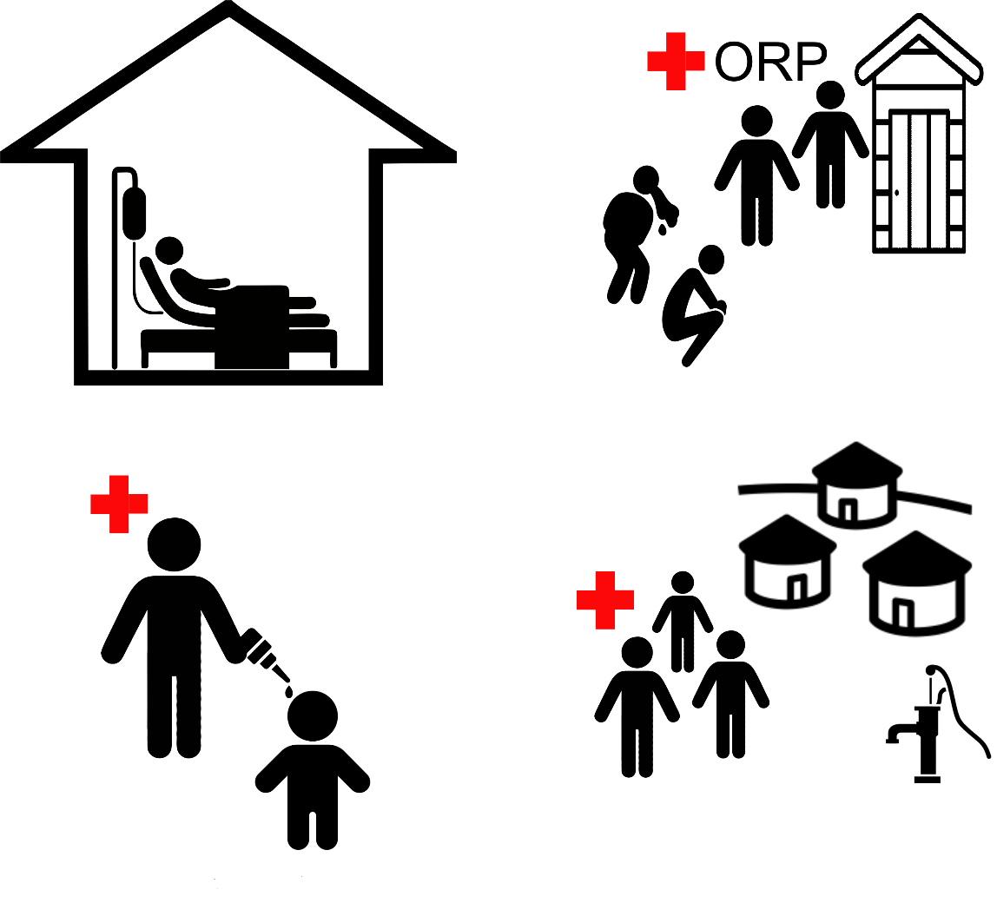

RCRC Preparedness and Response: How it works at community and branch level
ORT volunteers (Level 1 training) in the community are able to diagnose, treat and refer cases of diarrhea and levels of dehydration. They alert branch and District Health of increases in cases.
If there is a significant increase in cases, and the District Health Authorities are in agreement, one or more ORPs are set up to deal with the increasing number of cases (Level 2 Training).
Cases are thus registered in a line list either by ORT volunteers in their community; by volunteers working at the ORP or at government health facilities.
Registered Cases are used to identify local hotspots, that is, where there are most cases.
In coordination with the DHA the Branch Transmission Intervention Team move to areas with high case-loads in order to identify and break suspected transmission routes.
If cases continue to increase and it becomes a major outbreak the number of ORPs will be increased and BORT teams will continue their work being directed by line lists.
Where a government requests and is successful in getting oral cholera vaccine (OCV) doses, RCRC volunteers will support community mobilization in the campaign.

The Rationale for the Transmission Intervention team
The location of actions undertaken by the team follows the MSF 5 tier approach which asks the question:
Where is there the greatest risk of transmission?
Tier 1. In health facilities treating those with the disease
Tier 2. In the households of people identified as having the disease
Tier 3. In the neighborhood/community of households where there has been a case.
Tier 4. Amongst the most vulnerable groups in areas where an outbreak is reported e.g. refugees, fishermen
Tier 5. Amongst those who lack water and sanitation infrastructure

Overview of Branch Transmission Intervention Team Tasks
- Give any support the DHA requires to carry out IPC at health facilities (T1)
- In collaboration with District Health staff agree on the communities to be targeted based on location of cases as defined by the line lists.
- Carry out transmission breaking interventions in case households (T2).
- Carry out transmission breaking interventions in the clusters, neighborhoods and communities where cases have been registered (T3).
- With DHA, agree on key vulnerable groups to target and carry out transmission breaking interventions that are context specific (T4)
- Identify key actions or equipment that can continue to be used beyond the end of the outbreak which may prevent future outbreaks through the provision of WASH and other inputs (T5)

Work group activity 1
A few weeks ago there were several reported cases of Acute Watery Diarrhea in the district health center and one (1) reported in a nearby village.
As a BORT team member, which are the potential and priority activities and actions you think you will focus on?
A volunteer has kept a logbook of the actions taken. Using the idea of the five-tier system and the related actions at each stage, work with others to try to put the logbook entries in order.

The 5 Tier Approach in the COVID-19 Pandemic
The risks around transmission will be similar with COVID 19, though more fluid. Because transmission is easier, and the spread of the disease probably quicker, high risk groups should be targeted earlier once case locations have been identified.
Tier 1: Volunteers should not be in a clinical setting where there are respiratory infections
Tier 2: Work outwards from case households into the community; work with neighbours and local volunteers to ensure the household reduces contact with outside and is supported in doing so.
Tier 3: Key intervention will be setting up of handwash units in key areas which following physical distancing rules. Ensure safe water supply; most handwash facilities fail due to lack of water supply.
Tier 4: Identify households with elderly or people with underlying conditions and work with neighbours and local volunteers to reduce their contact with the wider community
Tier 5: Ensure the continuity of handwash facilities and the following of physical distancing rules.

Government and Country Analysis: National Cholera Plan and hotspots
To be designed by the NS in coordination with the Training development team.
Not to exceed 5 slides (this is for NS and government contribution to the design)
The mapping of hotspots for most countries is available on the Cholera platforms: http://www.plateformecholera.info/ add extra slide with a map if it is felt to be useful.
The status of the National Cholera Plan is included in the country profile on the platforms, but government should be approached so as to understand its status, get updates and understand its links with the CSP.

Government and Country Analysis: District and Community Health Set Up
To be designed by the NS in coordination with the Training development team.
Whilst volunteers may have some knowledge of the set up of this, it is important that such knowledge is made clear to them – it is important to understand the system and people with whom they will work. Use diagrams.

Government and Country Analysis: Linking with Government Health Staff and volunteers
To be designed by the NS in coordination with the Training development team.
A presentation should be given to government of the capacity the NS is putting in place, what it can respond to and how it responds. Discussions should then be held as to how this would fit with what already exists. This slide should describe whatever is agreed with government. Use extra slide if necessary.

Work group activity 2
As a group draw a diagram which shows how the BORTworks overtime with the Health Authorities and with ORT volunteers in the communities and ORPs which have been set up as first response

Review of Module 1
- The Branch Transmission Intervention Team (BORT) is one of three elements of response, the others being Oral Rehydration Therapy through ORT volunteers (when only a few cases) and ORPs (when there are larger number of cases); and support to OCV campaigns.
- Whilst they will often run at the same time, the provision of ORT is the priority as it saves lives
- The BORT prioritizes its actions through adherence to the 5 Tier system working from where there is highest risk of transmission to least risk of transmission.
- It will often be the case that interventions are being undertaken across many tiers at the same time.

Module 2: Cholera and COVID-19 transmission routes

What we will cover in Module 2
- Develop an understanding of the range, and the most likely, transmission routes in cholera and person-to-person (COVID-19) disease in order to inform decision-making for an efficient and effective response.

Key learning for participants
By the end of the session, participants will understand:
- What are epidemics and how do they occur?
- Basics of Epidemiology: direct and indirect routes of transmission.
- F-diagram
- Cholera: Detailed review of transmission routes and most common contexts for outbreaks (water and food)
- Vehicles for transmission
- COVID-19: Person-to-person spread in droplet spread disease and contexts which facilitate spread
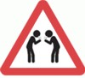
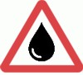
- Risk assessments

By the end of the session, participants will be able to:
- Investigate a cholera outbreak using a desk scenario, asking the facilitator the questions they would want to be answered
- Demonstrate use of a simple checklist for a cholera outbreak investigation including a sanitary survey (this will be used in future modules)
- Investigate a COVID-19 outbreak using a desk scenario, asking the facilitator the questions they would want to be answered
- Demonstrate use of a simple checklist for COVID-19 outbreak investigation including a sanitary survey (this will be used in future modules)

Requirements for epidemics
An epidemic is just an increase in cases above the background or endemic level.
There are several requirements for an epidemic like the planting of a crop:
- Biological susceptibility – people become infected (Haiti there was no immunity – cholera imported) – seed & soil
- Cultural/behavioural practices make spread possible (touching of the body/patient or caring for a person can allow infection in some diseases - Ebola) - flowering
- Sufficient contact between infected people (directly or indirectly via some vehicle) to allow spread within the period of infectiousness (at the Guinea funeral many people gathered and travelled back to their homes) –reseeding
- All three make the difference between a case and an epidemic

Epidemics - learning from the past
- Every outbreak has a trigger – something which allows it to spread in a population
- In Ebola in West Africa what was the trigger? (not the initial case but the situation which allowed it to spread)
  - There was a large funeral of a popular cleric in Kissigougou, Guinea – 1 case went to 62.
- In cholera it is often a common shared source (in Haiti there was one thing which facilitated spread – what?)
  - UN camp had untreated sewage being emptied into a river
- In a recent surge in cases of COVID in the United Kingdom in December what was the main reason?
  - People prepared, and went home, for Christmas

Cholera in England 1854

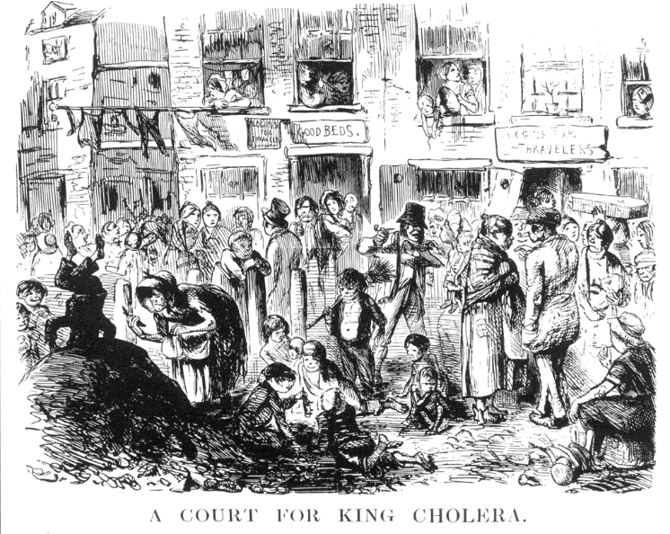

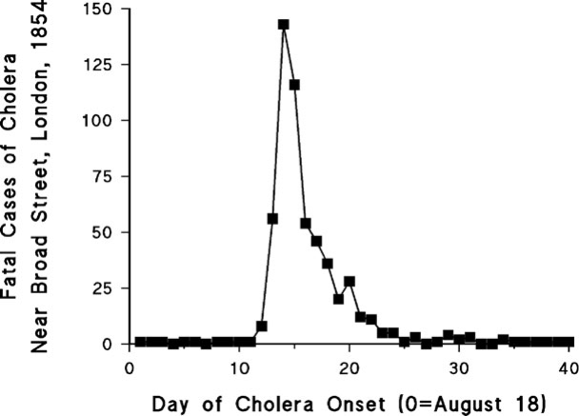
Why did it increase and drop so quickly?

Common source – one well, if they drank water (not beer) they drank cholera at the same time. They died or recovered.

London:
- There is very little lasting immunity to cholera and water had been heavily contaminated.
- A well had been dug close to a cesspit only 1 metre from the well – which leaked human faecal waste.
- Many hundreds of people shared the well (indirect contact via the vehicle - water).

Question: Rank the reasons England is free from cholera today?
- We have sewers?
- We wash our hands?
- We chlorinate water?
- We control flies?
- We have piped water?

Answer: Correct ranking
- We chlorinate water TREAT SOURCE / CAUSE
- We have piped water PROTECT SOURCE
- We have sewers REMOVE INFECTIOUS MATERIAL
- We sometimes wash our hands PREVENT INFECTION
- We don’t control flies, do remove waste FOODBORNE RISK
1 (with support of 2) can still be effective without 3 4 and 5

Cholera in West Africa 2012
Did the population have:
  - Biological susceptibility?
  - Cultural/behavioural practices to make spread possible?
  - Sufficient contact between infected people (direct or indirect)?
- Discuss

Cholera in Sierra Leone 2012

Why is this so slow at first and then what happened in Week 28?

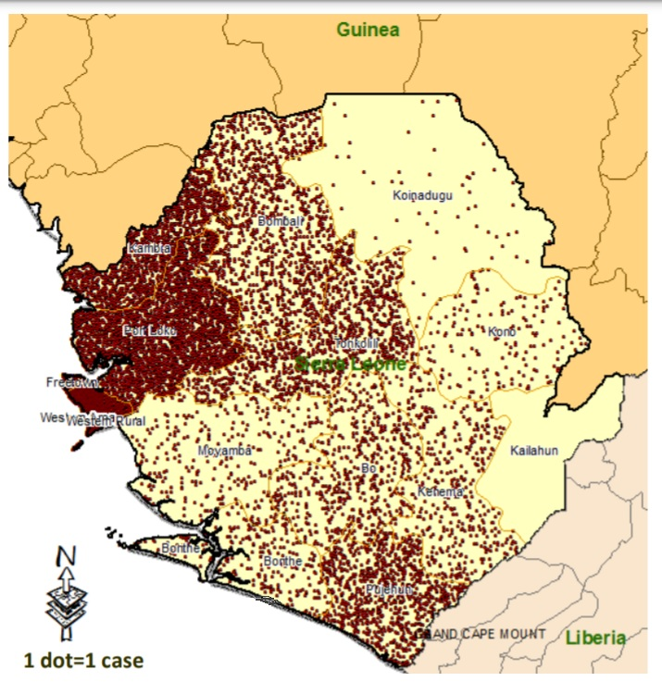
When it entered the most densely populated areas

Week 28

Transmission risk factors in 2012
Characteristic | mOR | 95% CI
Crab | 3.29* | (1.03–10.56)
Okra | 0.49 | (0.13–1.81)
Hot rice | 0.04 | (0.002–1.24)
Vended water | 9.7* | (2.01–43.72)
Unsafe water | 3.43* | (1.07–11.04)
Secondary education | 0.47 | (0.113–1.91)
*Statistically significant at P < 0.05
mOR = matched odds ratio
CI = confidence interval

Cholera

Not all will be infected

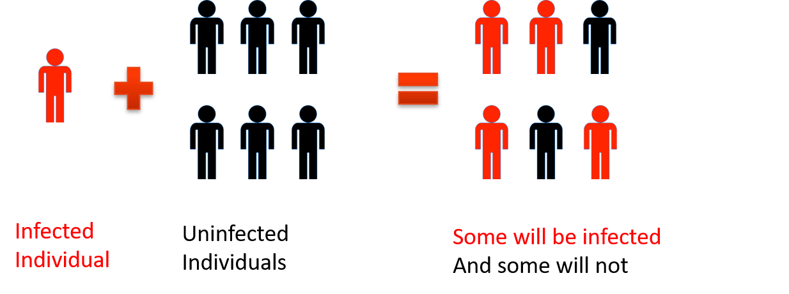

Cholera is an infectious, communicable disease, which follows a fecal-oral transmission route. Not all infected will develop disease.
Untreated, 25-50% will die. Treated, <1% mortality

Routes of cholera transmission
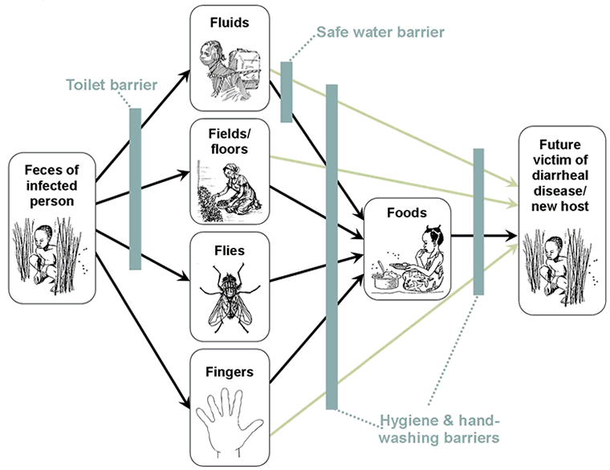
Fecal-oral
Transmission

“F diagram”
Not all routes have equal probability of occurring

Direct and indirect transmission
Diseases can transmit:
- Directly from person-to-person; or
- Indirectly via an intermediary (surfaces, water, food, insects and other animal vectors)
- Cholera and COVID-19 have the potential for both
- Cholera mainly transmits INDIRECTLY by water and food (contaminated surfaces contribute). Flies play a role too.
- COVID-19 mainly transmits DIRECTLY person-to-person, but contaminated surfaces are also important

Mode of infection
- You must swallow cholera bacilli – the organism which causes the disease. You must swallow a lot of the bacilli
- Contamination of water or food with a little is insufficient
- Contaminated and then left on food or water, the number of bacilli will become millions in hours and days
- This results in many people in watery diarrhoea (rice water description) and vomiting (within 2h - 5 days).
- Death occurs through dehydration and shock*
- Nobody needs to die from cholera – no drugs** are needed, only rehydration
*This is one of the most serious complications of dehydration. It occurs when low blood volume causes a drop in blood pressure and a drop in the amount of oxygen in your body. If untreated, severe hypovolemic shock can cause death in minutes.
** drugs sometimes used to decrease duration in hospital and so free resources Also for opportunistic infections (antibiotic treatment)

Where water can be contaminated
- At source:
  - rivers
  - lakes
  - unprotected wells and springs
  - contamination of groundwater, etc.
- Through distribution pipe network
- At collection point
- At transport of water
- Household – stored water

How water can be contaminated
- Source (rivers, lakes); latrines emptying into; swimming or defecating in; washing contaminated clothes in
- Source (unprotected wells and springs): touching bucket and submerging; hand or container contact with water
- Distribution network: low pressure, pipes through contaminated water (trench, effluent water outflow into)
- Collection point: cleaning each others’ containers with common water; touch well mouth with container/hand
- Transport: carrying container is contaminated, hands make contact with water
- House/shop – stored water (scoop / hand submerged)
- + TIME

How cholera is consumed in water
- Consumption of water directly in home
- Consumption of water from vendors or cafés
- Manufacture: ice, ice cream
- Food contamination where contaminated water is used in food “washing”, mixing, making without proper cooking; or to irrigate crops
- Contamination persists without treatment of water (chlorine, boiling, UV treatment, other sterilisation)

Where food is contaminated
- In field or lake
- In preparation of food
- Through washing of food
- In storage
- During serving

How food is contaminated
- Field or lake/sea: foods that are not cooked, which grow close to the ground, can be contaminated by faeces or contaminated irrigation water; crab or other shellfish can be contaminated by effluent water
- Food preparation: any food or contaminated water can cross-contaminate other foods; or hands / utensils
- Washing food: with cholera-containing water
- Storage: cholera in mildly contaminated food will replicate in the right temperature and humidity; flies (which have eaten on faeces) make contact with cooked or raw food
- Serving: lower risk (higher for other infections) with unclean hands and utensils

How cholera is consumed in food
- Consumption of food directly in home
- Consumption of food from vendors or cafés
- Food contamination where contaminated water is used in food “washing”, mixing, making without proper cooking
- Contamination persists without proper cooking, storage and service
- Risk is high in common sources like vendors where: contaminated water is used in food preparation; hand hygiene is poor
- With TIME, a little contamination becomes a lot

Vehicles for introducing cholera
Water:
Food:
- Hands
- Utensils
- Plates
- Flies
- Cross-contamination with other food
- Hands
- Latrines and open defecation
- Containers
- Scoops
- Adding contaminated water
These risks should form the basis of investigations (this is not a sanitary survey but they form a part).

Investigating cholera risk
Principles
- You will not be able to identify all sources or all potential sources as you do not have sophisticated methods of detection
- Most of your methods will be observational – your skills in observing behaviour are your best tool
- You will have some basic testing for contamination of water
- You must intervene even if there is no cholera (clean water may be contaminated as the epidemic spreads) – residual chlorine is the best weapon against cholera
What to do, in practice
- Rapid sanitary survey to identify potential public water contamination
- Water collection / storage practices (home and business)
- Water treatment practices (home and business)
- Use of water in manufacture (e.g. ice, ice cream)
- Irrigation of crops
Then
- Coordination of information
- Analysing data – looking for commonalities

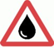
Desk scenario
- You have been called to a district referral hospital after 8 people have been admitted with confirmed cholera
- You can ask the hospital staff and the families (patients are weak but able to talk and answer your questions, or their family can answer for them)
- What questions will you ask them to help you understand the risk even before you go to the community?
- Think about TIME, PLACE, PERSON
Then…
- Using the rapid assessment form for cholera risk
- What do you find from the village?

COVID-19

Direct-indirect transmission
Remember, all infectious diseases can transmit:
- Directly from person-to-person; or
- Indirectly via an intermediary (surfaces, water, food, insects and other animal vectors)
- Cholera and COVID-19 have the potential for both
- Cholera mainly transmits INDIRECTLY by water and food (contaminated surfaces contribute). Flies play a role too.
- COVID-19 mainly transmits DIRECTLY person-to-person but contaminated surfaces are also important

Mode of infection - direct
- Transmitted through droplets of different sizes
- COVID-19 virus is primarily transmitted between people through respiratory droplets and contact routes. Droplets defined as those that fall to ground soon through gravity
- Analysis of 75,465 COVID-19 cases in China, airborne transmission was not reported (by smaller aerosols which remain suspended in the air)
- Occurs when a person is in in close contact (within 1 m) with someone (e.g., coughing, sneezing, speaking)
- Airborne transmission is different* – but droplets may remain in the air for longer in poorly ventilated indoor environments – under the right circumstances
- Disease within 2-14 days (average 6)

Mode of infection – indirect
- Transmission may also occur through fomites (surfaces) in the immediate environment around infected persons
- Indirect contact with surfaces in the immediate environment or with objects used on the infected person (e.g., stethoscope or thermometer, surfaces where droplets land, coughing into hand)
- The virus can remain viable for hours or days, depending on the humidity, temperature and nature of the material
- Then contact by hands or materials with the mucosae or conjunctiva (mouth, nose, eyes)
- Surface cleaning, and handwashing are important. Keeping distance (1 – 2 m) from people (whether they appear infected or not) is most important

Where is the greatest direct risk?
- Places where there are likely to be people close together and infected. What are these?
- Discuss…
- Hospitals (in the UK up to 40% of cases may be hospital acquired – even where PPE are worn by staff) – symptomatic in-patients
- Homes of sick people – symptomatic people
- Clinics & family medical practices – symptomatic people
- Restaurants and cafés - asymptomatic and mildly symptomatic people – nobody wears masks when eating
- Indoor market places and shops - asymptomatic and mildly symptomatic people with poor ventilation

COVID – greatest risk areas
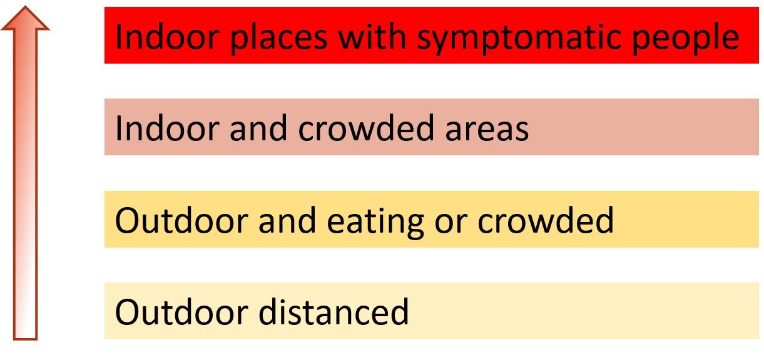

Desk scenario
Using the rapid assessment form for COVID-19 risk:
- The District Health Officer has informed the branch that there are 5 cases of severe respiratory illness in elderly people in a town in your area.
- It is consistent with COVID-19. One has died.
- The town is known to be more densely populated.
- What is your approach? What should you do?
- You can ask the MoH questions but because of the infection risk you cannot go to the hospital.

Review of Module 2
- Every outbreak has a trigger which allows it to spread. Identifying, and acting promptly to address, that trigger will increase likelihood of rapid outbreak control.
- Not all individuals in the general population will be infected. Understanding transmission routes, and people susceptibility, will increase likelihood of rapid outbreak control.
- Cholera and COVID 19 transmission can be direct or indirect, and through different modes, Water and food can be contaminated – at source, collection, transport, or storage level. Surfaces can also be contaminated, although the risk is lower.
- You will not be able to identify all sources/ potential sources of cholera – use your observational skills and identify the greatest risk, then intervene.
- For cholera, you must intervene even if water is clean, as it may be contaminated as the epidemic spreads – residual chlorine is the best weapon against cholera

Module 3: Integration of WASH interventions with health facilities

What we will cover in Module 3
- What are the different types of cholera treatment facilities
- Role of the branch team in support of treatment services
- At oral rehydration points (ORP – training as included in ORT2)
- In cholera treatment centers (CTC) / cholera treatment units (CTU)
- In community health facilities
- Monitoring

Key learning for participants
By the end of the session, participants will understand:
- The varying forms and scales of branch cholera transmission intervention controls within health facilities (Oral Heydration Points / Cholera Treatment Centre / Cholera Treatment Facilities)
- The role of the national society, branch and volunteer network in various health facilities
- Infection Prevention Control and requirements for sanitation / hygiene management for Cholera treatment in health facilities
- Monitoring and management of Cholera health facilities

By the end of the session, participants will be able to:
- Draw a plan of the layout of an ORP, including entrance, patient areas, staff areas, latrines, handwashing facilities, waste disposal, sprayers etc.
- Highlight differences between CTC and ORP
- Describe activities that the NS will undertake to contribute to operation and management of ORP’s / CTC’s
- Discuss if the layout of ORP / CTC can be improved

Cholera Health / Treatment Facilities
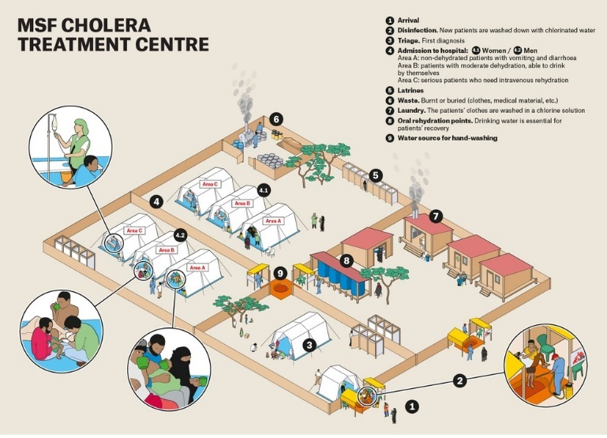
Rapid access to treatment key:
- Treatment in the community – at home or via community volunteer or community health workers = ORT
- Oral Rehydration Points → oral rehydration at community level, referral of severe patients to other treatment facilities. Decentralized, important for early access to treatment.
- Cholera Treatment Units → standard oral and intravenous rehydration
- Cholera Treatment Centres → oral and intravenous rehydration, treatment of complications and co-morbidities
- All treatment structures → education on cholera prevention for staff, patients and caregivers

Oral rehydration point (ORP)

ORPs as second level of treatment

What is an ORP?
- An ORP is a point of entry, at community level, to AWD / cholera treatment and referral - able to handle a significant number of suspected cholera / AWD patients.
- The RCRC has created an ORP kit that contains all materials necessary for one or several ORP volunteers to successfully provide these services at community level.
- Different to the ORT volunteer system (available at all
times), an ORP is meant to be deployed temporarily
during an AWD/Cholera outbreak (emergency response)
- It is an identifiable structure in a clearly defined and easily accessible area (see signage example below)

ORAL REHYDRATION POINT

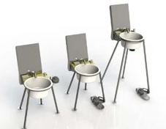
- It is more operational with access to treated water, handwashing units, sanitation and a strong Infection Prevention and Control (IPC) element
- ORP is open min. 12 hours a day, and where security permits and cases require, up to 24 hours a day.
- It is manned by a minimum of 2 volunteers, preferably 4 (on rotation)

When to set up an ORP?
- An ORP should be deployed in AWD emergencies
- > 5-10 new cases/day)
- Implemented in partnership and agreement with the Local Health Authorities
- The ORP will be closed when the number of AWD cases goes down to a manageable level.
- The kit can produce enough water to treat approximately 35 patients per day using the safe water from the filter
- You should not see more than 25-30 people per day, if you do, alert your ORP supervisor

Standard contents of the ORP kit (Annex Module 3)

Activities of an ORP
- Initiate early treatment of mild to moderate cases of dehydration by giving ORS
- Provide an infection free environment through strict IPC procedures
- Distribute key supplies such as ORS, soap and household water treatment chemicals or advice
- Act as a referral point for severe, or at-risk cases to health facilities
- Be part of community-based surveillance by recording all suspected cases of cholera
- Provide key health and hygiene messages to the community to help prevent cholera.
- Key point for social mobilization activities in the community

IPC at an ORP
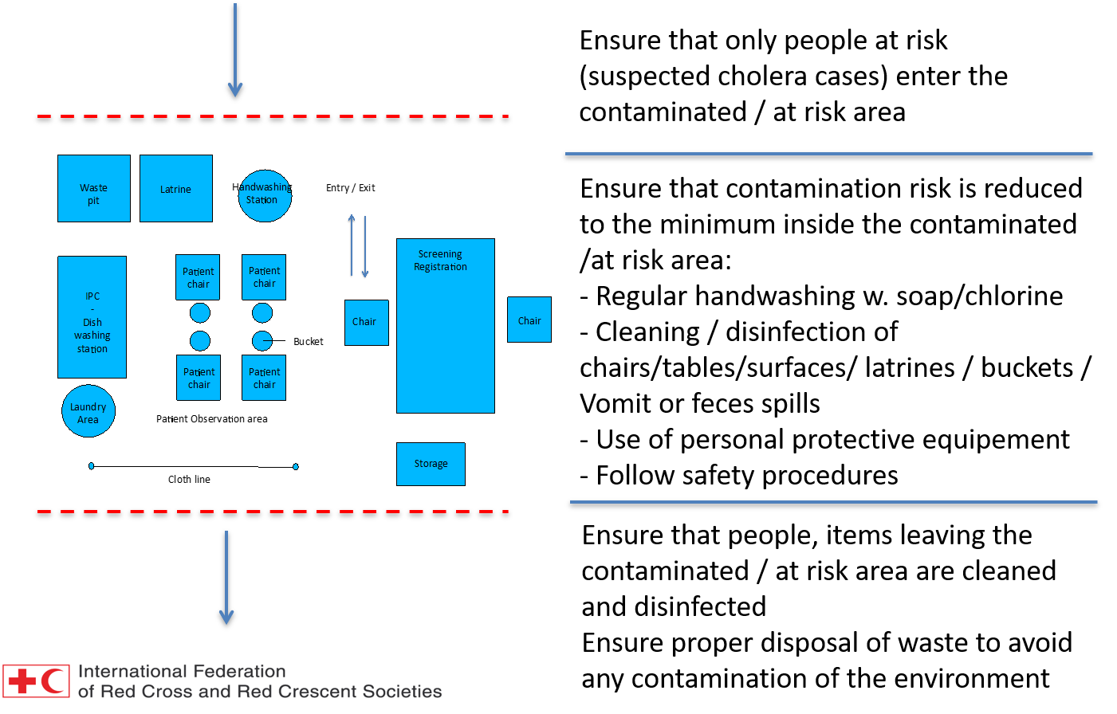

Q & A: Hand washing at the ORP
Answer these questions:
- Why is hand-washing important?
- Who should wash their hands?
- When should people wash hands (before and after which activities)?
- How to wash your hands?
- Where to locate Handwashing stations?

Health and hygiene promotion at ORP
- Effective hygiene practice reduces potential for communal transmission via secondary sources. Also helps prevent against other rapidly infectious diseases such as COVID-19/EVD
- Hygiene awareness and promotion are a crucial part of every ORP.
- If possible, hygiene and water treatment supplies should be given to (suspected) patients. (soap, chlorine tablets, etc)

Where to locate Handwashing stations
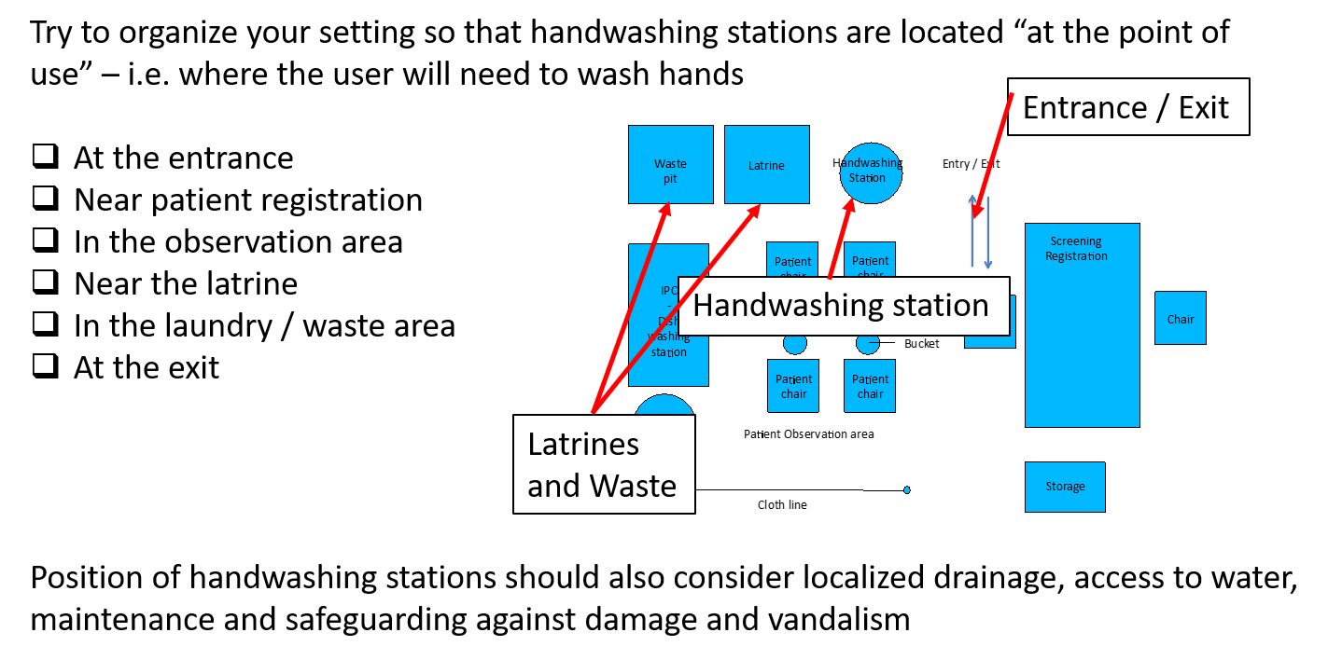

Cleaning surfaces and items

General Principles
RINSE (with clean, clear water)
WASH / CLEAN (with soap and detergents)

DISINFECT (with chlorine solutions)

Essential for preventing transmission of other pathogens and viruses such as coronavirus. Use of PPE is necessary to prevent against transmission of other diseases such as covid-19, which may increase co-morbidity issues and further drain available resources.
Only clean items / surface (free from dirt, oil etc) can be efficiently disinfected.
Consumable PPE should never be reused in an ORP / CTC /health facility.
Nb: if not clean – chlorine will react with organic matter rather than with microbes.
Floors, surfaces (beds, tables, chairs) and sanitation facilities (showers, toilets, washing areas) must be cleaned at least twice a day or each time it is soiled. Items used for collection and disposal of vomit / excreta should also be regularly cleaned and disinfected (typically daily). Key steps for this are:
- Wash/clean items with water & detergent or liquid soap, then rinse / wipe down
- Disinfect with 0.2% chlorine solution spray and dry. Surfaces such as chairs and utensils may also be sprayed with 0.2% chlorine solution to disinfect. Excreta collection receptacles to use 2.0% solution.
- Laundry should also be disinfected post standard washing routine, with 0.05% solution.
- Items must be clean / free of material before disinfecting
- Further details MODULE 8 – MATERIAL AND CHLORINE SOLUTION PRODUCTION

CTC Patient Beds, Bathing/showers, Laundry Areas, Cleaning CTC (Annex 3)

Dead Body management
ORP staff should not be confronted with this situation.
However, if this happens, the following information could help:
- The bodies of people who have died from cholera are extremely contagious. Safe and culturally appropriate management of dead bodies is a sensitive issue and should be performed by trained personnel (designated by the Ministry of Health).
- Immediate notification to the health authorities should be sent with request for support of a trained health staff.
- Unless the Red Cross is specifically tasked with assisting in management of dead bodies, volunteers should be discouraged from participating in this activity.
- Explain to community and family members that they should not
touch the body – to avoid possible contamination

Cholera Treatment Unit (CTU)/Cholera Treatment Centre (CTC)

CTU/CTC are in-patient health care structures

Design of Cholera Treatment Facilities
Cholera Treatment Facilities / Centres (CTF/CTC) are an​ extension upon ORP's and are designed to accommodate larger number of patients.
Organisation & design of treatment facilities are based on two key principles:
- Isolation of the entire facility from other public structures such as schools, health services and markets.
- Separation of patients (contaminated area) from the ‘neutral area’ (not contaminated).
Cholera treatment centres can become sources of contamination if hygiene, waste disposal and isolation measures are inadequate.

Layout of CTC/CTF
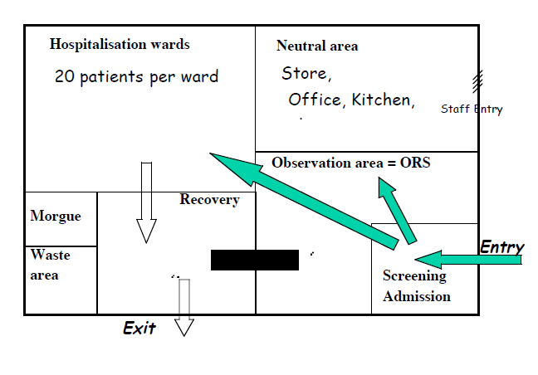
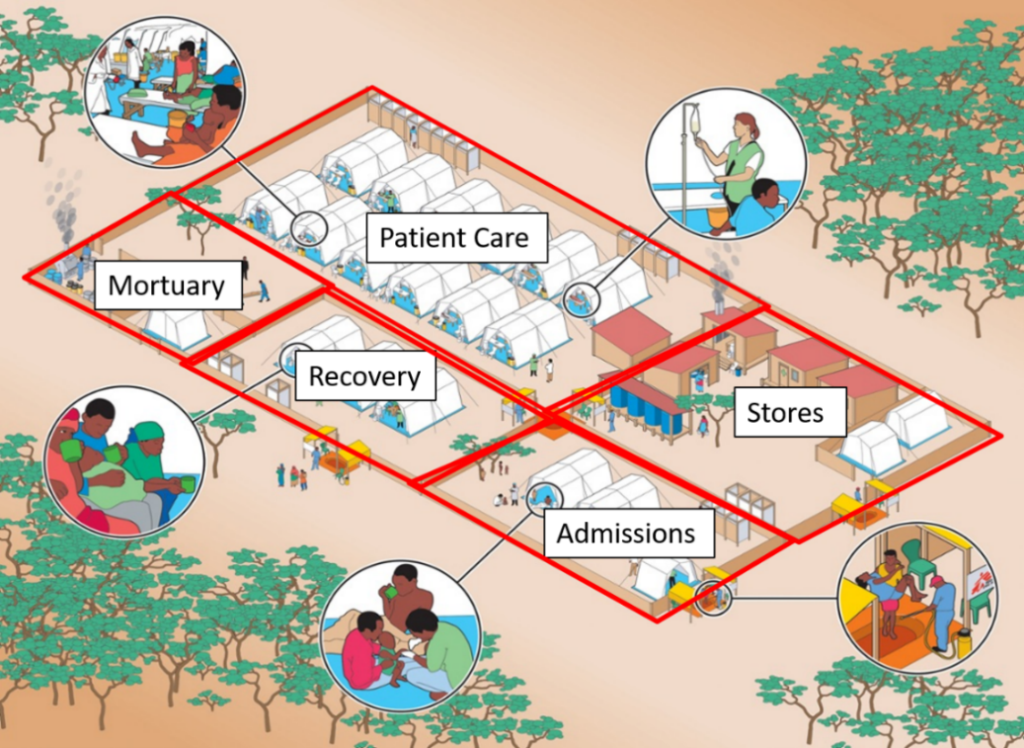

Size / Capacity of CTC/CTU
Total surface area
The total surface area required is calculated on the basis of approximately 30 m² per patient. For example: for a CTC of 100 beds about 3000 m² are immediately required, but if the site is 3800 m² at least 25 more beds can be added if needed.
Surface area per patient
A bedridden patient requires about 4 m² and a seated patient about 2 m². For example: in a 75 m² room, 17 beds (maximum 18) + one nurse station can be set up.
The space available or allocated by authorities may not be big enough to build a CTC with the required number of beds. In this event set up several CTUs at strategic points

Water supply standards in CTC/CTU/ORP
Water Quantity
- CTC/CTU – 40- 60 litres/patient/day – this should be enough for patients, staff, caretakers and cleaning
- ORP – 10 litres/patient/day
Water Storage
- Ideally, sufficient for 3 days, but as a minimum a 1 day should be stored on site.
Water Quality (for consumption)
- Residual chlorine 0.5 mg/l (pH<8)
- Turbidity <5 NTU (up to 20 NTU in initial emergency phase). Cloudy / turbid water should be filtered using a sand-cloth filter or a commonly available filter, such as filter pot / filter siphon

Types of Water Filter
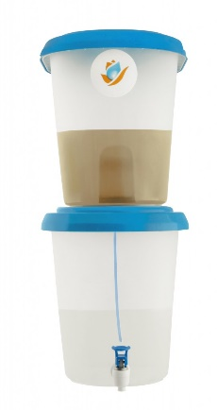
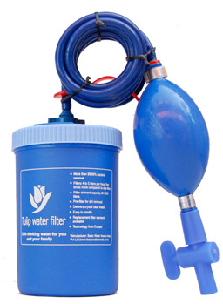

ORS
- Only use safe (clear and purified) drinking water for ORS preparation
- Once mixed with water, ORS should be stored for no more than 24hrs and avoid storing in direct sunlight.
- ORS solution can become contaminated with cholera during storage. (chlorine concentrations diminish quickly when ORS is mixed and therefore do not provide residual protection.).
- Provide ORS in special closed colour containers with tap

CTC Set-up
In the first 24 hours
a) Isolate the CTC and organize the sectors
Demarcate the outer boundaries of the CTC. Demarcate the sectors of the CTC
b) Set up the tents
Put up patient tents - It is usually not necessary to put up all the estimated number of patient tents. For example, for a CTC with a capacity of 100 beds, start by putting up 5 tents then add further tents as/when admissions increase. Number the tents.
Set up a hand-washing point in front of each tent.
Put up one or two tents for stock. Put up a tent to isolate deceased patients
c) Install initial stocks
d) Provide potable water
Initially potable water must be provided at least for drinking, preparing ORS and hand-washing. Water must be chlorinated. If the site has a water supply system, check the free residual chlorine levels and adjust if necessary (See Module 8). If no water supply system, water needs to be supplied by water truck with a bladder
f) Provide lighting
g) Dig latrines

In the following days
Finish or complete installations: potable water distribution system, latrines, hand-washing points, showers, laundry point, rainwater drainage, soakaway pits, grease traps, zone for preparing chlorine solutions, stock storage, morgue, changing rooms, waste treatment area, kitchen, permanent fencing, etc. until the entire CTC is completely functioning.
It is important to differentiate the potable (chlorinated) water distribution system from the evacuation of wastewater system. In order to avoid the risk of contamination of potable water in the event of a leak, these networks must not overlap.
Install or complete signage to help the increasing number of patients, attendants and staff to get around and correctly use the facilities.

Key Hygiene Principles
- Hand washing should take place at all entry and exit points to the facility and between different areas.
- Movement through the facility should be strictly controlled. (one caretaker only per patient)
- Disinfection of shoes/feet is recommended
- Nothing leaves CTC/CTU without adequate disinfection

Group Work
Instructions:
1/ Draw a plan of the layout of a CTC one of your group members is working in, including entrance, patient areas, staff areas, laundry, latrines, handwashing facilities, waste disposal, sprayers etc.
2/ Highlight differences between CTC and ORP

3/ Discuss if the layout can be improved

WASH in HCF and WASH & COVID-19 resources (Annex Module 2)

Review of Module 3
- There are varying levels of health facility required for varying scales of Cholera outbreaks.
- There is a new ORP kit, which has been distributed to NS’s. NS’s and volunteers should be trained in the use of these ORP’s
- Role of the National Society and volunteers in the establishment, operation and maintenance of health facilities needs to be determined through engagement with government
- Strategic layout of facilities is paramount to ensuring that IPC is maintained within the varying heath facilities used. Sanitation of health facilities can be performed using chlorine solutions as described in Module 5
- Supply and management requirements for varying scales of health facilities will increase in accordance with caseloads and number of affected individuals / groups.

Module 4: Household interventions

What we will cover in Module 4
- Develop an understanding of the range, transmission routes in cholera and person-to-person (COVID-19) disease at Household level and the interventions BORT can undertake in the HH and the link with community actions to ensure there is no duplication.
- How the BORT identify clusters of case households where transmission breaking interventions can be carried out in coordination with the District Health Authority.
- Understand the prioritized interventions which can be undertaken in the home and with support of the Hygiene and disinfection kit .
- How to coordinate household and community actions to ensure there is no duplication.

Key learning for participants
By the end of the session, participants will understand the following regarding case households:
- Transmission routes of waterborne disease in a household
- Food-borne disease and the role of water in further spread in households with poor hygiene and unprotected stored water.
- Risks for person-to-person transmission (SARS-Cov-2).
- Effective interventions to break water-borne transmission at HH level.
- Effective interventions to break food-borne transmission at HH level
- Effective interventions to break person-to-person transmission.
- Content of the Household Hygiene and disinfection kit
By the end of the session, participants will be able to carry out the following in case households:
- Practically implement interventions to break water-borne transmission using the Household Hygiene and Disinfection kit (HHD).
- Practically implement interventions to break food-borne transmission using the HHD.
- Practically implement interventions to break person-to-person transmission using the HHD.
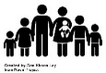
- Community engagement including monitoring.

Training Module 4 Agenda
- The rationale behind household interventions
- How to work with DHA to identify the households where interventions will take place
- What interventions will be carried out and how they will be implemented
- What the contents of the HH Hygiene and Disinfection Kit are for and what the key messages are for affected households.
- Practical Session using the kits

Cholera Risk: Proximity
Whilst several factors should be included in assessing risk, studies suggest that proximity is a key indicator.
Same Household 100x greater risk
Less than 50 metres 36x greater risk
Less than 100 metres 6x greater risk
Less than 150 metres 5x greater risk

Why Household level interventions for Cholera
- 80% cholera transmission is within the household
- Household contacts have 100 times risk of cholera
- V. cholerae is hyper-infective during first 7-10 days of shedding from cases, thus interventions in case households should be carried out immediately.
- Transmission through shared drinking water, food and caring responsibilities is more likely within a household

Targeting and Visiting Households
In an outbreak there needs to be careful targeting of interventions in order to use the limited resources to the best effect.
‘Blanket’ distribution of kits to households should be avoided.
Initial targeting will be case households indicated from the line lists of health facilities, CTUs/CTCs or Oral Rehydration points and will be done in coordination with District Health Authorities.
Household level interventions should take place as soon as possible.
- If possible, contact the Household and village authorities before visit to explain the purpose. Move to the village with enough kits for the case household(s) and a small buffer stock.
- The approach to a household should be done with a village leader and be kept low-key. It is important to avoid any sort of panic in the community or stigmatization of the case household.
- Introduce the team, the reason for visiting and planned actions.
- It is important that, if possible, actions at both HH and community level are happening concurrently. Some actions in the community shared spaces will be based on the answers to questions asked at household level.

Avoiding Stigmatization and following Cultural Norms in the operation
- If a single HH is visited its members may become stigmatized and even ostracized by the community. By visiting a group of HHs around the case household this can be avoided to some extent.
- Individual volunteers visiting households may be viewed negatively, especially in cases such as single women led households. Visiting with a village leader and going in pairs can help avoid rumours and suspicion.
- It is therefore recommended that two volunteers work together going from household to household and that a group of HHs rather than a single one are targeted
- Think about any potential unintended consequences of the activities you are planning. Is it possible they could cause someone to be put at risk or increase their vulnerability, through impacting on their safety or dignity, increasing discrimination or limiting access to services and information?
- Ensure a system is in place to receive and answer questions and complaints. Share important information clearly, honestly and in a way the community can understand - e.g., when services will stop, what will happen next, what is the role of the community, and how to get in touch with the National Society.
- Tackle rumours quickly by addressing them and providing the correct information.

Schedule of the visit
(assumes team of three or more volunteers)
- Introduce the reason for the visit and describe what actions will be taken.
- Ask questions about the cholera patient: their routines, facilities in the household and in the community they use. Is there any other family member or neighbour with the same symptoms?
- One team member goes with the community leader to the community facilities described.
- Based on answers to questions carry out relevant actions in the household.

Activity 1
Thinking about the usual transmission routes of Cholera covered in module 2, make a list of questions and 'show me' requests you will ask the members of the household.
Put these in 4 categories: Water, Sanitation and hygiene, Handwashing and Food.
Circle 'community link' questions*
15 min group discussion.
15 min presentation

Cholera Transmission Risks in the Case Household
- Common drinking water storage, treatment and serving techniques.
- Common preparation and handling of food
- Care responsibility contact and proximity
- Common sanitation and hygiene locations
- Common area of habitation which will be cleaned by certain members of the family.
- Clothes and other linen cleaned together

Infection Prevention at home
Households may have to deal with patients in the home either because a patient returns home but deteriorates again or other members of the household have become infected.
KEY MESSAGE
Stools, vomit and soiled clothes of cholera patients are highly contagious and should be handled safely.
DEALING WITH PATIENT FLUIDS
Give vomiting patient a bucket to collect vomit safely
Dispose vomit bucket content and all spills / soiled water in latrine pit
KEY MESSAGE
In case of vomit/faeces spills: collect in a bucket, add chlorine and dispose in latrine pit
CLEANING THE HOUSE: 1) WASH – 2) RINSE – 3) DISINFECT
- Every item that has been soiled must be cleaned, rinsed then disinfected with bleach
- Cleaning cloths and soiled clothes should be:
1) Washed with water/soap (soiled water should be disposed of in the latrine pit)
2) Rinsed,
3) Soaked in bleach solution for 15 minutes
4) Hung to dry in the sun

LIMITING HOUSEHOLD TRANSMISSION
- WASH HANDS with soap and running water carefully after taking care of patients, or cleaning items
- WASH HANDS with soap and running water carefully before taking care of someone else.
- WASH HANDS with soap and clean kitchen items carefully before preparing or eating food
- WASH HANDS with soap and containers carefully before preparing ORS/drinking water
Be careful of where you dispose of contaminated water and where you wash contaminated clothes, bedding and other items

Key Actions to Reduce Cholera Transmission Risk in the Case Household
- Treatment of water ensuring residual chlorine. Safe drinking water storage and serving techniques preferably from a bucket with tap.
- Practice of personal and food hygiene during the preparation and handling of food and its safe storage.
- Practicing personal hygiene before, during and after care responsibility contact and proximity to case
- Ensure safe and disinfected common sanitation and hygiene locations

Water Treatment, Storage and Serving
What the Kit contains to achieve this
- 10 litre bucket with tap
- Water treatment sachets for 4 weeks
- Cloth for filtering water with thick elastic band
- Information card on the use of the water treatment sachets tape

Actions, Training and Guidance to give household
- Disinfect the water collection vessel
- Set up bucket with tap and demonstrate
- Demonstrate the filtering of the water using a cloth
- Treat existing HH water if not treated, demonstrating use of water treatment sachets.
- Tape the info card to the wall where water is stored.

B. Hygiene measures during Food preparation, handling and storage
What the Kit contains to achieve this
- Soap handwashing and dishwashing
- Food storage net
- Info card: food preparation
- Info card: handwashing frequency.
- Info card: parts of hand often missed.

Actions, Training and Guidance to give household
- If possible, observe the household preparing a meal, if not ask them to describe how they prepare meals.
- Particular attention should be given to seafood and fish if these are consumed in the household.
- Treat water to be used for food preparation.
- Discuss food storage options and demonstrate the use and the purpose of the food cover.
- Ask about hand washing at meal-times.

C. Personal hygiene and location disinfection before, during and after care contact and proximity to case
What the Kit contains to achieve this
- Soap
- 10 litre bucket, mop, cloths and disinfectant (chlorine)
- Laundry soap
- Info card: handwashing frequency.
- Info card: parts of hand often missed.

Actions, Training and Guidance to give household
- Immediately work with the HH members to disinfect all areas where the case was situated. Use this as a demonstration.
- Demonstrate the process for washing soiled linen
- Demonstrate the process for cleaning surfaces
- Demonstrate handwashing techniques

D. Ensure safe and disinfected common sanitation and hygiene locations and personal hygiene during and after use
What the Kit contains to achieve this
- Soap
- 10 litre bucket, mop, cloths and disinfectant (chlorine)
- Scrub brush with handle for latrine cleaning
- 2 litre plastic container and nylon cord to fabricate tippy tap

Actions, Training and Guidance to give household
- Demonstrate effective handwashing using diagram of parts of hand often missed
- Demonstrate methods for economical use of soap such as dissolving shavings in water
- Disinfect and clean the latrine by way of demonstration practicing good personal hygiene during process. Plastic sheet around latrine to allow for easier cleaning*. Ensure water stationed for cleaning and flushing.
- Latrine: raise and cover where possible #
- Ensure hand wash facility beside the latrine by constructing tippy tap if necessary

Actions to prevent COVID 19 Transmission at Household Level
- Carry out disinfection of surfaces and shared facilities
- Isolate/shield the case ensuring distancing from other households
- Encourage regular handwashing in the home and make facilities for this available.
- Ensure community support to give supplies, clean water etc for vulnerable people (long term conditions, older) where the household cannot provide this for itself.

The Household Hygiene and Disinfection Kit List
Household Kit items
- 10 litre bucket with tap
- 10 litre bucket
- 2 litre container (tippy-tap)
- Bottle of chlorine
- different colour cloths (clean and water filtering)
- Thick elastic bands
- Mop with separate handle
- Soap: body and laundry
- Water treatment sachets
- Nylon cord
- Info cards and tape.
- Scrub brush for toilet cleaning
- Thick Plastic sheet 1 m.sq.
Items which volunteers should carry to distribute or use where necessary
Chlorine
ORS sachets
Water treatment sachets
Small soap bars
Information cards

Hygiene – Disinfection Kits Examples (Annex 4)

Please also refer to Module 5, for the following materials:
- Mixing chlorine using different formulations powder, liquid, tablets etc.
- Different solutions and their application – estimating dosage, and encouraging standardising this for simplicity (chlorine measuring equipment and diagrams)

Activity 2: Getting to know the kit assessment and actions
Get familiar with the HH kit
Get familiar with the volunteer kit
Get familiar with the Household assessment
Scenario Activity

Coordinating Household and Community Interventions
The BORT will be carrying out interventions at household and community level at the same time and coordinating what is done at each level is vital.
Example: avoiding the double chlorination of water
In addition, information gathered initially at case household level can help to make community space interventions more targeted.
Example: prioritizing treatment of the water source used by the case household before other sources.

Review of Module 4
- Those in case households have a much greater risk of infection and should be targeted immediately
- Vibrio cholerae is hyper-infective during the first 7 to 10 days of shedding
- Awareness of IPC around patient care in the home
- Key areas to cover are water treatment, storage and serving, food hygiene, personal hygiene when in proximity to case and sanitation with hygiene.
- Coordinate household information and actions with those aimed at the community

Module 5: Community Shared Spaces

What we will cover in Module 5
- Develop an understanding of risks for disease transmission in community shared spaces, how to intervene in the most effective and efficient way, and how to monitor progress for use in the final evaluation.

Key learning for participants
By the end of the session, participants will understand, for community shared spaces:
- Transmission routes of waterborne disease in a community
- Food-borne disease and the role of water in further spread in areas with poor hygiene and unprotected stored water.
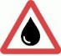
- Risks for person-to-person transmission (SARS-Cov-2).
- Effective interventions to break water-borne transmission.
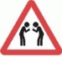
- Effective interventions to break food-borne transmission.
- Effective interventions to break person-to-person transmission.
Materials section
- Understand the use of various materials to produce chlorine solutions for use as part of community interventions, for both drinking water disinfection and surface disinfections
- Understand the background requirements and parameters of source water for mixing solutions for water sanitation and water disinfection
- Become more familiar with alternative active or inline chlorinator systems (e.g. Evidence Action)
- Use of GTFCC App in estimation of chlorine dosing rates and common use materials
- Solution Preparation, Concentrations, Testing (Free Residual Cl, NTU and pH)
- Material handling / Health and Safety / Storage of materials for drinking water and surface disinfection

By the end of the session, participants will be able to, for community shared spaces:
- Undertake household behaviour and risk assessment survey
- Practically implement interventions to break water-borne transmission. Mix chlorine solutions and test for residual chlorine
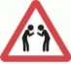
- Practically implement interventions to break food-borne transmission.
- Practically implement interventions to break person-to-person transmission.
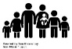
- Community engagement including monitoring.
Materials session
- Use of GTFCC App to calculated out necessary dosing rates and chemical quantities for disinfection solutions
- Undertake necessary basic calculations to determine dosing requirements for production of chlorine stock solutions and dilution
- Provide recall of testing and analysis requirements for drinking water disinfection (Free Residual Cl, NTU and pH)

Principles of response
- EFFICIENCY - target where risks are common, acting first to stop the sources that affect the most people
- GUIDING and CONTROLLING - If you rely on changing behaviour it will take weeks or months, people will die – give practical support for quick safety improvements.
- KEEP IT SIMPLE, MAKE IT CONVENIENT - Changes you make must be simple (easy to do, not complicated) and convenient (available in the right place) or nobody will apply them

Discussion – identifying risks
- Groups to discuss among themselves the risks in photographs (if webinar, then to put their ideas in the chat)
- Rank the risks in terms of number of highest to lowest with 1 as highest for greatest risk to greatest number of people. Think about why.

CHOLERA – WATER
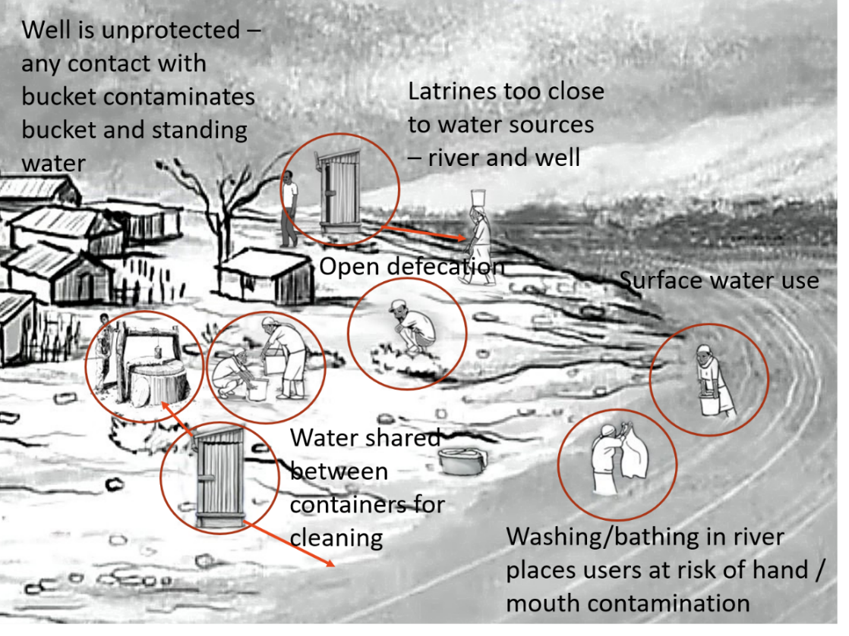

Transmission routes of waterborne disease
The main areas of risk in shared spaces for waterborne disease are:
- Drinking water source (contamination from latrine too close, surface water contamination from open defecation bathing), collection (shared containers, contamination from well mouth) and storage (unclean containers, hand contamination)
- Bathing water to mouth and nose
- Cleaning water to utensils, plates, water containers (unclean water)

Drinking water
Drinking water, recall, is always going to be the cause of large outbreaks because:
- You have to consume a lot of cholera bacilli to get cholera
- Cholera bacilli multiple rapidly in water from a few organisms to millions
- Everyone drinks water and usually stores it in their homes
- There are many opportunities for contamination.

Drinking water sources
- Ground sources may be protected or unprotected wells, springs (piped not equal safe)
- Assume all unprotected sources are contaminated (no need to test bacterial levels as what is clean today will be contaminated tomorrow.)
- Bacteriological testing protected sources is an option (once you have disinfected the well mouth)
- Test for residual chlorine - ideally 0.5mg/l after 30 min (0.2- 1.0 mg/l acceptable)
- Surface sources we can assume are unsafe for cholera (occurs naturally and higher risk if people in contact with water)
- Uncertain source (trucked water, vendor water and water from food sellers) – risk?
- Uncertain safety – piped network – risk depends on treatment and network integrity

Drinking water collection
- Even if sources are protected (well/spring with pump/apron) contamination occurs at collection.
- Contamination occurs by contact with the tap/well mouth with hands/containers. Transmission is both from collector and to collector.
- Contamination occurs from collectors immersing their hands into their own container/bucket.
- Contamination occurs by sharing of water between collectors (where people collect water and pass their water to another for cleaning, for example).
- A little cholera/bacterium multiplies during storage.

Water trucking and vendors
- The same risks apply to contamination at source, collection and storage
- Important to monitor the drinking water distribution chain and to develop control checks to reduce risk of contaminated at these stages
- What you need to understand:
  - What are original the sources of water (where operators abstract raw water).
  - What stages of transfer down to vendors and households?
  - Sketch this, identifying risks of contamination at each point.

Food vendors supplying water
- Do not assume that food vendors are only supplying food. Their water may be contaminated – at site or source.
- Water, ice and drinks made with untreated water present risks
- The source will be similar to households (either ground, surface or trucked/piped with one of those sources, and either treated or untreated)
- There could be common patterns in cholera cases sharing these sources. In 2012, water from vendors was a high risk for cases of cholera

CHOLERA – FOOD

Food Discussion – identifying risks
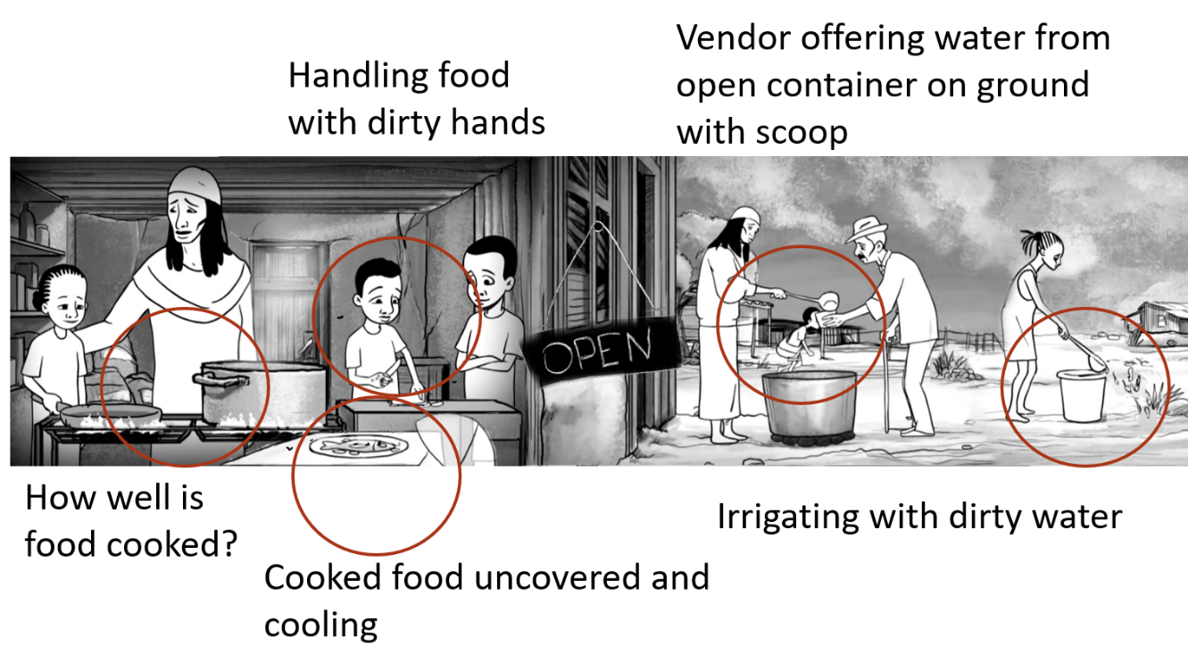

Transmission routes of food-borne disease
The main areas of risk in shared spaces for foodborne disease are:
- Food naturally contaminated.
- Food contaminated by hands.
- Food contamination from mechanical transfer by flies.
But don’t forget:
- Even if food is a cause, water will usually be the main vehicle.

Food sources
- Humans are the main reservoir of cholera. WHO maintains we are the only reservoir but this isn’t precisely true.
- However, there are environmental reservoirs (it is found in the environment in water) and animal reservoirs (water dwelling creatures such as crustaceans and shellfish)
- Aquatic foods can be contaminated before being caught, or after in the storage water.
- Contamination will remain in undercooked food. They can survive in crab boiled for up to 8 minutes. Eating crab from vendors was a risk in 2012 Sierra Leone epidemic.
- Foods at risk of contamination: rice; millet gruel; vegetables; fruits (not sour); poultry; meat; and dairy products. Foods acidic, dried or salt/sugar-preserved (salt fish/jam) are safest.

Food contamination - people
- Contamination by hands is most effective as people clean themselves after the toilet but don’t wash their hands.
- Often a person preparing food is ill, or does not demonstrate symptoms, and continues to work in markets and food stalls.
- Food can also become contaminated by contact with surfaces – such as cutlery or plates washed in contaminated water.
- Food can be contaminated by irrigation with contaminated water during growing (especially those foods growing close to the soil and ones which are not peeled).
- Cholera bacilli on foods will rapidly increase in number if left standing at room temperature (remember, you must swallow a lot of bacilli so casual contact will be low risk).
- Reused food is a risk especially if improperly cooked.

Food contamination - flies
- Although contamination by hands is most effective contamination from mechanical transfer by flies is also possible.
- This usually occurs where food is not refrigerated, and is left uncovered when standing.
- The type of food, the temperature of the food and the ambient temperature, will determine how rapidly cholera will multiply. Refrigeration will reduce growth but will not kill it.
- But remember, hands have a large surface area and potential for volume of faecal matter than do flies.

COVID - rank the risks
Question: rank the following risks
- Water collection point
- Distribution point – food, NFIs
- Indoor eating places
- Outdoor market eating places
- River bathing area
- Community centre hall
- Athletics field
- Public bus

Answer:
- Indoor eating places
Indoor and crowded
areas
- Public bus
- Community centre hall
- Outdoor market eating places
Outdoor and eating or crowded
- Distribution point – food, NFIs
- Water collection point
- River bathing area
Outdoor distanced
- Athletics field

Transmission routes of person-to-person disease
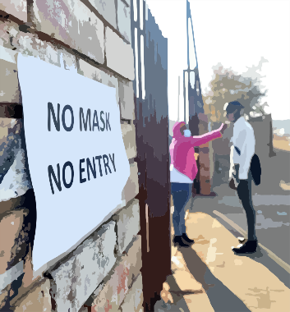
The main areas of risk in shared spaces for foodborne disease are:
- Congested environments.
- Unventilated indoor spaces.
But don’t forget:
- Places with common touch points where the virus can remain for days.

Direct transmission
- Droplet-spread disease requires proximity of under 2 metres.
- The longer the duration of close proximity to infected persons, the greater chance of infection.
- A significant proportion of people will have no symptoms of mild disease and will be mobile.
- Places of highest risk will be those where people congregate – such as water points, markets, shops.
- Masks provide some reduced risk of onward spread but this requires the majority of people to wear them and it should not come at the expense of maintaining distance.

Indirect transmission
- Common touch points offer places for indirect transmission of COVID-19 and other acute respiratory illnesses (as well as hand contamination for faecal-oral disease).
- Examples are water taps, pump handle, table surfaces and door handles (including latrines).
- Gloves do not protect users from infection as the virus will remain on gloves (gloves are only used in clinical settings as they are disposed of between patients).
- Masks, used repeatedly and touched, provide additional opportunities for indirect transmission to the user and others.

Drinking water interventions
- You cannot develop water, sanitation and hygiene infrastructure because you have:
  - Insufficient staff/volunteers
  - Insufficient materials and funds
  - Insufficient time (there is an outbreak so an emergency)
- TESTING limited to chlorine level (assume all is contaminated)
- Be EFFICIENT – target where risks are common, acting first to stop the sources that affect the most people
- GUIDE and CONTROL – if you rely on changing behaviour it will take weeks or months, people will die
- Anything changes you make must be SIMPLE (easy to do, not complicated) and CONVENIENT (immediately available in the right place) or nobody will apply them

Treating at source
- Treating at source will always be the most efficient, but it may not be where contamination occurs.
- As you can chlorinate to ensure residual chlorine at household, this helps if contamination occurs further along the chain.
- Treating at source is easiest with protected groundwater (passive chlorinators).
- Treating at source is more difficult with surface water: active chlorinators (mean choice and people may not do it); or bucket chlorination (requires permanent staff stationed, estimate container doses).

Active chlorination at pump
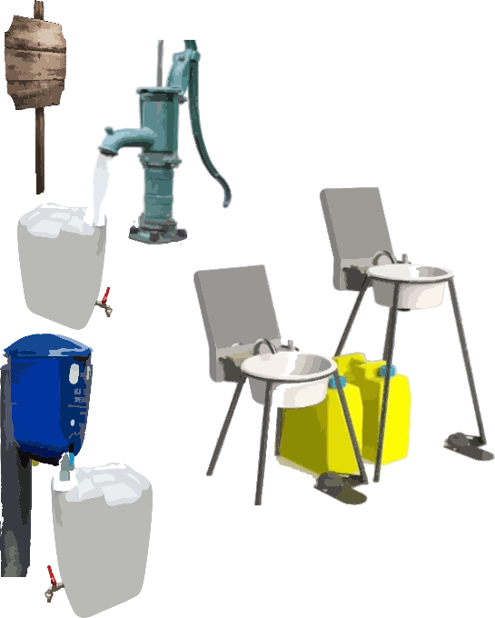

Active chlorination at surface collection
Ensuring active chlorinators are used
In practice, people will not use an active dispenser (0-28% use) without the following being in place:
- source selection (sited in the right place)
- chlorine solution quality and supply chain
- hardware maintenance
- promoter remuneration
- experienced program staff (RC has this)
- working with local partners (RC is this)
- regular monitoring
- integration into larger WASH programming, and
- establishing a sustainability plan
With these, 63-81% effective use

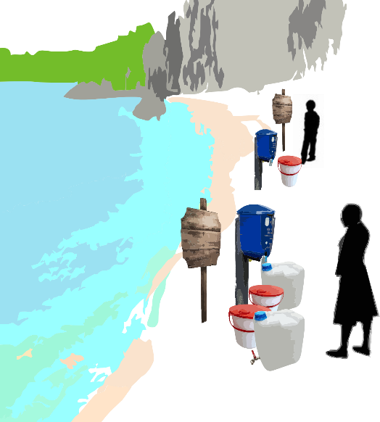
What could go wrong?
- People don’t use it
- People use it incorrectly
But there are things you can do

Action in trucked and vended water
- Use the sketch of supply chain and contamination risks to identify the place or places where interventions can be initiated
- Along the drinking water supply chain plan the intervention including negotiation with suppliers to make it safe
- 1 confirmation – take sample for testing of residual chlorine level. Optional - presence of faecal coliform – negative does not mean safe. Work with local authorities to monitor quality (Spot check high-risk areas)
- 2 removal of risk (sources of human excrement, container contamination – as for other sources, act where possible).
- 3 Bulk chlorinate
- Ensure water is treated (a separate session on chlorination comes later)

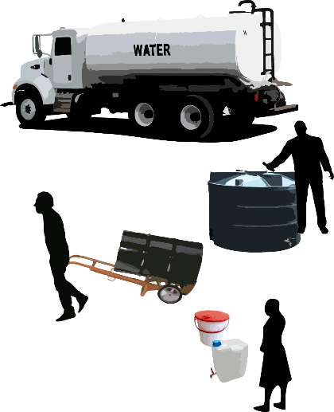
Trucked/vended water treatment
- For most complete coverage, with the least effort, treat the water as close to source as the situation allows after testing for chlorine level.
- The most common test is the dpd - diethyl paraphenylene diamine - indicator test, using a comparator. This test is the quickest and simplest method for testing chlorine residual.
- Training for those in the chain: It is necessary to negotiate support and organize training for water vendors / trucking operators on drinking water disinfection, provide them with access to chlorine.

Food vendor water treatment
- Ensure that food vendors’ stored water is protected and disinfected. This is important as it is a common source for many people (the reason it was a common source in the 2012 epidemic of cholera in West Africa)
- Training for water vendors on proper drinking water disinfection could be combined with water trucking operators
- Provide them with access to chlorine for future use.

Removal of bulk contamination risk - decommissioning a latrine (Annex Module 5)
A handout on how to decommission a latrine is supplied with these slides

Food interventions
- You probably cannot intervene in every private business’s behaviour because you:
  - Are not a regulatory agency
  - Have insufficient time (there is an outbreak so an emergency)
- Be EFFICIENT – target where risks are common, influencing those higher risk vendors that affect the most people
- GUIDE and CONTROL – if you rely on changing behaviour it will take weeks or months, people will die – give practical support for quick safety improvements. Don’t forget water!
- Changes you make must be SIMPLE (easy to do, not complicated) and CONVENIENT

Food health protection
Encourage vendors to ensure their products are:
- HOT: Well cooked, served hot.
- STERILIZED: Seafood like crabs boiled for 15-20 minutes, no raw shellfish. Sterilizing water they are in with chlorine. Also, drinking water.
- COVERED: Food to be covered to protect from flies (cover makes contact with flat surface, no gaps.
- HANDS: practical assistance for vendors and users (hand washing enabling technology, soap and water or alcohol hand gel).
- It’s pointless to simply tell people to wash their hands – nothing will change! Remember, make it convenient!

P2P interventions
- You probably cannot intervene in every private business’s behaviour because you:
  - Are not a regulatory agency
  - Have insufficient time (there is an outbreak so an emergency)
- Be EFFICIENT – target where risks are common, influencing those higher risk vendors that affect the most people
- GUIDE and CONTROL – if you rely on changing behaviour it will take weeks or months, people will die – give practical support for quick safety improvements.
- Changes you make must be SIMPLE (easy to do, not complicated) and CONVENIENT.
- Ensure that your WASH activities don’t make things worse!

P2P health protection
In WASH interventions encourage:
- DISTANCE: Ensure there are practical guides to ensure people are spaced in queues and no congested areas (e.g. rocks painted yellow, paint footprints). Outside your own operation you can encourage, and others may replicate your work.
- HYGIENE: All WASH interventions have handwashing places which are replenished – preferably with large water tanks and secured solid soap (more sustainable, less waste). It’s pointless to simply tell people to wash their hands – nothing will change! Remember, make it convenient!
- CONTACTLESS: Reduce touch points with elbow and foot operated valves and pumps (and graphic signs). Hands free door opening.

Activity

Practical – water
- Rapid risk assessment - engaging communities and sustainable systems – use training site (or nearby community space), rapid assessment tool and decision tree (table handout)
Decide WHAT you will need to include, WHERE and WHEN (full session on use later):
- Refilling and installing active chlorinators
- Testing residual chlorine (R) to 0.5 mg/l – DPD (diethyl paraphenylene diamine) indicator test (in emergencies the upper limit is advised)
- Rapid test for faecal coliforms
- Bulk water chlorination for trucked water
(chlorine production using WATA is covered separately)
- Decommissioning latrine(s)
Additional considerations:
- Signs and instructions
- Initial oversight and monitoring
Practical – food
- Rapid assessment (using the checklist for canteen or café near training site) and engaging (includes rules for safe preparation of food to prevent food poisoning)
- Approaching vendors, have an introduction prepared and observe their systems using the prepared rapid assessment checklist (HOT, STERILIZED, COVERED, HANDS)
Decide WHAT you will need to include, WHERE and WHEN:
- Handwashing for staff and clients
- Signs and instructions
- Initial oversight and monitoring

Practical – P2P / COVID-19
Health protection:
- Rapid risk assessment (using the checklist near training site) and engaging communities
Decide WHAT you will need to include, WHERE and WHEN:
- Installing distance markers / cordons and crowd control
- Reducing touch points
- Signs and instructions
- Initial oversight and monitoring

Practical – all Handwashing
Handwashing with soap and water (where to site in area near training site):
- Needs assessment based on other interventions, engaging communities and sustainable systems
- Installation of hands-free handwashing enabling technology
- Securing hygiene materials (solid soap, liquid option) – how will you do this? Discuss
- Efficient regular water supply – what are the options. Remember, the more frequently you have to refill, the less chance it will be done
Additional considerations:
- Signs and instructions
- Initial oversight and monitoring

Constructing Jengu – Arup-designed handwashing device
Link to video on Vimeo:
https://vimeo.com/430247485

REVIEW OF PRINCIPLES
EFFICIENCY
target where risks are common, influencing those higher risk vendors that affect the most people
GUIDING and CONTROLLING
if you rely on changing behaviour it will take weeks or months, people will die – give practical support for quick safety improvements.
KEEP IT SIMPLE, MAKE IT CONVENIENT
Changes you make must be simple (easy to do, not complicated) and convenient

Module 5 – part II Chlorine Solution Materials, Applications and Preparation

Training Module Agenda
- Products / materials for Chlorine solution production
- Mixing solutions for water sanitation and water disinfection
- Passive Inline Chlorinators
- Use of GTFCC App
- Solution Preparation, Concentrations, Testing (Free Residual Cl, NTU and pH)

Material handling / Health and Safety / Storage
- HTH Calcium Hypochlorite - Ca(ClO)2 (60 – 70% Active Chlorine]
- Aquatab pills - NaDCC – (60% Active Chlorine – One tablet containing 1.67g NaDCC releases 1g available chlorine when it is dissolved in water)
- Household Bleach - NaClO 4 - 6% active Chlorine
- Wata – production of chlorine by electrolysis (Chlorine concentraton 5 mg/L)
- Products and methods for water disinfection differ between places. They may also differ between response types (emergency, development, health facilities, schools)
- Use of Kit 001 - https://itemscatalogue.redcross.int/emergency-preparedness
- Products/solutions recognised by the IFRC / RCRC include:

WATA Unit Chlorine Production
WATA Standard Unit Chlorine Production
- Production time: 2 hours
- Production volume: 2L sodium hypochlorite at 5g/L
- Quantity of chlorine produced: 10 g of active chlorine
- Dimensions of device: 15 x 6 x 5 cm
Kit contents
- One WATA-Standard device + control box +15V/5A power supply
- One 50 mL syringe
- One production bottle
- One WataTest kit
- One WataBlue kit
- User Manual
- pH Test Kit
- Solar Kit (optional)

Solutions for disinfection (Wata)
- Different treatments required based on need
- Wata product is 0.5% chlorine (i.e. 5 g/L)
- 0.5% solution for heavily contaminated surfaces - widespread faeces, vomit (treatment centre) – no skin contact it burns
- 0.05% solution for handwashing (1 litre of Wata stock solution mixed with 9L water 1+9=10 or, 0.5% diluted 10x)
- Drinking - every 10 litres add 6ml* (use syringe) = 3ppm or 3mg/L
*approximate – depending on residual chlorine jar tests

% of active chlorine in the solution | Main purpose
0.50% | Wata Stock Solution (2 litres)  NB stock solution concentration assumes it is Wata
0.50% | blood and body fluids large spills
0.10% | Surfaces and item disinfection
0.05% | Hand and dishwashing

Surface Disinfection with Different Products
 | 0.05% | 0.2% | 2%
HTH (70% active chlorine | 1 table spoon in 20 litres of water | 1 table spoon in 5 litres of water | 2 table spoons in 1 litre of water
Bleach (5%) | 14 table spoons in 20 litres of water or ¼ cup in 20 litres of water | 20 table spoons in 5 litres of water | 2 cups in one litre
Use | Washing hands and clothing (soak for 15 minutes)  Skin disinfection | Disinfecting of beds, floors, latrines, kitchen, utilities of patient, etc | Disinfection of vomit and stool.  Disinfecting dead bodies (clean or spray with this solution before last offices)
Precautions | Solution must be changed every day and protected from heat and light | Use with gloves  Solution must be changed every day and protected from heat and light | Use with gloves  Solution must be changed every two days and protected from heat and light

Water disinfection with different products
Producing a standard 1.0% solution of differing water concentrations will differ between products
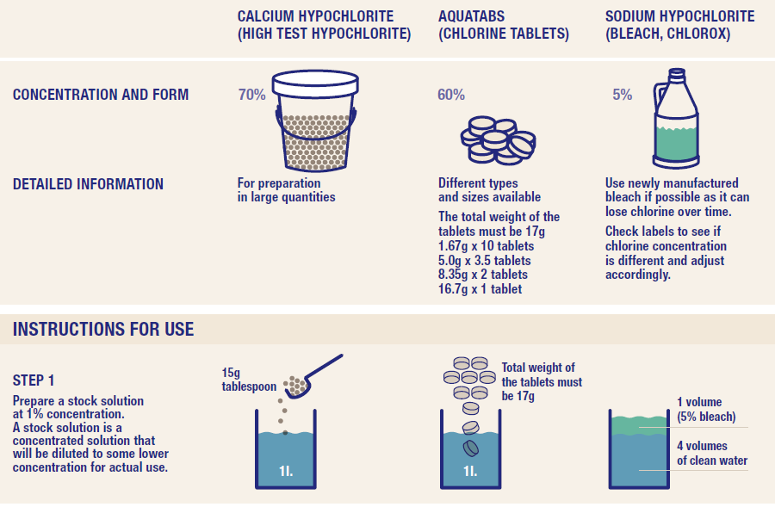

Factors affecting chlorination
- Residual chlorine depends on variables in the water:
- Suspended solids, described as turbidity or nephelometric turbidity units (NTU)
- pH, acidity - alkalinity
- < 5 NTU should be the aim; above 5 NTU, higher chlorine doses or contact times required to inactivate microorganisms. Above 5 NTU requires flocculation and filtration
- pH ideally 6-8. Above pH 8.0, higher chlorine and/or contact times required to inactivate microorganisms. Below 6.0, treatment will be compromised
- Residual Chlorine should be 0.5 mg/L Bench/jar test using a pool kit testing reagent (“pool” test, by litmus paper or similar reagent)

Testing residual chlorine in water
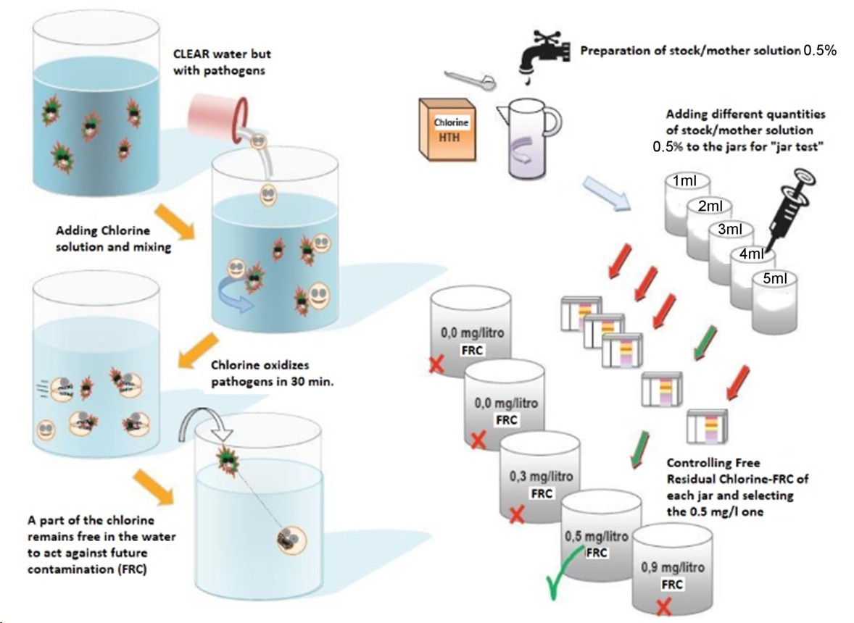

Testing residual chlorine in water
- Jar Test Method: Produce 1L of a 0.5% stock solution using the available Chlorine (guidance – look at the GTFCC App)
- Add volumes of 0.5% solution (from Wata device) in the following quantities to buckets or jerry cans of known volumes (10L is good) with syringe, as indicated in table.
Bucket 1 | 2ml
Bucket 2 | 3ml
Bucket 3 | 4ml
Bucket 4 | 5ml
Bucket 5 | 6ml
Bucket 6 | 7ml
- The container with residual close to 0.5mg /L - use that dose (e.g. 5ml per 10L)
- Give main treatment team member with electronic chlorine meter (can also use pool testing kits or chlorine disc)

Passive Inline Chlorinator Example
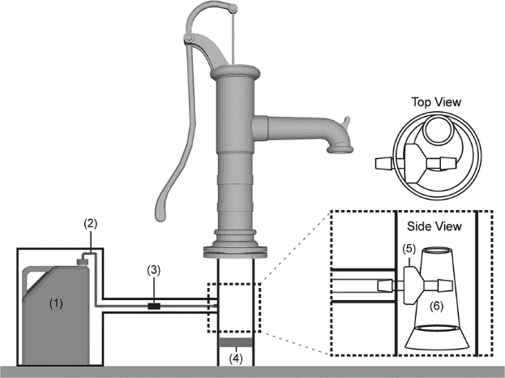
1. 10 L chlorine reservoir (jerrycan);
2. flexible tube (1/8 inch dia) to injection point;
3. regulator to control dose;
4. brass non-return valve within pipe, below injection point;
5. two non-return valves each end of tube (one shown located at injection point, one hidden inside chlorine reservoir outlet);
6. plastic funnel inserted in pipe below handpump to direct the flow past the injection point.
Source: https://www.researchgate.net/publication/273137367_Differences_in_Field_Effectiveness_and_Adoption_between_a_Novel_Automated_Chlorination_System_and_Household_Manual_Chlorination_of_Drinking_Water_in_Dhaka_Bangladesh_A_Randomized_Controlled_Trial

Exercise – Use of GTFCC
Q - Calculate out the necessary quantity of HTH product (70% free chlorine) required to produce 10L of 2% Chlorine Solution?
A – 300 grams
Q – What concentration of solution is produced with is required to produced 10 mL of Bleach and 1 L of water?
A – 0.05 %

Exercise – Use of GTFCC App
Q - Calculate out the necessary quantity of HTH product (70% free chlorine) required to produce 1L of 1% Chlorine Solution for drinking water stock solution?
A – 15 grams
Q – What are the ideal parameters for water quality (ntu, pH) to provide for effective disinfection? What is the ideal residual chlorine content (for a 24 hours period)
A – ntu < 5, 6.0 <pH <8.0, 0.5mg/L

Material handling, health & safety
- Product is dangerous – it is bleach!
- Prepare in well ventilated areas using wood spoon/stick to mix (no metal).
- Prepare solutions daily. Don’t create large quantities.
- Don’t mix NADCC and HTH
- Don’t combine disinfectants, can cause respiratory irritation and release potentially fatal gases (particularly combined with hypochlorite solutions)
- Use and label containers (do not put in drinking containers) Label as “not for drinking /bathing” XX% Chlorine Solution for YY purpose (depending on the concentration and intended application)

Material handling, health & safety - PPE
Keep solution in dry, shaded place, not exposed to heat, sunlight (burns off chlorine), out of reach for children !
Recommended PPE are:
  - rubber gloves
  - thick apron
  - closed toe shoes
  - face mask / respirator and eye protection such as safety glasses to avoid splashes

Scenario 1 - Household
You are presented with a household a member who has become ill with cholera. You are required to provide a description of how to purify household water for consumption, and create a standard stock solution for handwashing.
Q. What concentration is required for handwashing and water purification solution? What is the amount of HTH required to produce 1 L of this solution?

Scenario 2 – Health Facility
You are required to train health facility workers on disinfection solution for the cleaning of beds and other surfaces. Also you are required to provide training on the production of drinking water with suitable residual chlorine concentration?
Q. What concentration is required for surface disinfection for faecal matter and vomitus?
Q What is the residual chlorine content required for water consumption?

Review of Module 5
- Numerous modes of transmission, with varying levels of risk of exposure. Transmission routes can be from water vendors, water distribution points, food sellers and can also be direct and indirect.
- There are numerous common, readily available materials which can be used to develop chlorine stock solutions. There are also systems which can provide passive inline treatment of water so as to minimise
- Chlorine solutions can be used for surface disinfection, disinfecting water for consumption, sanitising of households and health care facilities.
- The use of the GTFCC app can easily reduce confusion about concentrations and quantities required for producing stock solutions and water disinfection.
- It is ESSENTIAL that drinking water is tested for residual chlorine concentration (0.5 mg/L) using the jar / beaker test.
- Environmental factors and other water quality aspects such as temperature, turbidity and pH can affect water disinfection and chlorine
- Storage and use of corrosive and dangerous chemicals such as HTH and other chlorine must be in accordance with health and safety requirement. Chlorine solutions are UV sensitive and will degrade under direct UV light.

Module 6: Cholera and COVID-19 High Risk Groups

What we will cover in Module 6
- What occupations or life circumstances increase exposure, and therefore risk of contracting, Cholera and COVID-19.
- Focus on four main high-risk populations/ practices: fishing communities, nomadic populations, refugee settings, funeral practices.
- RCRC National Societies can focus on, and adapt this model based- on, which what is most relevant to the local context.

Key learning for participants
By the end of the session, participants will understand:
- Why each high risk group/ situation presents specific vulnerabilities.​
- What increases these vulnerability/ risks.
By the end of the session, participants will be able to:
- Identify, and implement, solutions to address vulnerability and reduce risk.

High Risk groups
- Occupational risk – certain livelihood activities will increase exposure to, and thus risk of contracting, Cholera and Covid 19
- Examples – fishing communities, mining communities, funeral practices.
- ‘Life circumstances’ risk – certain traditional lifestyle, such as pastoralism or being a nomadic population, or being a migrant/ IDP/ refugee, will also increase risk.
- Increased risk may be through increased exposure but mainly through increased susceptibility – lower access to health care services, poor WASH services (poor safe drinking water, not save excreta disposal, and poor hygiene practices), poor food hygiene etc.
The following high-risk groups are analysed in this presentation. Please choose those relevant to your context, and further adapt them.
- Fishing communities
- Nomadic populations
- Refugee settings
- Funeral practices

High Risk groups – Fishing communities

1. Why vulnerable
- Communities live by and often gain their livelihood from surface water and the creatures living in and around it, which act as reservoirs for vibrio cholerae
- Often the water source is used for all purposes including defecation meaning that disease spreads quickly
- Basic safe drinking water, safe excreta disposal and hygiene practices tend to be limited
- Limited knowledge regarding cholera transmission
- Fish and crustaceans from the water are prepared either for self-consumption or to sell (without following proper food hygiene)

2. What increases vulnerability/ risk
Understanding Cholera
- There are over 200 groups of vibrio cholerae, but only 2 cause cholera in humans.
- Ingestion of Vibrio cholerae with food products decreases the infectious dose required to cause cholera,
- Vibrio Cholerae colonize the intestinal passage of humans and multiply, going through a selective enrichment period. However, due to low initial concentrations of choleragenic vibrio cholerae, the human carriers normally show no symptoms of the disease.
- Asymptomatic (no symptoms) carriers will shed pathogenic clones in their stools, further enriching the water sources with virulent bacteria and facilitating the initiation of an epidemic
Hosts
- Vibrio cholerae is found in algae, shellfish, chironomid egg masses, fish, waterfowl, amebae, and most commonly, copepods (microscopic crustaceans). Copepods thrive in algal blooms.
- Crustaceans such as shrimp and blue crab
- Anthropods eggs…on water flies, midges etc
- Waterfowl such as cormorants, pelicans, seagulls, egrets, and herons.
- Waterfowl consume other potential reservoirs of V. cholerae such as shellfish and crustaceans. Findings strongly support the hypothesis that migratory waterfowl act as disseminators of V. cholerae across water bodies.
- Fish including Tilapia which is known to consume copepods and chironomids, known reservoirs of V. cholerae. Findings demonstrate that fish act both as a reservoir and vector for the transmission of V. cholerae, facilitating colonization of humans and also dispersal of the bacterium through migration to new habitats.

Cycle of Infection Around Water Sources
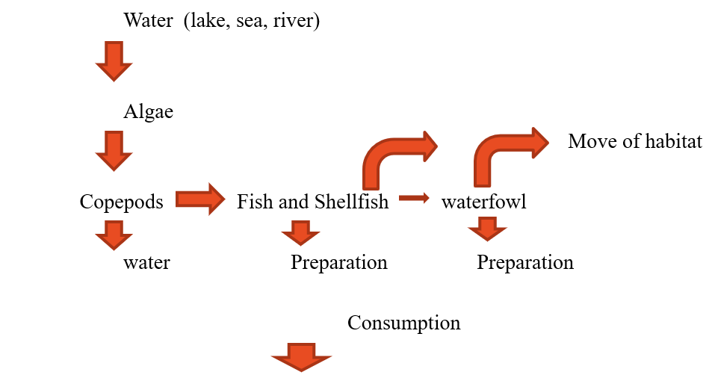

3. Solutions
Block transmission
Copepods removed from water through filtering or water treatment.
- Obviously, water for drinking and food preparation should be fully treated where possible, but if this is not possible even the filtering through cloth can have an impact on transmission.
- It was found that the removal of particulate matter from drinking water through filtration with a traditional Indian garment termed a sari yielded a 48% reduction in the incidence of cholera in some areas of endemicity in rural Bangladesh (23). A subsequent study showed a sustained decrease in the incidence of cholera in those villages that kept using the sari filtration method (21).
Hand hygiene when preparing aquatic life which may harbor Vibrio cholerae
- Good personal hygiene, especially handwashing with soap should be carried out after the preparation of shellfish and fish. After preparation and washing this should be thoroughly cooked and not eaten raw or semi-cooked.
Proper disposal of fish waste
- Fish guts and other waste should be disposed of properly and buried away from the water to prevent other animals/flies eating them.
Proper disposal of human faces
- If open defecation is the only option ensuring it is away from the water and done in a safe manner, preferably burying the faeces. (Particular attention of safe disposal of children faeces)
Carrying out the suggested measures at all times as outbreaks may be avoided
- There may be an ongoing outbreak some distance away but linked by the water or the fish and birds which move around the water body
- Vibrio cholerae may already be present in the environment, but humans remain asymptomatic as the concentrations are still low. Ensure faecal matter is not returning to the water as this will slowly increase concentrations.

Key considerations for fishing communities
These are often poor communities with limited resources thus messaging should be simple, straightforward and easy for them to carry out without creating a burden on them.
If there are limited options around water treatment/disinfection, distribute cloths and ties (strong rubber bands) to households and promote the filtering of water. This can be put in cheaply as a long-term action.
Give the household small, simple digging tools in order to bury faecal matter and waster from the preparation of fish and other creatures for consumption.

Suggested Kit
1x5l buckets
1x10l bucket
Trowel
Filter cloth and ties
Soap
Water treatment tablets

High Risk groups – Nomadic populations

1. Why vulnerable
- Insecure nomadic lifestyle – coping mechanisms which might increase vulnerability/ risk
- Poor access to:
  - Healthcare
  - Supplies for cholera treatment
  - Information about cholera prevention, transmission routes and treatment
- ‘Cattle camps’ > little or no access to safe water and sanitation
- Traditional beliefs and practices (about cholera transmission, prevention and treatment)
- Mistrust in local health, and overall, services – trust providers who come from/ with ties to same tribe/ clans/ areas of origin

2. What increases vulnerability/ risk
- Within nomadic populations, pastoralists present lower risk than semi-nomadic/ settled populations > distanced during migratory season, constant movement (and so can move away quickly from areas of risk)
- However, pastoralist present higher rates of open defecation and contribute to faster spread of cholera outbreaks, if transmitted within their community (transborder movements during seasonal migration, which often coincides with rainy season)
- Increased insecurity and climate change caused increased patterns of sedentarism in nomadic populations. Villages where traditionally women and children relocate, whilst men are at cattle camp or migrate with their herds, are overcrowded and underserved.
- Chronic water insecurity (impact on water quantity and quality) (and also common to nomadic lifestyles) water is collected and often directly consumed from open sources such as ponds, rivers, and puddles as soon as it becomes available following rains. Water is stored in open containers. These unprotected water sources are also common sites for bathing and open defecation and may therefore be contaminated with faecal matter.
- Shortage of cultivated food leads residents to increase their consumption of roadside-vended food, where food is often not served hot and handwashing is inadequate
- Women and children at increased risk (sedentarism, caring for the sick, traditional beliefs that children’s faces are not infectious).
- Languages of nomad population might not be the same of the language used on the local radio messages to mobilize the communities.

3. Solutions
- Address the paradox of settlement and cholera transmission. Infectious diseases are more prevalent in nomadic semi-settled communities than pastoralist ones, but access to health facilities to treat illness is easier for settled communities. Nomadic livelihoods require protection, and settlements need better health prevention.
- Facilitate access to mobile or fic health services (for treatment – link with ORPs)
- Improve access to trusted source of information – tailored cultural interventions (link Branch Response Teams with local nomadic leaders, and similar. Include these in cascaded training)
- Improve WASH infrastructure (periods without outbreaks-seasonality of cholera during rainy season) – in key villages where nomadic population (temporarily) settle and along migration roots (chlorination of ‘seasonal’ boreholes along migratory routes, during migration/ rainy season, improvements of sanitation, handwashing campaigns etc..)
- Portable Ultra Filtration Membrane water filters: effective against virus and bacteria, no cartridge, backwash (See example in attached annex – possibly for next phase of training and for those NS/ Branches where nomadic populations present high risks/needs)
- Overlapping of vulnerabilities – migrant fisher communities
- Coordinate with WHO and UNICEF on the OCV cholera vaccines to prevent and control of outbreaks.

COVID-19 considerations
- Similar vulnerabilities, reasons for increased risk and solutions as outlined for Cholera.
- Lack of data – nomadic populations are a ‘blind spot’ in global health surveillance (for COVID-19, and to some extent overall)
- ‘Transborder’ pastoralist communities face an increased risk of imported COVID-19 transmission > One Health approach (need to further elaborate?)

Practical Tools considerations
Sanitary survey assessment tailored on nomadic communities
- Check for open defecation practices.
- Check for safe disposal of children faeces.
- Check water container (not covered, not clean, etc.)
- Check where people collect water (for example unprotected water sources like such as ponds, rivers, and puddles).
- Check practice of handwashing with soap.
- Check for consumption of street food (i.e. food is often not served hot and handwashing is inadequate).
- Check if cattle access drinking water at the same communal water point where people collect drinking water.

High Risk groups – Refugee settings

1. Why vulnerable
- Limited access to livelihood activities and opportunities and general poverty of displaced camp communities
- Living in overcrowded conditions with poor safe drinking water, unsafe excreta management, poor handwashing
- No water quality surveillance/monitoring.
- Wastewater flowing directly into open drainages.
- Often marginalised and stigmatised (particularly re: the transmission of communicable diseases) by local communities
- When living in camps, congested shelter and environment prone to floods (camp areas are allocated by local authorities, often on less valuable ground, i.e. prone to flooding)

2. What increases vulnerability/ risk
- Frequent flood/waterlogging events lower the general health status and increase exposure to cholera transmission through flooding of latrines, pit overflowing and general spreading of surface contamination from high risk areas such as landfills and congested markets across large areas.
- Negative coping mechanisms increases their vulnerability to cholera transmission, e.g. selling latrine materials to buy school books; selling NFIs to buy food; or selling soap to buy clothes.
- Movements between camp and surrounding host community often frequent for trade, work etc. and this is an important transmission risk during outbreaks.
- Movements between camp settings in host country of asylum and place of origin (to check on property, visit family members etc) are also common which complicates the containment of disease transmission.

3. Solutions
Checklist for Refugees
- RESPOND QUICKLY: Don’t wait for official confirmation or declaration to respond.
- INTEGRATED WASH and HEALTH interventions: WASH team to be integrated with health team for duration of outbreak -with frequent ‘exchange, update & coordination’ meetings.
- HEALTH STRUCTURES: WASH team to facilitate WASH for case management: IPC WASH in CTCs and related health structures including ORS points. IPC -Infection Prevention and Control.
- TARGETING: Be guided by health surveillance team for accurate targeting of WASH actions in community.
  - Do simple maps.
  - Correlate case maps with WASH facility maps, and likely risk maps, and cross-check with household visit reports of known cases
- 100% CHLORINATION: Ensure 100% of water supplies are chlorinated (e.g. bucket or HH chlorination for water from hand pumps/surface sources, active/passive chlorination etc.)
- +++ CHLORINATION: Increase chlorine dosage and standard chlorine residual (e.g. from 0.5 to 1.0 mg/L –context variable). (Passive/Active chlorination devices)
- WATER MONITORING: Increase water quality monitoring to systematic daily measurements at all points in water chain + ensure random cross-checks (focus on bacteriological contamination parameters).
- +++HYGIENE PROMOTION: Deploy pre-trained hygiene promotors for Cholera specific public awareness (high impact interventions messages: safe excreta disposal, safe drinking water, handwashing with soap and water).
- Can accompany latrine disinfectors, or bucket chlorinators, or soap and other NFI distributors, or ORS corners.
- Initiate Cholera specific hygiene promotion from all ‘angles’ –radio/loudspeaker/posters/house-to-house/schools & institutions etc.
- Increase Cholera specific hygiene promotors at CTCs targeting carers of patients accompanied by NFI package to carer and household of affected patient.
- +++ WATER: Emergency water trucking (or supply) for under-served areas (making sure water is safely disinfected).
- +++ LATRINES: Emergency latrine construction for under-served areas.
- +++ NFI: Emergency hygiene NFI distribution in under-served areas.
- DISINFECTION: Emergency latrine slab (not household) disinfection in affected areas, communal handwashing points.
- AUTHORITIES: Engage local authorities for public awareness and targeted access restrictions in high-risk areas e.g. swimming ponds/market food stalls etc.

Funeral practices- checklist
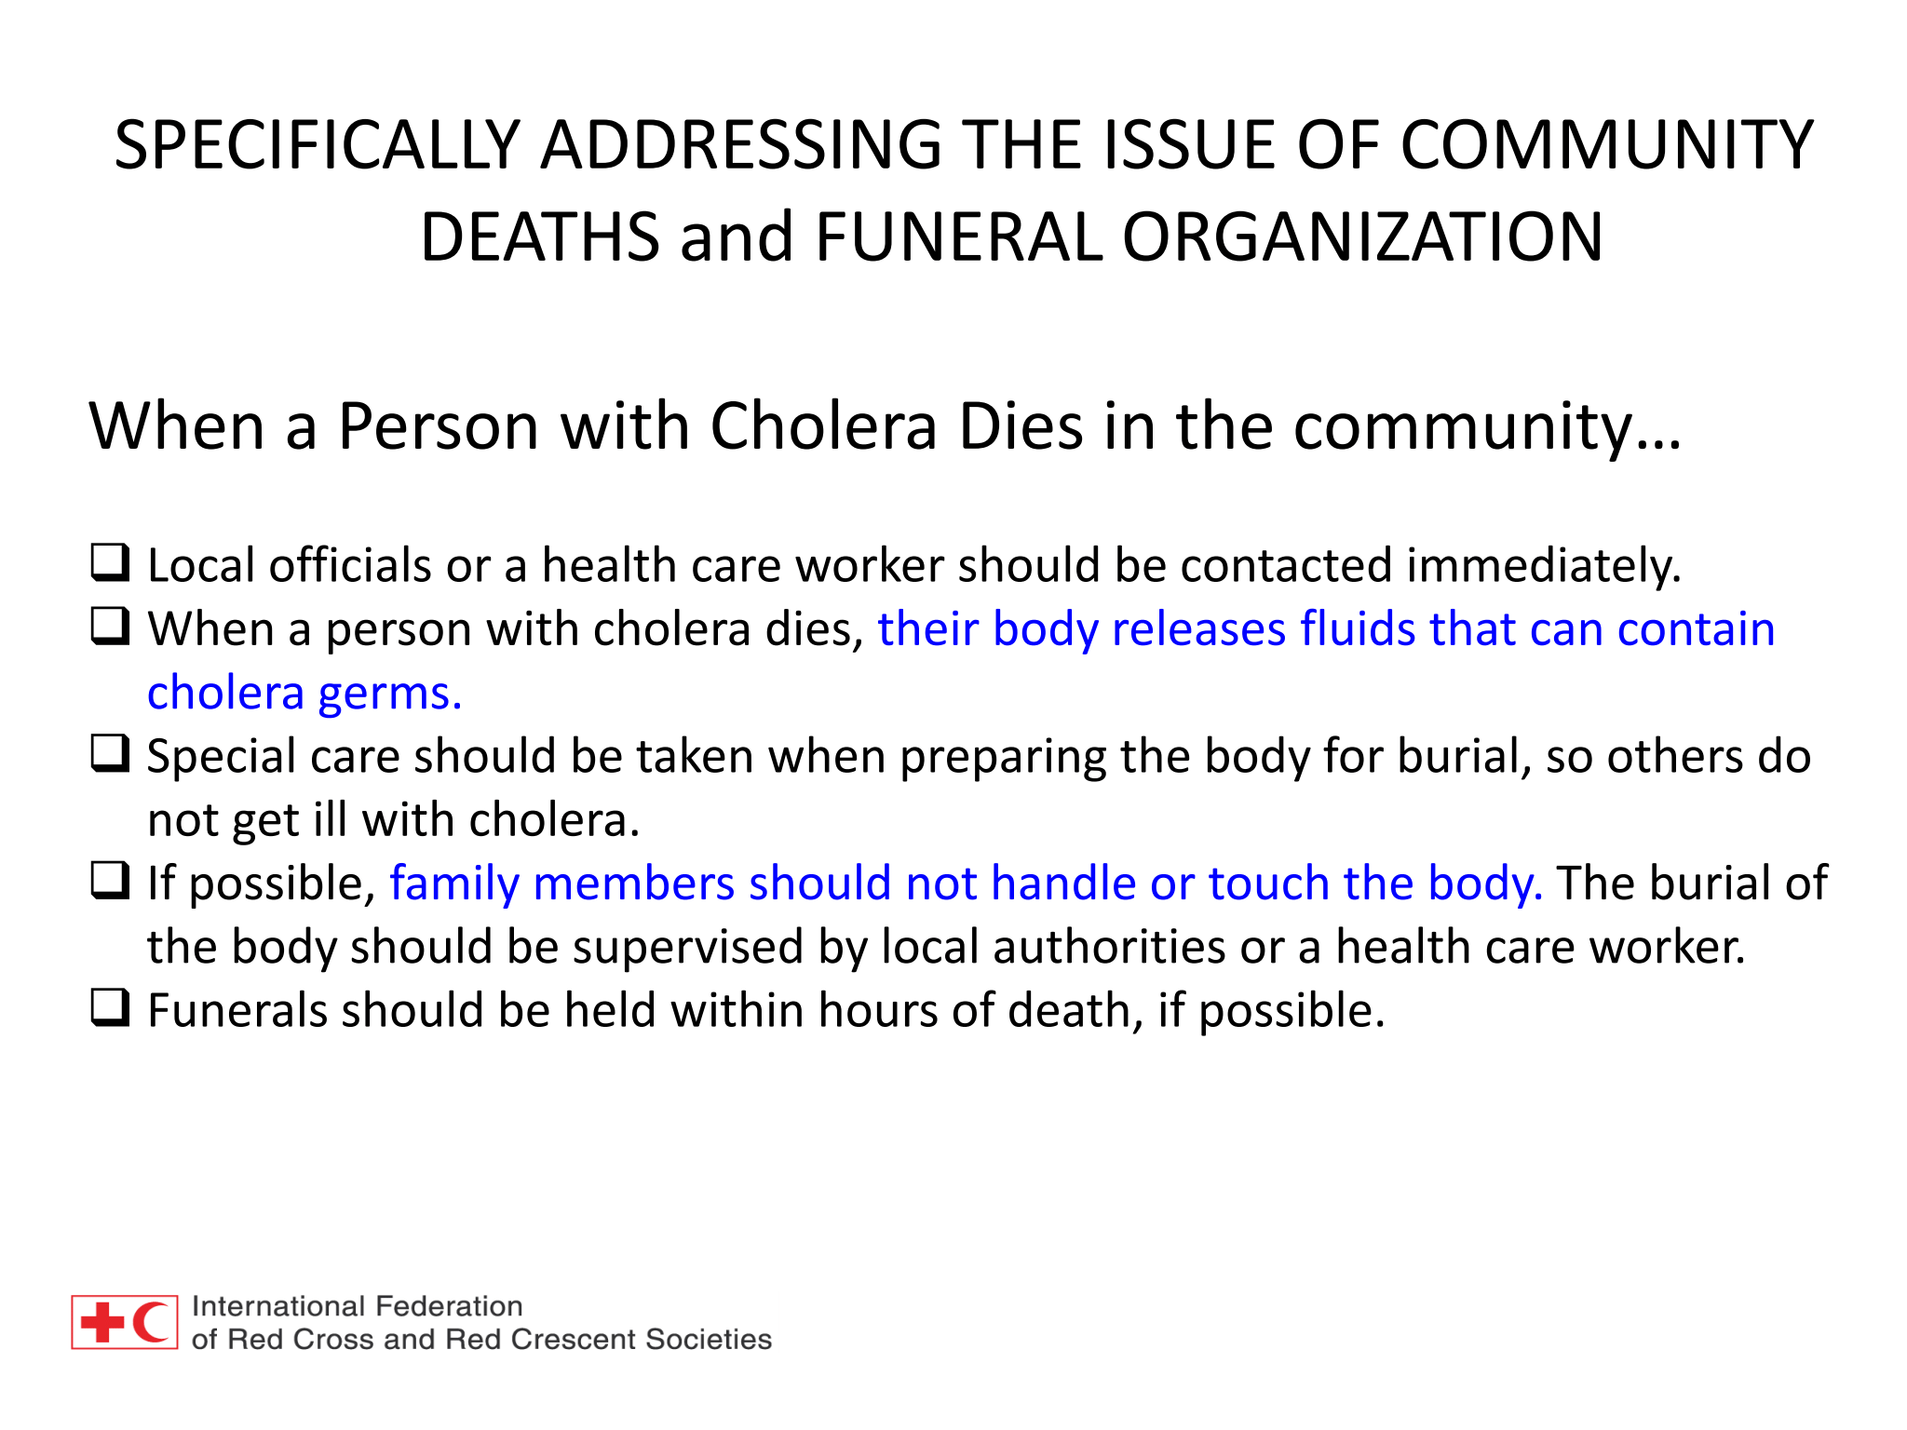
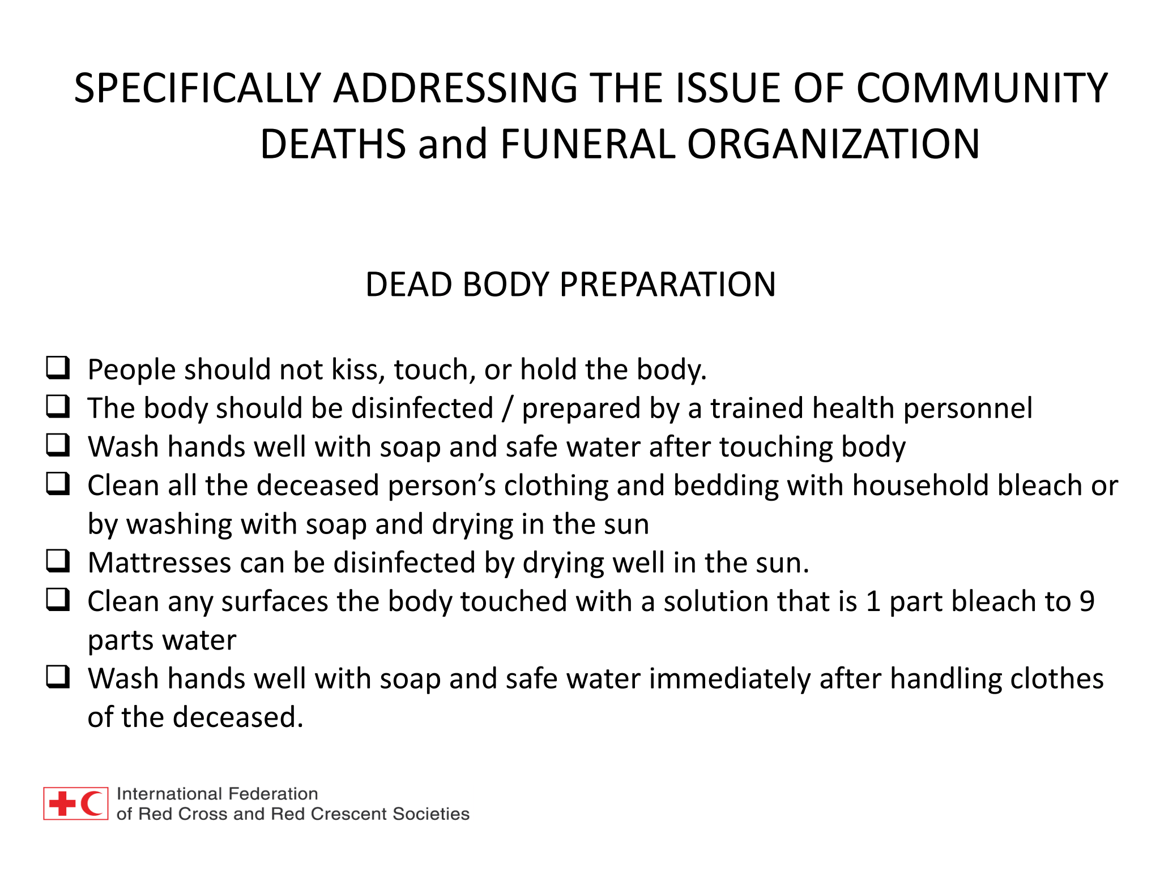
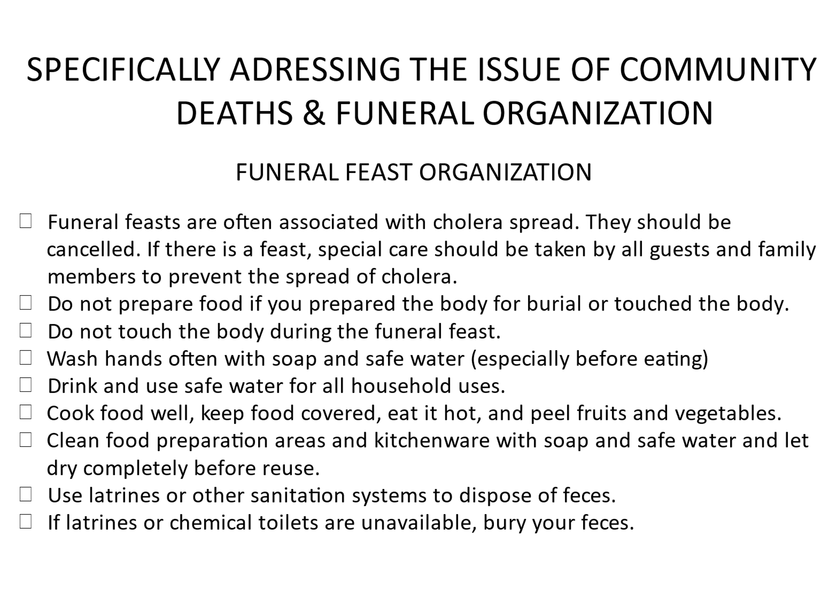

Review of Module 6
- High Risk groups/ situations present specific vulnerabilities. Use the provided assessment/ checklist tools to identify, and address, these.
- High Risk groups/ situations need to be incorporated in response plans.
- In context where specific high-risk groups are identified, the BORT teams need to establish links with those communities (through traditional leaders, village committees, etc.).

Module 7: Medium and long-term interventions

What we will cover in Module 7
- Linking the emergency with medium-term prevention
- Evidence Action Model
- Set up and maintenance of the EA model

Key learning for participants
By the end of the session, participants will understand:
- How to integrate the BORT into medium and longer-term response, according to the local context and existing RCRC programmes
By the end of the session, participants will be able to:
- Identify specific means to improve the use of information generated by the BORT intervention, local production, and maintenance of materials, and institutionalise community gains.

Rationale
After a typical emergency response, information which has been accumulated through much effort will be left with people unsure what to do with it and with no strategy for its use. Items brought in which have been used in ending the outbreak are left and stored for future use in an outbreak or left in communities and eventually run down into disrepair. Those who have become more aware or learnt new skills will retain some of that capacity, but without regular refreshing or the need for its use, over time it will reduce.
To better integrate the BORT emergency response training with prevention of, and preparedness for, (health) crise, we can:
- Make better Use of Information provided during the training
- Expand means of production and maintenance of BORT/ materials
- Institutionalizing the community capacity gains

Discussion points on better use of information, local production and maintenance of materials, and institutionalizing community capacity gains (Annex)

Chlorine Manufacture and the Evidence Action Model of Water Supply Protection
Objective: Medium-term provision of chlorinated water or possibility of access to chlorinated water
Output: Local production or procurement of chlorine and dispensers. Model for its distribution and use through chlorine dispensers sited at any type of water source.
Actions: During response WATA chlorine makers introduced and training given. Dispensers are fabricated (or imported). Distribution systems organized and linked to DHA set-up. Local volunteers trained in monitoring and logistics of supply.
Community choose modality of engagement:
- Chlorinate continuously
- Chlorinate if any cholera or AWD outbreak is announced in country or District
- Chlorinate only if there is a cholera/AWD outbreak in the area or community

Chlorine Distribution: How it works
Unsafe water sources are identified and discussions undertaken with community and local authorities explaining the system. Chlorine drip dispensers are located by the water sources and are regularly filled by volunteers. Those collecting water put drips of chlorine into the water to treat it. Chlorine supply will be organized through the branch and the participation of local authorities.
Communities can choose how they wish to engage:
- Constant chlorination
- Chlorination in cholera season
- Chlorinate when outbreaks are reported in the vicinity

Emergency to Medium Term – Jengu handwashing unit manufacture (Annex Module 7)

Ram Pump Installation or Manufacture (Annex Module 7)

Latrine Slab Manufacture (Annex Module 7)

Review of Module 7
- Cholera outbreaks and the subsequent response often result in the accumulation of information, capacity building of communities and an increase in resources available.
- There is a need to identify opportunities to use the above so as to create medium term interventions which can contribute to the prevention of future outbreaks.
- During any operation one eye must be kept on the possibility of rooting such interventions in the response.
- Examples: HW facilities, chlorine production and use of dispensers, ram pumps and sanplats.

