## End of Deployment Report Part 1 & 2

##### Part 1 – EoD Operational Report

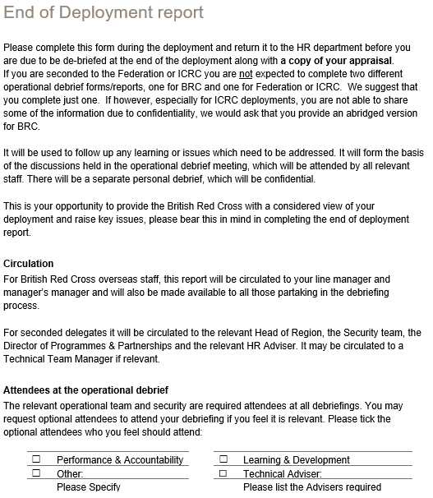

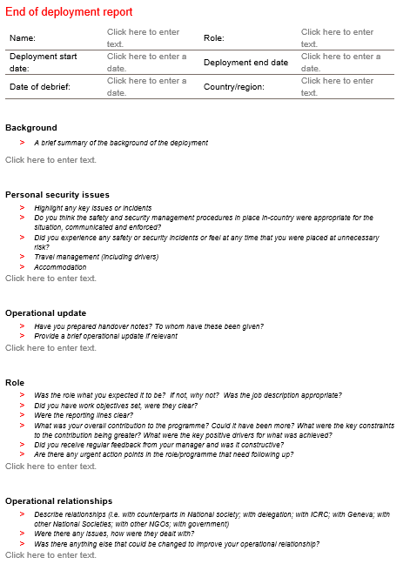

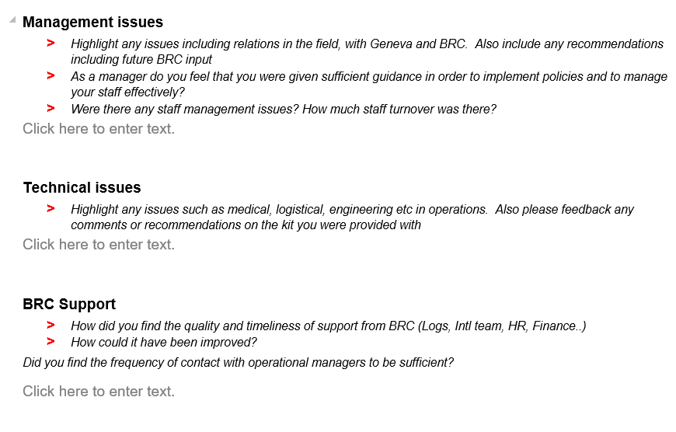

##### Part 2 – End of Deployment Personal Debrief Form

##### 

##### 

## Handover Information Needed

1. Outline the approach taken to the intervention;
2. Summary of progress to date against targets;
3. Identify key issues, challenges including how the response / rotation engaged with communities, HNS and met Community and Engagement, Diversity and Inclusion, and Safeguarding and Protection, minimum standards;
4. List key contacts, counterpart staff, volunteers and other stakeholders with contact details;
5. Weekly schedule of meetings / activities;
6. Outstanding actions and liabilities;
7. Lessons learnt; including on all the above points under (3)
8. Recommendations going forward and for exit.